SINGAPORE POLYTECHNIC

SCHOOL OF DIGITAL MEDIA AND INFOCOMM TECHNOLOGY



PROJECT NO. DISM/FT/3A/01/62

SECURED-T

SECURED ONLINE ASSESSMENT VIA SOFTWARE DEFINED NETWORK

4th AUGUST 2017

PROJECT NO. DISM/FT/3A/01/62

SECURED-T

SECURED ONLINE ASSESSMENT VIA SOFTWARE DEFINED NETWORK

**SUBMITTED BY:**

1444968 RADIN AYUWANDIRA BINTE RADIN AMIRMUMININ  
1529546 LIM XIN LI  
1551271 BAVANI D/O RAMAN  
1551354 T.PUVARNESWAREN RAJA

A REPORT SUBMITTED IN PARTIAL FULFILMENT OF THE

SUBJECT PROJECT – ST2601 (DISM)

PROJECT SUPERVISOR: MR KARL KWAN

SCHOOL OF DIGITAL MEDIA AND INFOCOMM TECHNOLOGY

SINGAPORE POLYTECHNIC

500 DOVER ROAD

SINGAPORE 139651

**ABSTRACT**

|  |  |
| --- | --- |
| Purpose : | To provide a secured and controlled environment to host online assessments for students. |
| Brief Description :  Of Project | To develop a lockdown system that sets up the desired test environment while allowing students to use their personal notebook during the assessment to access online resources. |
| Conclusion / :  Recommendations | After numerous in-depth testings, we believe that Secured-T has successfully delivered the essentials and dismissed several concerns of our lecturers. Some recommendations for improvement that can be implemented into our system could be network traffic logs, port scanning, enhance compatibility with non-Windows operating systems and so on. Other than that, some recommendations for potential usages could be for use in classroom teaching environments, parental control and highly confidential companies. |

**ACKNOWLEDGEMENTS**

The team would like to express our gratitude to our mentor and supervisor, Mr Karl Kwan for his guidance and support throughout the preparation of this Final Year Project as well as our sponsor, School of Digital Media & Infocomm Technology (DMIT), Singapore Polytechnic for providing us with the essential hardware tools.

**LIST OF ILLUSTRATIONS**

Figures

Figure 1: Gantt Chart

Figure 2: Secured-T Setup

Figure 3: Secured-T

Figure 4: SDN Diagram

Figure 5: OpenFlow Virtual Switch

Figure 6: Ryu Controller

Figure 7: ASUS RT-AC55UHP Wireless Gigabit Router

Figure 8: CSI

Figure 9: Poster

Figure 10: Login Page

Figure 11: Signup Page

Figure 12: Features/Help Page

Figure 13: Home Page

Figure 14: Add Module Page

Figure 15: Remove Module in Home Page

Figure 16: View Upcoming Assessments Page

Figure 17: Add Assessment Page

Figure 18: Remove Assessment in Upcoming Assessments Page

Figure 19: Add Announcement Page

Figure 20: Search Announcement by Module Code

Figure 21: View White Domain Page

Figure 22: Add Whitelist Domains Page

Figure 23: Remove Whitelist Domains Page

Figure 24: Monitoring Page

Figure 25: All Assessments Page

Figure 26: History View Of All Students Page

Figure 27: View Profile Page

Figure 28: Edit Profile Page

Figure 29: Detailed Help/Guide Page

Figure 30: Automatically Download

Figure 31: Click To Download

Figure 32: Login Page

Figure 33: Announcements Page

Figure 34: Submissions Page

Figure 35: Logout Warning

Figure 36: T_ANNOUNCEMENT

Figure 37: T_ASSESSMENT

Figure 38: T_LECTURER_INFO

Figure 39: T_MODULE

Figure 40: T_STUDENT_INFO

Figure 41: T_WHITLELIST_DOMAIN

Figure 42: 3D Burndown Chart - Sprint 1

Figure 43: 3D Burndown Chart - Sprint 2

**Tables**

Table 1: SDN Layers

Table 2: Comparison of Routers

Table 3: Features and Functions of CSI

Table 4: Features and Functions of SecT

Table 5: Features and Functions of StudentSecT

Table 6: Risk Analysis & Planning

Table 7: Recommended Improvements for Secured-T

Table 8: Recommended Potential Usages for Secured-T

Table 9: Scrum Roles

**Contents**

|  |  |  |
| --- | --- | --- |
| **S/N** | **Topics** | **Page No.** |
|  | Cover Page |  |
|  | Title Page | i |
|  | * Name of proposed system * Diploma name, group number, supervisor’s name * Admission numbers (in ascending order) and members’ names * Date of report |  |
|  | Abstract Page | ii |
|  | * Purpose * Brief Description of Project * Conclusion / Recommendation |  |
|  | Acknowledgements | iii |
|  | List of Illustrations | iv |
|  | Contents | vi |
|  | * Serial Number (S/N), Contents & Page Numbers |  |
| **1** | **Introduction** | 1 |
| 1.1 | Purpose | 1 |
| 1.2 | Background | 1 |
| 1.2.1 | Student’s Point of View | 1 |
| 1.2.2 | Lecturer’s Point of View | 1 |
| 1.3 | Scope | 2 |
| **2** | **Project Plan** | 3 |
| **3** | **Solutions** | 4 |
| 3.1 | Existing Solutions | 4 |
| 3.2 | Our Solution: Secured-T | 5 |
| 3.2.1 | Software Defined Network | 7 |
| 3.2.2 | Packet Flow | 9 |
| 3.2.3 | Mininet | 10 |
| 3.2.4 | OpenFlow Protocol | 11 |
| 3.2.5 | Ryu Controller | 12 |
| 3.2.6 | Router | 13 |
| 3.2.7 | Detective System | 15 |
| **4** | **Web Application** | 17 |
| 4.1 | Lecturer Web Application | 17 |
| 4.2 | Student Web Application | 20 |
| **5** | **Database** | 21 |
| **6** | **Risk Analysis** | 22 |
| **7** | **Conclusion** | 24 |
| **8** | **Recommendation** | 25 |
| 8.1 | Improvements | 25 |
| 8.2 | Potential Usages | 26 |
| **9** | **Reflections** | 27 |
| 9.1 | Reflection (Radin Ayuwandira Binte Radin Amirmuminin) | 27 |
| 9.2 | Reflection (Lim Xin Li) | 34 |
| 9.3 | Reflection (Bavani D/O Raman) | 38 |
| 9.4 | Reflection (T.Puvarneswaren Raja) | 40 |
| **10** | **References** | R1 |
| **11** | **Appendices** | A1 |
| 11.1 | Appendix A: Poster | A1 |
| 11.2 | Appendix B: Web Application Features | A2 |
| 11.2.1 | SecT | A2 |
| 11.2.2 | StudentSecT | A9 |
| 11.3 | Appendix C: Database Details | A11 |
| 11.4 | Appendix D: Scrum Roles List | A13 |
| 11.5 | Appendix E: Burndown Chart | A14 |
| 11.6 | Appendix F: Weekly Attendances | A15 |
| 11.7 | Appendix G: Weekly Monitoring Reports | A39 |
| 11.8 | Appendix H: Minutes Meetings | A68 |
| 11.8.1 | Official Minutes Meetings | A68 |
| 11.8.2 | General Minutes Meetings | A123 |
| **12** | **Programs Listing** | PL1 |
| **13** | **Guides** | G1 |
| 13.1 | Installation Guide | G1 |
| 13.2 | Lecturer Guide | G32 |
| 13.3 | Student Guide | G48 |

**1 Introduction**

**1.1 Purpose**

The purpose of this project is to attain a secured system for lecturers to facilitate online assessments and for students to use their own notebook to take their online assessments in a controlled environment by making use of the Software Defined Network (SDN) model.

**1.2 Background**

In most educational institutions, the assessments are conducted as written papers annually. However, for technical related modules that involves programming, it requires students to do coding. It is less appropriate to assess them in written format.

**1.2.1 Student’s Point of View**

In a student’s point of view, taking technical related modules for an examination in written format feels unfamiliar as they have been doing all their practical labs and assignments on their own notebook. Having them to switch to written format makes them feel unaccustomed to the change. Students also find it unfair as they feel that written exams are testing on their memory skills instead of their technical capabilities. In addition, students find it unfavorable to them during an open-book examination as they would need to buy and bring the hard-copied resources to the examination hall. However, if the exams were online, they could access information on the internet or the notes on their notebook. This makes it much more convenient and time-saving for them.

**1.2.2 Lecturer’s Point of View**

In a lecturer’s point of view, allowing students to use their notebook to take online examinations causes various concerns about the problems it may lead to. Even in a normal examination, monitoring all the students at the same time is very challenging for lecturers due to not having enough invigilators or having students who are determined to cheat. Taking the examination online gives students the opportunity to take advantage of the situation and commit cheating acts such as communicating with fellow mates to ask or share answers.

During an online examination, lecturers have previously experienced cases like students cross-talking through social medias such as WhatsApp, Telegram and Skype and other mediums such as forums or using SSH and FTP to share or ask for answers. Students could also browse through the web to look for answers to copy since they have the freedom to do so and not be caught cheating. This makes it impractical for the lecturer to keep an eye on every student and their activities on their personal notebook.

**1.3 Scope**

This secured system is specially designed and developed for lecturers who wish to conduct online assessments for their students and for students who are taking technical modules in School of Digital Media and Information Technology.

**2 Project Plan**

As shown in Figure 1 below, we started to know and researched on our project rather early, on 23rd March 2017, during our semester break. Programming was started on the very first day and the website was started on 2nd May 2017, in conjunction with our programming period. We then did testings and debugging for almost two weeks. Overall, we took nearly five months to finish our project.

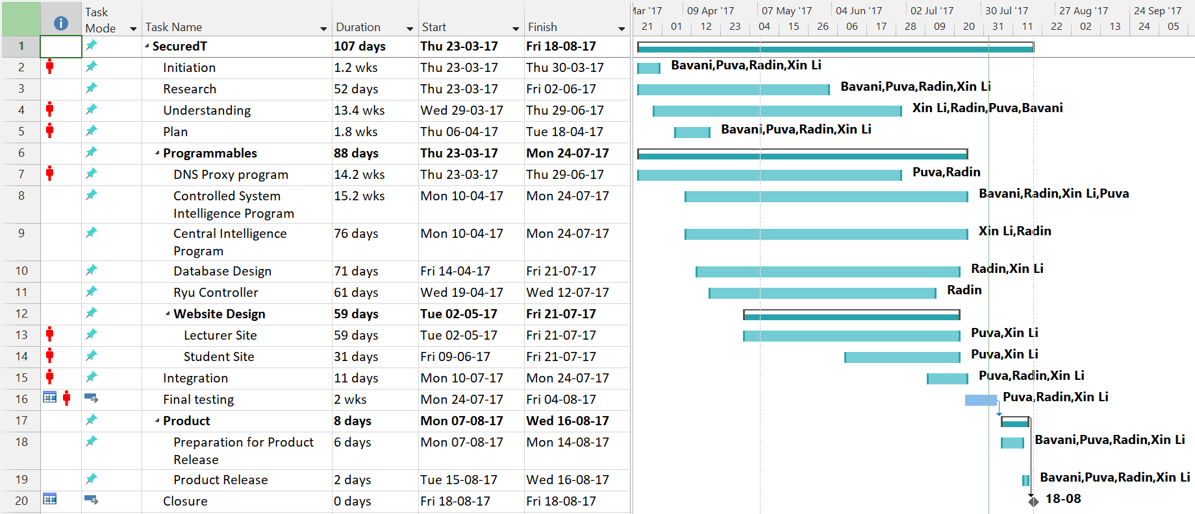

**Figure 1: Gantt Chart**

**3 Solution**

**3.1 Existing Solutions**

There are various existing solutions that can cater to the needs of the lecturers to have a secured system for students to do online assessments. However, there are some demerits in implementing these as solutions.

LanSchool Classroom Management Software is one of the existing solutions. This software is installed in every computer in the T2033 and T2034 computer labs. It can monitor, communicate, blank a student’s computer screen and also limit access to specific websites or allowing access to certain websites that their lecturers have preset. The downside of this solution is that the software needs to be installed on every student’s laptop which could be inconvenient and problematic. It also poses as a risk if the students do not have the software installed on their laptop on the day of the examination. Furthermore, this software does not record any data in the database for future reference and allows teachers to communicate with an individual or group of students within the classroom by either audio chat or using a chat box. Being able to chat with a specific individual or group aids students to cheat as they could be communicating with their fellow classmates during the assessment.

The second existing tool is called SecureExam Student. It blocks access to unauthorized external resources by locking down the student’s notebook operating system. This tool provides access to a secure essay and spreadsheet-formatted exam engine, but does not allow monitoring of the students’ activities.

The third existing tool is Junglebyte, a computer-room teaching software. It is quite similar to the LanSchool Classroom Management Software. It has various useful features such as screen broadcast, classroom layouts, internet locks, application lock, device lock, system lock, monitoring student desktop and student identification which can be useful for a secured online assessment. Howbeit, it also consists of unwanted features like instant messaging and chat forum. Students can use the instant messaging or chat forum to discuss answers with their classmates. Moreover, the software is outdated and it only supports a few operating systems like Windows XP/Vista/Windows 7.

**3.2 Our Solution: Secured-T**

With the aim of creating a suitable solution that caters to our problems, we have designed and developed Secured-T by making use of the Software Defined Network (SDN) approach that includes the following technologies:

* Mininet
* OpenFlow Virtual Switch
* Ryu Controller

Other than that, we have also incorporated the following technologies with SDN:

* DNS Proxy Server
* MySQL workbench
* VMWare Workstation Pro
* Apache HTTP
* Apache Tomcat Server

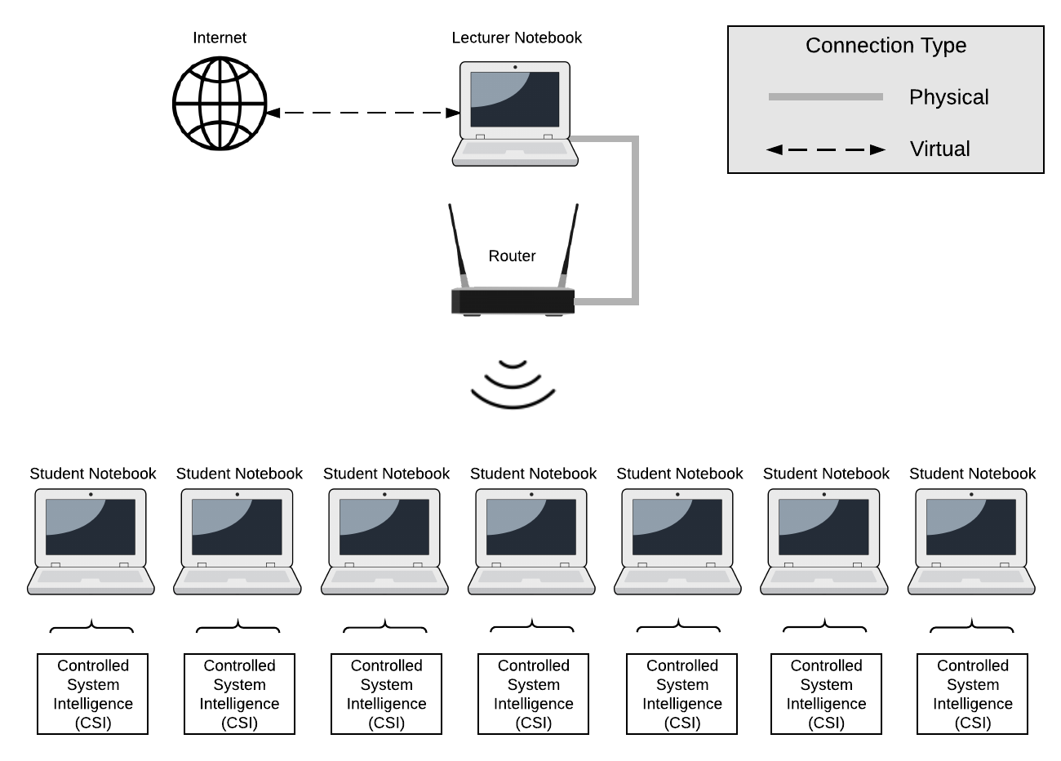

**Figure 2: Secured-T Setup**

Figure 2 above provides an overview of the system setup in a test environment. The lecturer notebook will be connected to the router and the router will provide the secured network for the students to connect to. The students would then run the Controlled System Intelligence (CSI) program in their notebooks.

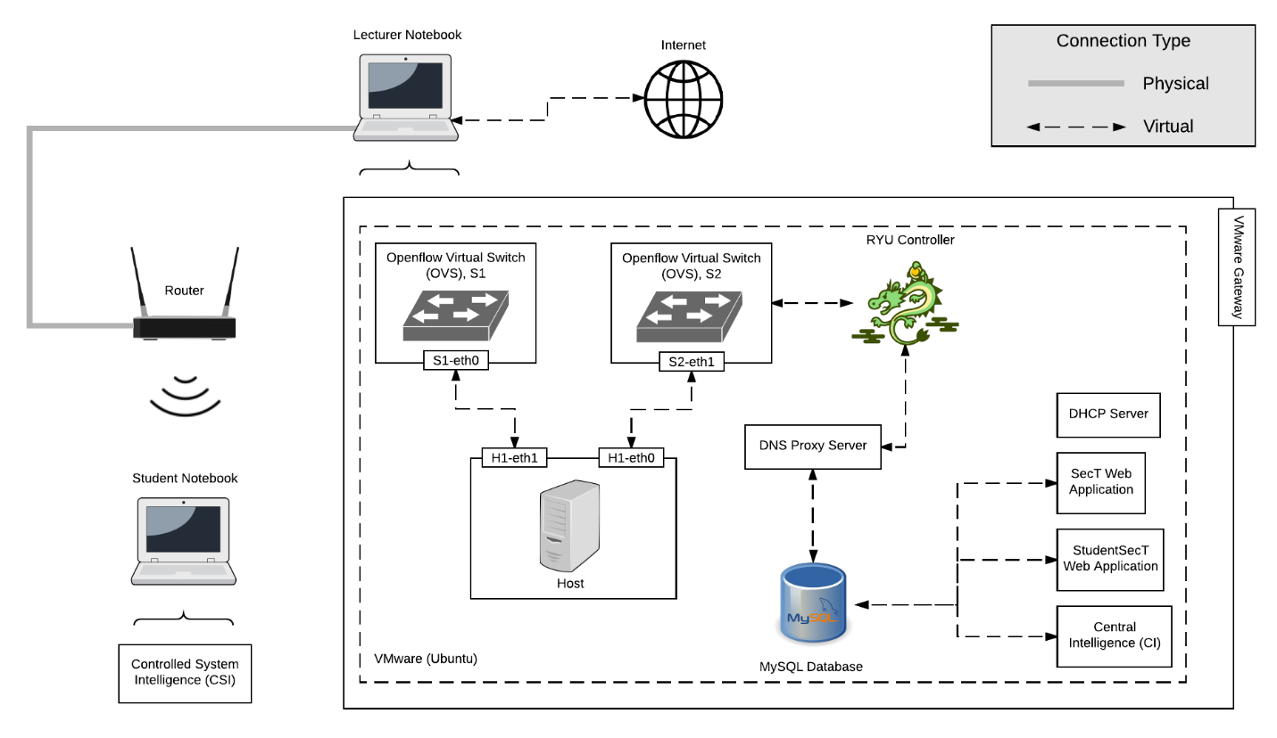

**Figure 3: Secured-T**

Figure 3 above provides an overview of how the technologies are used and linked up in Secured-T. As you can see in the figure above, the lecturer’s notebook runs two OpenFlow Virtual Switches(OVS), a Ryu Controller, a Host and a MySQL Database which is linked to the DNS proxy, two web applications, SecT and StudentSectT, and Central Intelligence (CI). These technologies will be further explained in details in the following sections.

**3.2.1 Software Defined Network (SDN)**

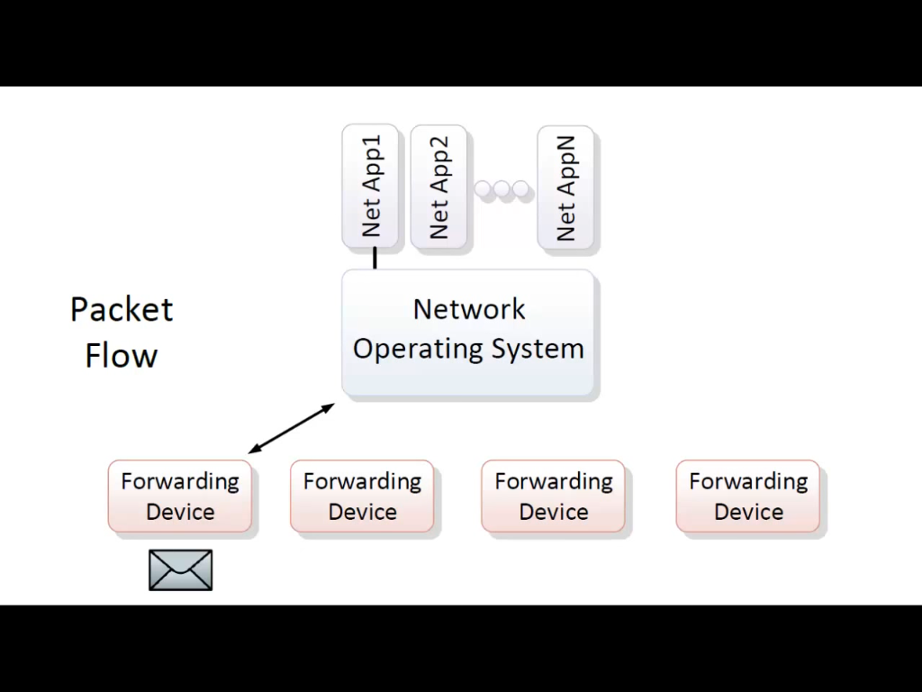

**Figure 4: SDN Diagram**

SDN is implemented so that the network could be open and programmable. If a specific type of network behavior or environment is required, one can develop or install an application to suit the needs. In simple terms, there are 3 basic layers, network application layer, network operating system layer and forwarding device layer, as shown in Figure 4 above. Table 1 below will explain more about the different layers.

**Table 1: SDN Layers**

|  |  |
| --- | --- |
| **Network Application: (top layer)** | The ability to develop or add in more applications, making a system flexible to customization. They are network focused. |

|  |  |
| --- | --- |
| **Network Operating System: (middle layer)** | The network has an Operating System (OS). The OS acts as a middleman, managing access from applications to underlying hardware and also managing system hardware on the lower level. The OS comes with core services to aid in the process of interfacing with network nodes and for providing a programmable interface to the network applications. It is commonly called as an SDN Controller. |
| **Forwarding Device: (bottom layer)** | Forwarding devices receive packets, take actions on those packets and update counter.    **Types of actions:**  - Forward to single ports or multiple ports  - Modify packet headers  - Drop the packet    The actions or rules as to how to handle the packets lies within the controller as it translates the instructions from the network application. |

## 

## 

## **3.2.2 Packet Flow**

When a packet arrives at a SDN controlled forwarding device, the forwarding device will parse the packet headers. It either knows or does not know how to handle the packet. If it does not know how to handle, it will query with the SDN controller.

The network applications on the SDN controller determine what actions to take on the packet and push the information down to the forwarding device. The controller will translate these instructions for the forwarding device and will then take the assigned action on the packet. The forwarding device may cache instructions so that there will no longer be a need to check with the controller for future similar packets. The same process will be done for each forwarding device. Since being able to control the packet flow is essential to us, it is implemented with SDN to provide a controlled environment.

**3.2.3 Mininet**

Mininet is basically a network simulator that enables users to study, experiment and monitor the network behavior. The user can create any type of topology and easily customize it using a simple Python API. Mininet can help to create or launch virtual network with hosts, switches, SDN controllers and links. It can use OpenvSwitch switches, OpenFlow switches or customized switches.

An Open virtual Switch is an open source multilayer virtual switch that enables the control of a massive network through the use of supported features including OpenFlow. Its default flow entry is to allow all frames to flow through. However, our system does not want to allow all packets to flow. Hence, we have to add the capability to manage the traffic flow and flow entries by using the Openflow protocol together with a SDN controller, in specific the Ryu Controller.

We primarily made use of a customized OpenFlow Virtual Switch (OVS) within the Mininet. We are using two OVS named as switch 1(S1) and switch 2(S2) as shown in Figure 5 below.

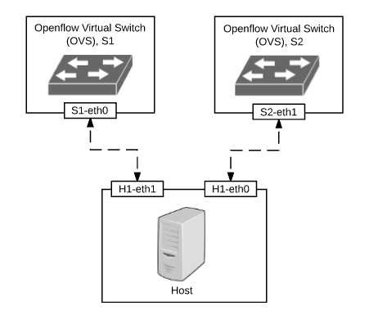

**Figure 5: OpenFlow Virtual Switch**

OVS create and modify flow entries in the switches. We can allow access to certain websites and disallow others. This can be done via an application to determine what action is to be taken and the Ryu Controller will handle it.

Instead of using OVS we could use firewall. It is easy to set firewall rules in a router to filter websites since it supports IP filtering. However, it can be very tedious and impractical to do repeatedly for every examination because it is not dynamic. It needs to be preset before the examination and be removed after the examination is completed. Firewall only supports IP filtering causing the entire website to be restricted. However, we would not only like to restrict access to online resources, but to also allow a certain number of websites to be accessed, leaving only parts on that website to be inaccessible for example advertisements or links that references another restricted website. If we were to use a software firewall, it will diminish the system’s performance thus causing other operation on the system to experience performance reduction. Hence, we use the OVS to help manage the control of the packet flow at a higher level.

**3.2.4 OpenFlow Protocol**

OpenFlow is an open standard that provides the flexibility for researchers to run experimental protocols in production networks. OpenFlow is added as a feature to commercial Ethernet switches, routers and wireless access points and the protocol is used to manage the switch (i.e., add/remove/modify flow entries, capture flow statistics, etc). The protocol allows for a SDN controller to communicate to an OpenFlow virtual switch to define its behaviour. Hence, we are making use of this protocol.

**3.2.5 Ryu Controller**

The Ryu controller is an open SDN controller. It controls the traffic flow in the switch (OVS). It is the brains of the SDN environment, passing information down to switches and routers and also communicate with network applications using the REST API. Just like the SDN model, the controller sits in between the switch and the SDN applications as seen in the Figure 6 below.

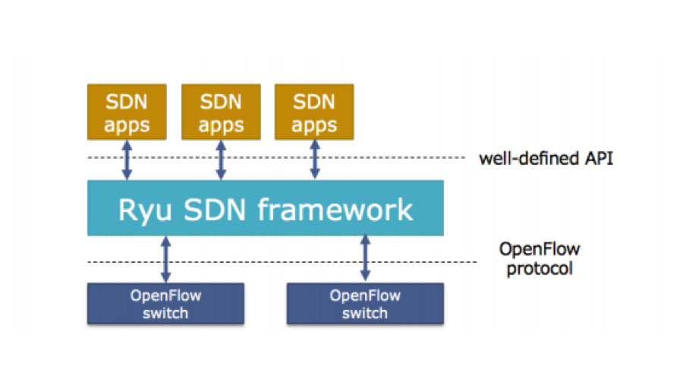

**Figure 6: Ryu Controller**

In our implementation, the RYU controller is used to monitor and control the network flow of the OVS. When a packet is sent to the OVS, if the OVS does not know what to do, it will send the packet to the Ryu controller. The Ryu controller will analyze the packet. After figuring out what action should be taken on this packet it will send the packet back to the OVS with instructions of how to handle it.

**3.2.7 Router**

As shown in Figure 2, we used a router as part of our solution. We initially needed a router to have firewall features to fulfill our requirements. After much research and discussion, we wanted to find routers with different operation modes as well. The different operation mode includes access point, wireless router, repeater, bridge, client and so on. Therefore, we researched on various brands such as D-LINK, ASUS, TP-LINK and NETGEAR and made comparisons to find the most suitable router. Table 2 below shows the comparison of the different routers we have researched on.

**Table 2: Comparison of Routers**

|  |  |  |  |
| --- | --- | --- | --- |
| **Name** | **Brand** | **Firewall Features** | **Operation Mode** |
| AC1750 Wireless Dual-Band Gigabit Router | TP-LINK | DoS, SPI Firewall  IP Address Filter/MAC Address Filter/Domain Filter  IP and MAC Address Binding | NO |
| RT-AC55UHP Wireless Gigabit Router | ASUS | Firewall: SPI intrusion detection, DoS protection | YES |
| Wireless N Dual Band Unified Service Router | D-LINK | Static route  RIPv1, v2  OSPF4  Dynamic DNS  Inter-VLAN route  NAT, PAT  Web Content Filtering (static URL, keywords)  Intrusion Prevention System (signature package included in firmware) | NO |
| WGT624NA Wireless G Firewall Router | NETGEAR | Double Firewall protection to defend your computer from external hacker attacks | NO |



**Figure 7: ASUS RT-AC55UHP Wireless Gigabit Router**

After much research, we chose the Asus RT-AC55UHP Wireless Router as shown on Figure 7 above. This router has operation modes like wireless router mode, access point mode and media bridge mode. We used the access point mode in our router configuration so that it will work as an Access Point in our system. It simply needed an SSID and password and the IP address configuration for the ethernet port that is going to be communicating with the lecturer’s notebook.

In our network system, the lecturer’s notebook will be physically connected to the router through an ethernet cable. The lecturer will give the students the SSID and password to the wifi, so that the students will be able to connect to the router wirelessly. Students must be connected to the router to access StudentSecT in order to be able to log into the web page or submit their assessments online. If they do not connect to the router, they will not be able to take their assessments.

**3.2.8 Detective System**

As mentioned in section 3.2, the student notebook will be running a program called the Controlled System Intelligence (CSI). The CSI is an agent that provides threat management. It monitors potential possibilities of cheating and handles the incident that mainly comprises of three detection methods as shown in figure 8 below.



**Figure 8: CSI**

The features of CSI are shown in table 3 below.

**Table 3: Features and Functions of CSI**

|  |  |
| --- | --- |
| **Feature** | **Function** |
| * Registration | Registers a student’s admission number and be stored in our database. |
| * Detection | Detect the student’s status whether it is:   * OK * CHEATING |
| * Monitor | Monitor illegal network connections. |
| * Logging | Mainly screen capture and keylogging as shown in the figure above. |
| * Report | Uses a heartbeat approach and pulses its status every eight seconds and reports it to the server program, CI. |

Students will download the CSI once they are connected to the StudentSecT website. They cannot take their online examination if they do not download it because the website will not accept any user to login without first registering with the CSI. The CSI will first detect the student’s behavior, followed by constantly updating the CI about the student's status using the heartbeat approach. The CSI also monitors the network traffic for unauthorized network connection and it does screen capturing and keylogging of student activities upon abnormal status. As an additional feature, we made the system be able to receive demands from CI to take both screen capturing and keylogging.

The Heartbeat approach helps us to determine if the students are connected to the network during their examinations and is able to report to the CI. If everything is going smoothly, it reports to CI as “OK” and if any student is cheating, it will alert CI as “CHEATING”. The moment the CI does not receive any update from the CSI, it is considered that the student is disconnected. Screen capture and keylogger is used monitors student’s activities upon receiving “CHEATING” and disconnection from the network.

**4 Web Application**

**4.1 Lecturer Web Application (SecT)**

We have created a user-friendly interface for lecturers to manage and facilitate online assessments. The features and functions of the lecturer web application is shown in the table below:

**Table 4: Features and Functions of SecT**

|  |  |
| --- | --- |
| **Feature** | **Function** |
| * Create an account * Login * View and edit account profile * Get help * Logout | Lecturers can have their own accounts so that it is personalized to the modules and assessments they are in charge of.  They can also change their name, staff number and password when needed.  If the lecturers are not sure what they are supposed to do, they can refer to the simple guide in the help page. |
| * Add modules * Remove modules * View modules | In an event where there are module changes, the lecturers can add or remove the modules on their own. |
| * Add assessments * Remove assessments * View upcoming assessments * View list of all assessments | Lecturers can create, remove and host assessments as desired.  The upcoming assessments made it easier for lecturers to know which assessments have not ended.  The list of all assessments allow lecturers to see the history of all the assessments hosted. |
| * Add whitelist domains * Remove whitelist domains * View whitelist domains | Lecturers can add domains that they want to allow the students to have access. The other websites not in the whitelist domain will be blocked. |
| * Add announcements * View announcements * Search announcements | Lecturers can add announcements that they want to convey to the students.  They can then view all the announcements for all the assessments they have created in the home page starting from the latest announcement.  If there are too many announcements, the lecturers can search for it using the module code in the search bar.  The announcements are not allowed to be removed after added to prevent confusion among the students. |
| * Start assessment * View details and status of students * End assessment | Lecturers can start assessment and monitor the students’ status and details.  At the end of an assessment, the lecturer will need to end the assessment for it to be considered completed. |
| * Demand logging from connected notebooks * Stop logging from cheating notebooks * Remove disconnected notebooks | During the assessment, lecturers can demand logging if they suspect the students are engaging in suspicious activities.  When the student is cheating, logging will be automatically started and the lecturers can stop the logging after verifying the students’ activities.  Once the student has disconnected for a valid reason during the assessment, lecturers can remove the notebook to allow the student to connect back. |

|  |  |
| --- | --- |
| * View history of all the students’ details | After the end of an assessment, lecturers can view the students’ information to check if the corresponding IP address and admin number matches the filename. |
| * Clear database | When information regarding a particular assessment is no longer needed, lecturers can clear the database rows related to the assessment. These include information such as announcements, students, whitelist domains and the assessment itself. |

**4.2 Student Web Application (StudentSecT)**

We have also created a user-friendly web application for the students to be able to download the CSI file and to connect to the assessment. The features and functions of the StudentSecT web application is shown in the table below:

**Table 5: Features and Functions of StudentSecT**

|  |  |
| --- | --- |
| **Feature** | **Function** |
| * Automatic download CSI.jar * Link to download CSI.jar | The moment the students enter the web page, the download will be automatically started. If it does not, there will be a link to download it manually. |
| * View warning message * View whitelist domains * View announcements | Students will be notified that they are under monitoring and they will be able to see the whitelist domains that they can access and announcements that are added by the lecturer throughout the assessment period. |
| * Upload submissions | Students can upload their answers as many times as they want and it will be stored in the lecturer’s notebook. |
| * Logout | Students must log out before leaving the assessment venue so that they cannot log in to submit again after logging out. |

**5 Database**

The database that we made use of is MySQL Workbench. It is used to store all the necessary and important information from our CI server and SecT and StudentSecT web application. The table below gives a brief overview of the tables and the details that we have inside our database.

**Table 6: Overview of Our Database**

|  |  |
| --- | --- |
| **Table Names** | **Details** |
| T_ANNOUNCEMENT | It stores all the announcements which the lecturer added in SecT. |
| T_ASSESSMENT | It stores all the assessments that the lecturer has added in SecT, regardless if it is upcoming or completed assessments. |
| T_LECTURER_INFO | It stores the lecturers’ account information such as their name, an encrypted form of their password and the lecturer number. |
| T_MODULE | It stores the modules which the lecturer added in SecT. |
| T_STUDENT_INFO | It stores the network connection information of the respective students such as the IP address and port number as well as the students’ information such as the admission number, table number and file names submitted. |
| T_WHITELIST_DOMAIN | It stores all of the websites that are allowed to be accessed by the students. Websites that are not in this table will be inaccessible by the student. |

**6 Risk Analysis**

Risk Analysis is an important and necessary framework that helps us to analyze and identify the vulnerabilities of Secured-T so that we can mitigate the risks. It is essential to ensure that there is at least a solution to deal with each risk. In the event of a problem occurring, we have compiled some of the risks, probability, effects and risk planning strategy for our system as shown in the table below so that invigilators can be prepared for any issues and potentially handle and resolve the problem.

**Table 7: Risk Analysis & Planning**

|  |  |  |  |
| --- | --- | --- | --- |
| **Risk** | **Probability** | **Effects** | **Risk Planning Strategy** |
| Router failure | Low | Students are unable to connect to the network | Have backup routers. |
| Notebook failure | Moderate | Students are unable to take the assessment. | Do notebook testing before the assessment. |
| Have extra notebooks that can be lent to the students. |
| DNS failure | Moderate | Website will be down.  Students cannot upload their assessments. | Invigilators should make sure the website works correctly a few hours before the assessment. |
| Invigilators cannot start the online assessment to monitor the students. |
| CI failure | Moderate | Students are not able to register on the website. | Invigilators should make sure CI works correctly a few hours before the assessment. |
| Invigilators cannot monitor the students. |
| Bypass system protection | Moderate | Students would be able to access unauthorized websites which are not in the white-list domain. | Invigilators should be walking around the room to ensure that the websites accessed are allowed. |
| Slow Network (if there is a large number of students) | High | Duration of examination is affected. | Implement more than one router. |
| Forget to bring Notebook | Low | Students will not be able to take the online assessment. | Send reminder by message, iChat or both. |
| Have extra notebooks that can be lent to the students. |

**7 Conclusion**

After numerous and in-depth testings, our solution, Secured-T has made it possible for students to access online resources using their personal notebook during the online assessment and we have implemented features to serve as a security barrier to prevent students from cheating and at the same time monitor their activities.

In comparison with other softwares mentioned in existing solutions, Secured-T is a portable solution that is significantly smaller and faster to set up and allows students to use their own notebook to refer to online resources during an assessment, thus making it more convenient while costing nothing for the end users. In addition, our CSI does not require to be installed in the client machine, simply requires it to be downloaded at 12KB and run it, making the process of preparation for a student not time-consuming.

We are confident that Secured-T has successfully delivered the essentials and dismissed several concerns of our end users. Nonetheless, we think that Secured-T is currently not the perfect solution to prevent students who are determined to cheat. Further enhancements to the system with our recommended improvements could drastically reduce the possibility of fraudulent activities piloted by the students.

On top of solving the project problem, Secured-T has many potential usages which provides plentiful space for development, thus extending reach to many more end users.

**8 Recommendation**

**8.1 Improvements**

Improvements that could be made to Secured-T are as shown in the table below:

**Table 6: Recommended Improvements for Secured-T**

|  |  |
| --- | --- |
| **Improvement** | **Reason** |
| Implementation of network traffic logs. | Can better monitor the students’ activities on the network as it includes important details such as source and destination IP addresses, used ports and the transmitted data. |
| Implementation of port scanning. | In order to identify which ports are active so as to gather insight on what the students are doing on their notebooks. |
| Enhance compatibility with non-Windows operating systems. | So that the system can work correctly on notebooks with operating systems other than Windows |
| Block website access by the subpage. | Able to block access to certain parts of the website such as the meeting room or the whiteboard page in tutorialspoint so that the other parts of the website can still be assessed. |
| Make DNS Proxy dynamic | In cases where the lecturers would like to modify, add or delete any online resources during the assessment, one improvement would be to make the DNS proxy to dynamically read the database to take in the new input made by the lecturer. |

|  |  |
| --- | --- |
| Live video recording of students’ activities | Lecturers could just click on a student’s computer on the monitoring page and be able to watch all of the student’s activity. |
| Integrate all the programs into a Raspberry Pi | Lecturers would be able to use their own notebook without using the Ubuntu image. |
| Implement hostname | Instead of using the IP address to access the webpage, change it to use a more user-friendly link by adding a hostname. |
| Add an event logging record | Whenever an abnormal status is reported to the CI, have a separate logging table to record down the events. |

**8.2 Potential Usages**

Potential Usages that could be made to Secured-T are as shown in the table below:

**Table 8: Recommended Potential Usages for Secured-T**

|  |  |
| --- | --- |
| **Potential Usage** | **Reason** |
| Classroom environment during lectures or practical lessons. | Lecturers are able to monitor the weaker students and control website access so that students could pay attention in class. |
| Easier parental control in households. | Parents can restrict and monitor their children’s activities on the internet. |
| Highly confidential company where sensitive information is involved and security is of high importance. | Secured-T can be used to limit website access and monitor any suspicious online activities. |

**9 Reflections**

**9.1 Reflection (Radin Ayuwandira Binte Radin Amirmuminin)**

**WEEK 0:**

So, from the very start of the project, even before school starts, I was given a briefing and a task to do by my supervisor and we worked in pairs for each task. I was assigned to do a task.

I have to be able to retrieve data from the database. Changing the number of domains or changing the domains should affect the DNS proxy’s behaviour. Using only 2 modules, with a few domain names to test it out, I learnt how to perform select commands to retrieve the rows of data by learning how the SQL commands work in python. It sure took me a while to understand the code, but I got it figured out.

Made a couple of mistakes, but I also learnt about the *cursor.fetchall()* and *cursor.fetchone()*. These were simply to retrieve the data. *fetchone()* returns just one matching row, whereas *fetchall()* returns all matching rows. I referenced from my_ovs_db.py for the base then went on to find out how to more than 1 row and continually work on it slowly.

**WEEK 1:**

Yes, by Thursday, the DNS_block program is done. We are able to retrieve data from the database and put it in a text file as a list. The data is the allowed domains that the client can enter. If they attempt to go to another website, they will only reach the default apache webpage. If we want to change the website they want to grant access to, we simply change from the database. However, end product will be that the lecturer will be able to add this through a web page and the data will be saved into the database.

**WEEK 2:**

This week, I tried out the server and client program that Xin Li and Bavani had done. I am assisting them in figure out a way to detect the client disconnecting from the network. But first, I have to make the client python program into an executable file. I do not know how to do that yet. I am able to run the server program though. Just the client program. Xin Li and I did up the notes compilation to make it look more organised.

**WEEK 3:**

**Day 2:**

Doing the risk analysis of our system allowed me to open my mind and evaluate what could be a potential risk about our system and how to resolve the issue. This made me think of what could go wrong and are we able to avoid it situation, just like a product evaluation. We also thought about the responsibilities of the 2 users on our website. I find that this is good when developing a system as we can assess our system in a more objective manner and have an idea of our limitations. Aside from this, I have been experiencing some issues with eclipse. Will get to working on it as soon as I resolve this issue.

**Day 5:**

Now, we are preparing the presentation slides for our interim presentation. It will contain what we think the project is about and what it is that we plan to do. I think this intersection is important because it really is a platform where it tests our understanding of the project and whether or not we understand it correctly. It gives us a better idea by having the concept of the project be written down (on powerpoint slides) and makes us research on the new technologies we will be using and interview our end users. I find this very useful and helped us be more prepared and ready to work on it properly for the following weeks.

**WEEK 4:**

**Day 5:**

Since the day before, the problem that I faced with eclipse still persisted. It kept telling me that my tomcat cannot start or that my tomcat is already running on several ports or so. I had this same problem the last time as well, but I have no idea how to solve this problem. I searched and googled for answers, tried it all out, but won't work out.

I sense that the problem lies in the resources. I tried to run my previous projects, they all seem to run just fine. However, when I tried to run this project, they won't allow me to, saying that there is no file or directory of this resource. I am trying to find out why.

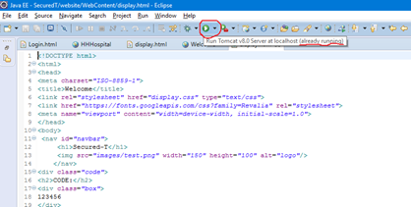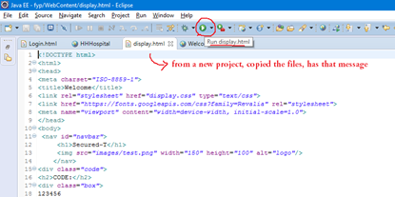

In the image above, that is what they kept telling me. That the server is running, however, when I tried to run another html file from another project, the following is showed. They are able to run the file.

**WEEK 5:**

**Day 1:**

Well, I solved the eclipse issue. I just had to create a new project and made sure everyone used the same eclipse version and tomcat version. From this, I realized what made me unable to run it. One, we are using github. Hence, all of us will get a synchronized project. Two, we are all using different tomcat versions and eclipse versions. We needed to be careful when editing the project so as not to clash each other when committing it to the github. So, this is something that I learnt from the problem on how to fix the problem.

**Day 3:**

Interim Presentation. From this presentation, I realized that we have a vague idea of what needs to be done and how the project would look like based on Mr Kwan’s explanation on the project. But we have yet to fully understand what it is we are dealing with at the moment. I also noticed our presentation skills and feedback session can be further improved. Looking at other groups’ presentation and how they presented their slides and manner of execution made me realize how our presentation could have improved. It was not only a chance to observe presentation skills, it is also a chance to have a vague idea what each group’s project is and what it is about. It was fun even though it was nerve-wrecking for me, since I was so nervous I had stomach cramps.

**WEEK 6:**

I am doing an update on the notes compilation. This compilation consists of the explanation and research we have done on the technologies we are currently using such as the ryu controller, the mininet, the SDN model and the openflow protocol. Mr Kwan has been kind enough and explained these technologies to us when we are still starting out. But that does not mean we do not do any research. I am thinking that these information could be useful to us when we write out the report. On the side, I searched for a Java-based client that talks to a python server for the heartbeat program. This is new to me as I have never done a cross language program such as the python server and Java-based client. I would assume they are similar, just different syntax.

On the other hand, I am also looking into the ovs sim_switch.py and the sendcmd.py. I learnt that sim_switch_rest.py is just the outer layer of the sim_switch.py that interacts with the website. I believe I understand how the flow works after Mr Kwan’s explanation. I find it interesting as well, getting to know the flow. We also updated him about the screen capture, and it looks like he had put in his own coding and made it better.

**WEEK 7:**

**Day 5:**

This is MST Week, But, I was able to work on the Screen Capture. Instead of naming the file with numbers, I modified it to be named by timestamp. Afterwards, another meeting with Mr Kwan revealed that he had modified the sim_switch.py again and he had understood the ovs switch well. I am trying to catch his explanation as much as I can. And he also modified his forwardOnly dns program. Now, something that I need to do is modify my dns block with some of his part. I see that this is a continuous learning and understanding process. I may still not get it fully, but I am slowly grasping what he is saying and what our program is supposed to do or does.

**WEEK 8:**

**Day 1:**

The start of a 2-week sprint. Scrum Master is Xin Li for this round and I am the Product Owner. Anyways, I have already worked on the DNS block program and modified the program. At first, I had a minor error that had something to do with the connection.py for some reason. The image below is the exception that I caught while I was running the program. I am working to solve the error issue.

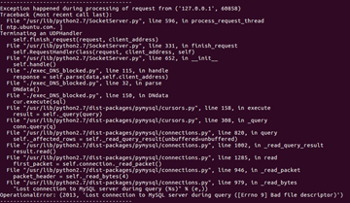

**Day 3:**

Started to look at the Heartbeat program. Since I wasn't able to start on it due to something I had to attend to in the afternoon, Xin Li started on it and gave me what she has done. All I am doing now is to understand what she did so that I can continue from there on. I got started on the heartbeat client jframe part for about 3 hours.

**Day 5:**

When I tested out the DNS block, found out that the student cannot type in an IP address of the websites, even if it is a whitelisted website. Of course, the non-whitelisted domains all redirect to the server's ubuntu default apache page. The whitelisted websites however, when you attempt to connect to it by typing out the IP address instead of the domain, it goes to a 403 error page. It is able to connect, but not able to let the client view it.

I also made a new connection in base workbench and create the tables in the base workbench and also in the Ubuntu image.

**WEEK 9:**

I helped Bavani with her screenshot task. There were new things to look at now though like Java pinging and threading. I cannot perceive how to do the pinging of the urls at this point. After much research, updating documentation, troubleshooting errors with jdk, I have finally set up the netbeans environment in my Ubuntu and link to my tomcat.

**WEEK 11:**

The heartbeat program had been passed to me to do and finish. I am not really confident I can handle it, but I must try. I did not learn Java and python for nothing. My DNS block program’s issue has also been solved. So I tried to incorporate some SPA elements into my SPAI. I feel that I need to fasten the pace. Especially for this program, which is an important feature for the system.

**WEEK 14:**

**Day 1:**

I feel the stress build up in me as Monday comes. I could not finish the server program in time for Monday's demonstration, and I had been caught in the pinging section of the client program for a while now because I still did not understand threading that well, and I did try to research it up. But I can't comprehend how it becomes a single value. What I done instead was to try and differentiate and give individuality to each IP address and put it in the queue. Initially, I also thought of using counter to check for how many values that are required to be wrong so that I can start the logging.

Then today in the afternoon, Mr Kwan helped me resolve the issue. I really did not want to disappoint him and seem stupid because I did not understand it. But I also could not form the words out to form a proper question. So from there, I learnt the way how we handle the multi-threads. They all will start at the same time, but the coding is assumed to be single, or at least, this is how I would put it. I see now how it is one handles a multi-thread that uses a common variable and how the logic flowed. They are all independent of each other but would come back to the ***startpolicing*** to report their status, whether they can access or not. He helped me with other things in my client program, which is nice. But I feel like I need to do more. I appreciate his help because I spent so long at this thing and cannot understand why it kept making this error, or why this is done this way.

**Day 2:**

I tried to work the server program. So far, I can only confirm that I can insert the initial student data to the database. Some of the rest of my logic is not working well. The on demand command is a bit tricky, but I will have to take care of them.

**Day 3:**

Today is bad. My laptop keeps overheating and the shut downs becomes more frequent. This is dangerous. What more, I don't have Wi-Fi at home anymore. Not till Friday. What bad timing! Nonetheless, it must still continue. Project must still go on. Thankfully, I can do my work without Wi-Fi. Just that no one can get to me while I am at home.

**WEEK 15 – 16:**

We have just been doing our report and at the same time an in-depth testing and debugging the programs after integrating it on week 14. A lot has been done, and a lot of lessons have been taught, whether we realize it or not.

Overall, this project helped me to improve my coding skills better and at taking up a project and learning new things is something that I may face in the future. Some lessons I take away from here is a function, ***isReachable()*** - a Java function that can be used to echo a ICMP packet out in Java. This is used for the pinging purpose in my CSI program. I learnt how to manage multi-threading and noticed that queue is thread-safe and is recommended to use it. I now have a good understanding of how multi-threads work after struggling with it for so long. Handling Java and python back and forth can be rather confusing sometimes and can mistake the syntax for the other language. But, I am glad I am able to manage it. Aside from the programming aspect, as a leader, I have developed to be a responsible leader, having to monitor my members every day and see their progress. I have to keep pushing the team to work earlier so that we can finish on time. I have learnt from my supervisor that I needed to be more firm with my answers and replies. I realized that this method makes me feel assurance on what I do and what I say and is good when handling disputes and clearing away any doubts. I should speak out more for myself and learnt to be confident from my meetings with him. I have learnt to broaden my mind and look at the same thing, in different perspectives. Having meetings is important so as to understand one another, and to agree and confirm on the ideas we have come up with. It has been a rather frustrating, stressful journey, but it also has been a meaningful project to work on.

**9.2 Reflection (Lim Xin Li)**Week 1:  
In the first week, I did research on ways to cheat and the problems that led to this project. I was also tasked to think about the significance and objectives of this project. While doing these, I contributed to the notes compilation from what our sponsor have explained to us.  
Other than that, I have also started on coding, where I have created a program and ran it in the server side. I was then tasked to find out how to convert python files to executable files. After successfully converting it, I ran the executable file in the client side where the client can echo back to the server side.  
It was quite confusing at this stage because I was not very clear on what each software’s role in the system is and how they work together especially since I am unfamiliar to the softwares like Ryu Controller, Mininet and Open Virtual Switch. We were also asked to look at a previous FYP group’s work so that we can incorporate what they have done as well. However, I could not understand what that FYP group was doing and I did not know how it could be used in our system.  
Week 2:  
In the second week, I continued my research and enhanced the server program. I also started on the client program and thought about the design of the web application.  
Even though I was not very clear on the infrastructure of the system, I knew what was needed in the programs after being briefed by our sponsor thus I worked on it rather confidently.  
Week 3:  
In the third week, I continued to work on the server and client program. As there is the interim presentation on week 5, I started to prepare the presentation slides as well.  
More explanation on the system was given to us by our sponsor and I have a little better understanding of how the individual software works and what it was supposed to do. I also managed to get a general idea of how the system infrastructure looks like. However, I am still not very sure where each software lies in the infrastructure and I could only manage to understand the surface of the infrastructure.   
Week 4:  
In the fourth week, I was still working on the server program. I also finalized the presentation slides for interim presentation in week 5.  
I think it was easy to convey the objectives and significance of our project but it was not very easy for me to explain the system and how the whole system will work at this point of time. There could be many ways it could work and we may change as time goes thus I was uncertain on how I could convey how the system would work to the audience.  
Week 5:  
In the fifth week, I continued with the server program and started working on the complete function and feature list of the web applications and database design.   
There was not much that impedes me and everything was quite smooth. One problem could be that I could not visualize what information may need to be stored in the database thus it could not be completed in one go and needs to be kept updated.  
Week 6:  
In the sixth week, a discussion was held on the report. I was also still working on the server program and the database design.  
I was met with some problems working with the server program but I managed to solve it by researching online. I was also quite behind my allocated tasks as I am supposed to start on version 2 of the client program but I could not get started on it due to some problems on the server program and other assignments.  
Week 7:  
In the seventh week, I could not do much due to MST and assignments but I managed to finalize the database design. I still have not started on version 2 of the client program and the design and implementation of the student web application.  
Time was tight as I need to juggle FYP among other modules. As important FYP is, the other modules should not be neglected as well. I will in return use more time during the holidays to work on FYP since our supervisor told us we really need to make use of our time well to complete what we have planned.  
Week 8:  
In the eighth week, I continued working on the server program where I would link it with the database. I have also created a web page to see the data retrieved from the database and compare the timestamp. I also finally started on the second version of the client program.  
Before I started I had some impediments because there is some coding I have not done in another programming language before. But while I was doing, it was not as tough as expected. There were many help given online. I also had to test out a lot of my own theory and see which column of the database would be affected by what variable.  
Week 9:  
In the ninth week, I manage to finish my allocated tasks so I helped the other members with their tasks.  
However, I have more unanswered questions about the system after advancing in the coding. What I originally thought was different from what the other members were thinking. It led to some confusion but we manage to get some feedbacks from our sponsor. Turns out I coded the client program incorrectly because I was only looking at getting the program to work but not looking at the bigger picture. I was not supposed to have any database in the client program since it is not accessible in the student’s notebook. With the help and guidance from our sponsor, I started to redo the programs again.  
I also configured Netbeans in the Ubuntu image and updated the readme document. I was tasked to use Netbeans to do the web application but I am only familiar with doing web applications on Eclipse. I would need to see if I can get the web application on Eclipse into Netbeans.  
Week 10:  
In the tenth week, I decided that someone needs to start on the web application because we were running tight on time. I passed my task, server and client program, to Radin since she just finished her allocated tasks and started to do the web application.  
As the details of what the outlook of the web application was not decided, I had a lot of freedom to decide what I want it to look like. Though it caused some problems because I would not know which feature to put in which page.   
Week 11:  
In the eleventh week, I continued working on the web applications, switching between the student web application and the lecturer web application.  
As the coding on the web application advances, I became more familiar with what I was doing, which made it a lot smoother and I became more confident in my web application skills.  
Week 12:  
In the twelfth week, I finished most of the major parts of the lecturer web application. I continued to finish up on the web applications and updated my database tables to my members so that they could test it on their side.  
As the coding was supposed to be finished in week 14, I became more anxious as I felt that I may not have enough time to finish the web applications since I had some problems with the javascript and jquery. The members also felt the need to add password encryption to the web application. Thus, I requested help from another group member and hopefully we do not need to drop any features.  
Week 13:  
In the thirteenth week, I managed to advance on the lecturer web application and added password encryption.   
There were not much major problems this week but the help that I was supposed to receive did not come to me. Thus, I would have to work on the web applications all by myself.  
Week 14:  
In the fourteenth week, I finished both the lecturer and student web application. I proceeded to do on the report and resolve problems that my members pointed out about the web applications. After that, we tried to incorporate the web application in the system and ended up with some problems.  
I had to continue testing the web applications with the system to make sure it works correctly. I was also recommended to have an option where there is an administrator account or the lecturer can clear the information in the database. As there were some improvements to make as well, I continued to work on the web application.  
Week 15:  
In the fifteenth week, I made the poster needed for the showcasing and started on the lecturer guide. I continued to do the report as well as testing, where I would make some changes to the web application.  
I met with some problems that does not occur when I test it locally and it took me quite a long time to figure out the problem. Some of the solutions worked but ended up causing more problem so I had to find some other way to do it.  
Week 16:  
In the sixteenth week, I finally settled all the problems with the web application and successfully added an additional feature to allow students to upload files without any problems. I also finished writing the lecturer guide and the report.

The whole FYP is coming to an end and I can say that I have learned a lot things that were not taught in class and have gained a lot of experience working on a project for one semester. It was tough especially towards the MST and EST week because there were a lot of other assignment due dates we must meet as well. Not only that, there were a lot of problems I came across and not all were resolved. However, I can positively say that I have done my best and understood the system to the best of my ability. I am grateful for this project as it has helped me upgrade myself by cultivating my personal skills and teaching me new technical skills. I still remember that initially, this project was what we chose not to do. However, I had to be positive and set a goal: To create a product that I would be proud of regardless of the topic. At the end of the journey, I am happy to say that my goal have been fulfilled.

**9.3 Reflection (Bavani D/O Raman)**I’m the team member of the Group 62. I remember when we got to know our Topic of our Final Year Project(FYP), I was a bit loss of what is this FYP about what we need do and deliver. A week after we got the topic we had our first meeting for with our supervisor on 23rd March 2017. That’s when our supervisor went through what the topic about. From that day, onwards we start meeting up with our supervisor every week at least 2 times sometimes 3 times a week till our semester start which was very useful and helpful for my group and myself as we had more time to understand the project and come out solutions.

By the time our semester start I get to know and understand more about the FYP topic even better than I expect. During the time when meeting up with our supervisor, he gave ask task to do which is related to the FYP and make sure we do and understand what we are doing. At first, we split into two to do the task which was assign to us and when days go we start doing individually and only when in doubt that’s when I or other members ask for help. I did research on Router where I get to know that and Screen Capture both in Python and Java. Each day while doing my work/task I learn new things and understand our project every well and it gets interesting and fun to work on the project.

I had face a lot of difficulties while working on the project such as the code we program didn’t work as we expect and there was a lot of installation needed and the VMware was slow and take long time to set up. I have been also falling sick till I cannot contribute very much but my team members are very understanding that they will split the work I should do and make sure I can contribute even when I am sick. With their help, I manage to contribute and do something for the project. On week 7 I could not do much as it was mst week and during the 3 week break, week 8 I had my sister's wedding which make me pull back my task but I somehow manage to do my task on week 9 and week 10, with the help and understanding of my fellow group members. The 3 week break was very hard to manage the time to the task as we had other assignment which were due at when school reopen but we manage to everything.

I carry out research and compile it into documents so that if my group member or myself need it later we can refer it to them in later part, and did like check list so that my group and myself are on right track and handle report writing, presentation and I did the on demand for the screen capture programming part with the help and guide of my leader Radin. I am assign to do promotional video for project which I am interested to be doing it.

Doing this project with this team have been great experience, even though we have team up for other group assignment so we did not have any problem with each other as all was very understanding and fun to work with. We try our best to motivate each other and keep us on right track as much as we can.

Overall this journey have been rough, stressful and had a lot sleepless nights to finish our given task but it was all worth it as we are able to finish our work on time and satisfied that we have fulfilled our user requirements as much as we can.

**9.4 Reflection (T.Puvaneswaran Raja)**

It was a long and slow journey for FYP, however my team made it better by always supporting each other. From not fully understanding what we were doing, we slowly learnt what our FYP project was about and start to learn more from it and now we understand our system better. We segregated our tasks and put in our hard work so that all of us will feel accomplished when we successfully complete our FYP. FYP has really taught me a lot, I have written codes that I have not thought of before and even learn things that are not usually taught in school. I did research on how to take screenshot on the machine globally with java and how to do keylogging on java and how to display it in a more readable format. I passed those to my teammate Xin Li and she modified the code and integrated on to our main program, CI and made them all work together. There were times where I did not know how to do a task, my teammates will always make time to help me despite being busy.

At the later part of the FYP I started to focus on putting together all the installations, configurations and codes on the FYP notebook as it was in my possession. As I was doing it, I started to build the installation guide as well. Since we did those configurations some time ago, I had difficulty remembering the setup. After some time, I managed to make it into the fully functional machine we needed. It was followed by adding on to updated programs and making them work together which took some time. After that, the router was passed it me for configuration, since I what configured routers before, it was easier. However, I still had some issues to set it up as what was needed for our system. After configuring the router and went back to edit the installation guide and replicate our machine from scratch. One problem I faced was that the ubuntu image we used at the beginning has been outdated and we needed to use a new image which had some different configurations. By the end of it, I became familiar with the installation of the system and managed to complete the installation guide. There were times where we stay till it’s very late, as we needed one another to do testing .It was difficult to multitask with FYP and other modules as I showed priority to FYP I feel that it would have been better if one semester was dedicated just for FYP as we would all be able to fully focus on it.

Our FYP topic was something simple but impactful for school environment, therefore I enjoyed doing it as I could relate to it and how it would be helpful for student and at the same time preventing any form of cheating. This FYP has been an important part of my poly life and I hope to see it in place in schools in the future.

**10 References**

GitHub. (2017). *PNET16/Prodaptive-NeT*. [online] Available at: <https://github.com/PNET16/Prodaptive-NeT> [Accessed 25 Jul. 2017].

Mahler, D. (2014). *Introduction to SDN (Software-defined Networking)*. [video] Available at: <https://www.youtube.com/watch?v=DiChnu_PAzA> [Accessed 4 Jul. 2017].

Mahler, D. (2013). *Introduction to Mininet*. [video] Available at: <https://www.youtube.com/watch?v=jmlgXaocwiE> [Accessed 4 Jul. 2017].

Mahler, D. (2013). *Introduction to Open vSwitch (OVS)*. [video] Available at: <https://www.youtube.com/watch?v=rYW7kQRyUvA> [Accessed 4 Jul. 2017].

Mahler, D. (2013). *Introduction to OpenFlow*. [video] Available at: <https://www.youtube.com/watch?v=l25Ukkmk6Sk> [Accessed 4 Jul. 2017].

Lenovosoftware.com. (2017). *LanSchool Classroom Management Software | LenovoSoftware.com*. [online] Available at: <https://www.lenovosoftware.com/lanschool> [Accessed 28 Jul. 2017].

Team, M. (2017). *Mininet Overview - Mininet*. [online] Mininet.org. Available at: <http://mininet.org/overview/> [Accessed 4 Jul. 2017].

(2017). *What is Ryu Controller? - SDxCentral*. [online] Available at: <https://www.sdxcentral.com/sdn/definitions/sdn-controllers/open-source-sdn-controllers/what-is-ryu-controller/> [Accessed 4 Jul. 2017].

Osrg.github.io. (2014). *OpenFlow 通訊協定 — Ryubook 1.0 說明文件*. [online] Available at: <https://osrg.github.io/ryu-book/zh_tw/html/openflow_protocol.htm> [Accessed 4 Jul. 2017].

Archive.openflow.org. (2011). *OpenFlow » What is OpenFlow?*. [online] Available at: <http://archive.openflow.org/wp/learnmore/> [Accessed 4 Jul. 2017].

Secure Testing. Anytime. Anywhere. (2017). *Software Secure Solutions | Securexam Student*. [online] Available at: <http://www.softwaresecure.com/product/securexam-student/> [Accessed 25 Jul. 2017].

Junglebyte.com. (2013). *Junglebyte, Provider of Premier Classroom Management Software*. [online] Available at: <http://www.junglebyte.com/default.aspx> [Accessed 25 Jul. 2017].

Linux Foundation (2016). *Multilayer Open Virtual Switch*. [image] Available at: <http://openvswitch.org/assets/featured-image.jpg> [Accessed 4 Jul. 2017].

SDxCentral (2017). *Ryu Controller Fits in SDN Environments*. [image] Available at: <https://www.sdxcentral.com/wp-content/uploads/2014/09/ryu-controller-sdn-framework.jpg> [Accessed 4 Jul. 2017].

Interbase Resources Sdn. Bhd. (2017). ASUS RT-AC55UHP WIreless Gigabit Router. [image] Available at: <https://www.asus.com/media/global/products/8bd3w3IkGTb42puy/SgdIHyfbRVmmhU9m_setting_fff_1_90_end_500.png> [Accessed 5 Jul. 2017.]

**11 Appendices**

**11.1 Appendix A: Poster**

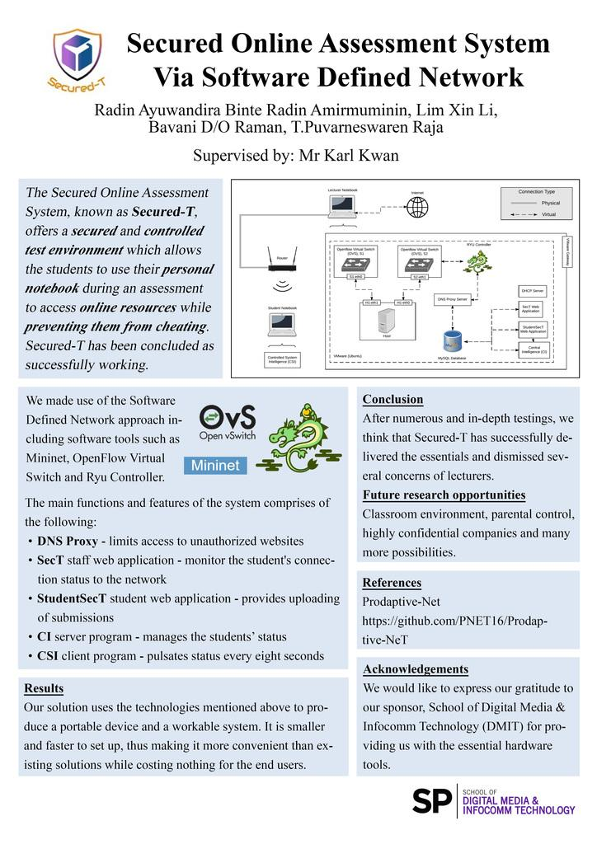

**Figure 9: Poster**

**11.2 Appendix B: Web Application Features**

**11.2.1 SecT**

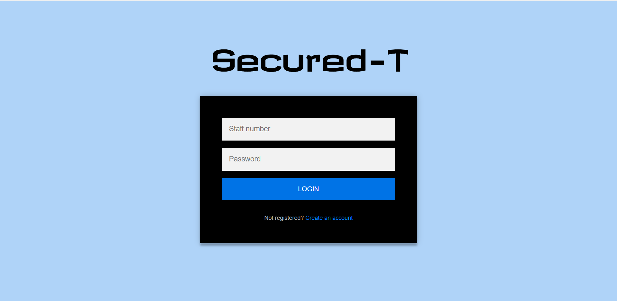

**Figure 10: Login Page**

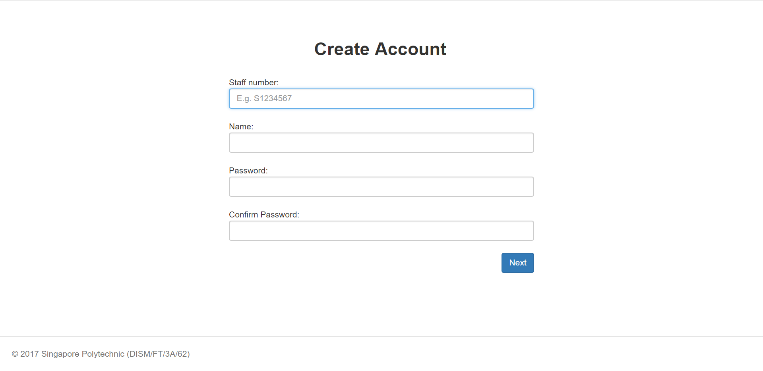

**Figure 11: Signup Page**

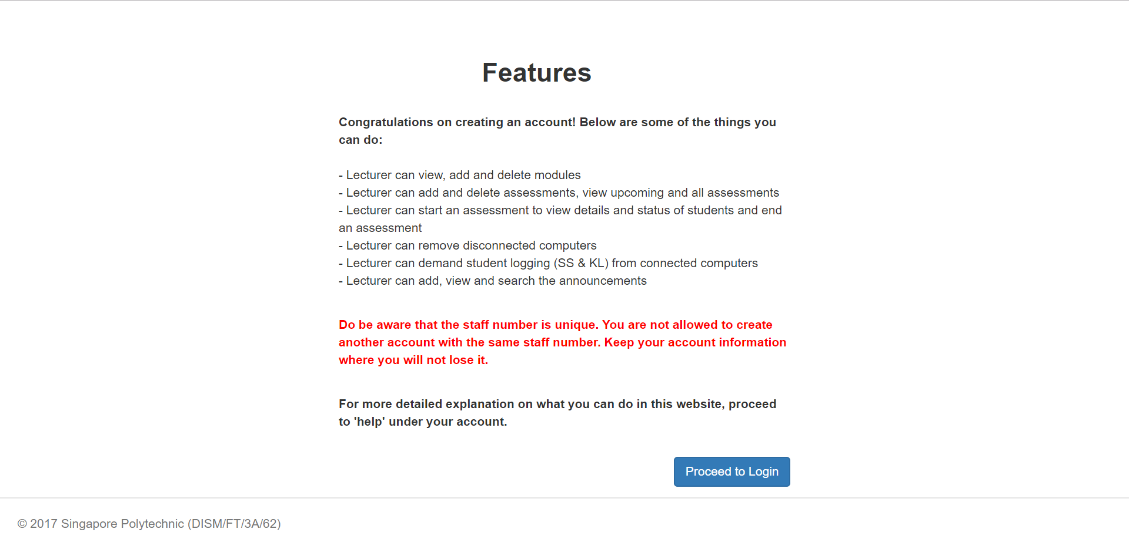

**Figure 12: Features/Help Page**

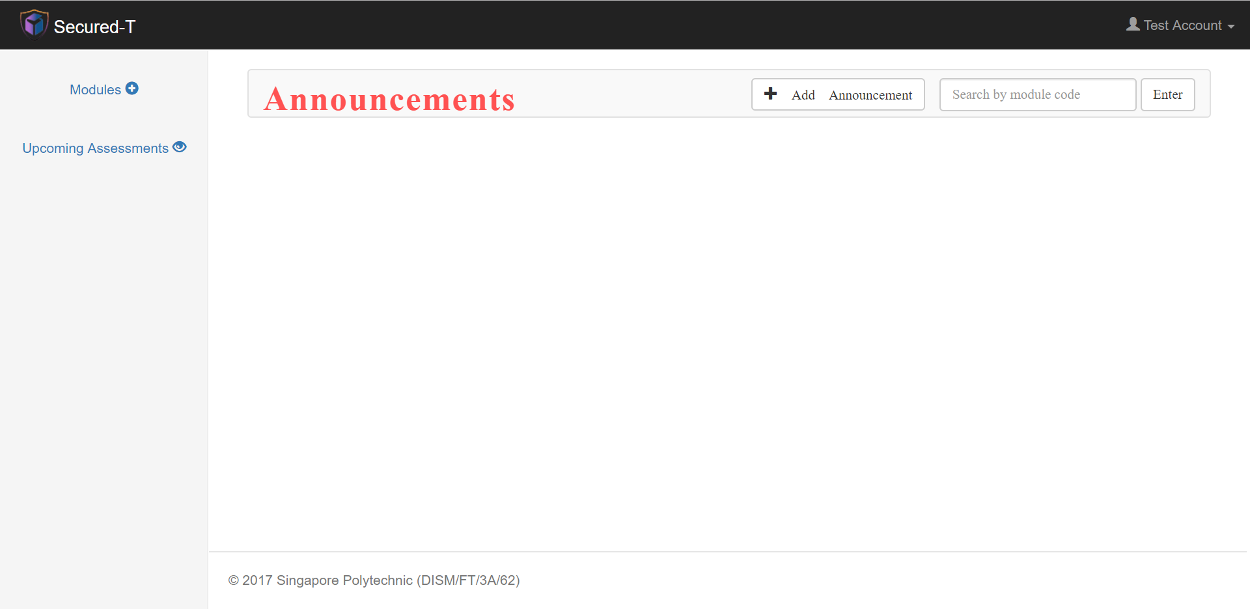

**Figure 13: Home Page**

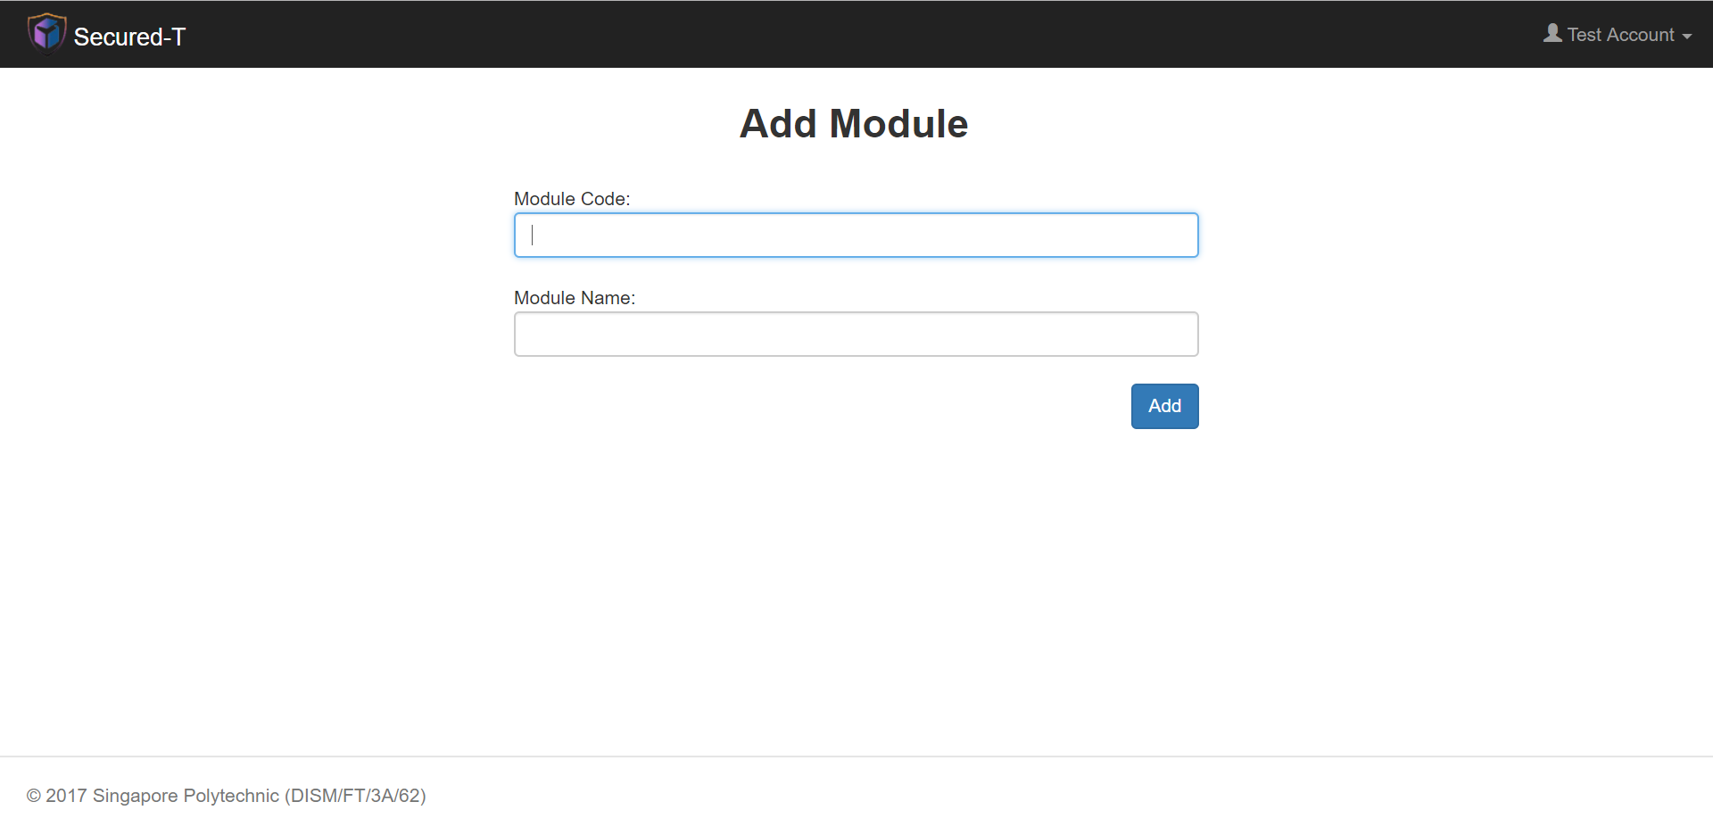

**Figure 14: Add Module Page**

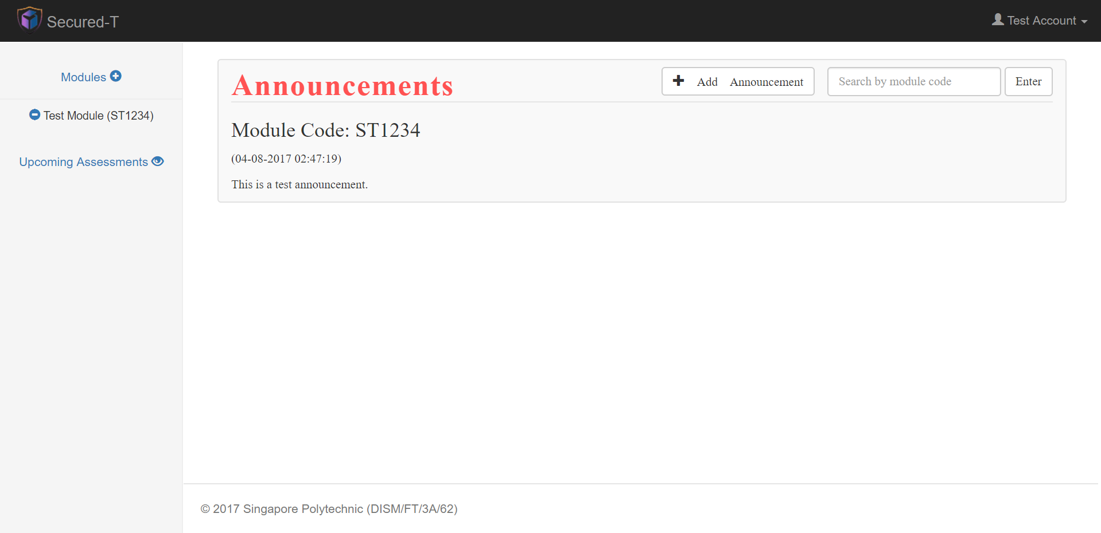

**Figure 15: Remove Module in Home Page**

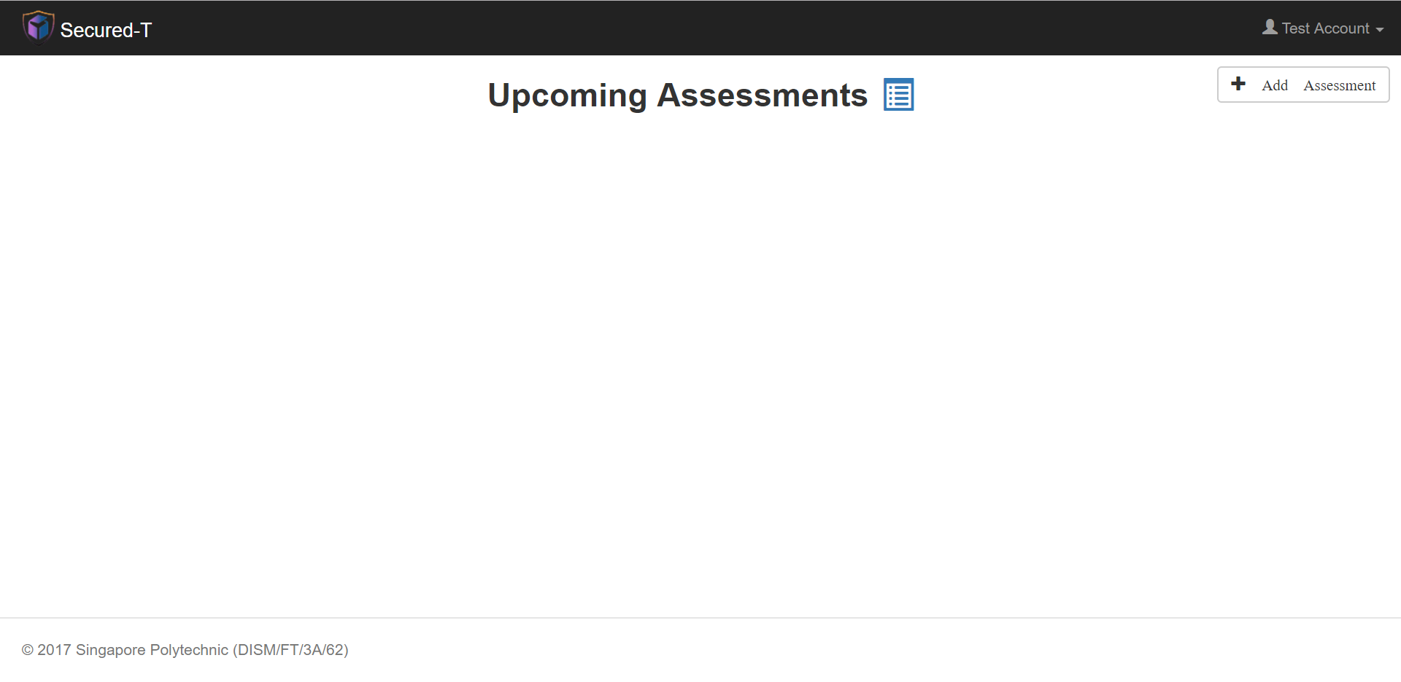

**Figure 16: View Upcoming Assessments Page**

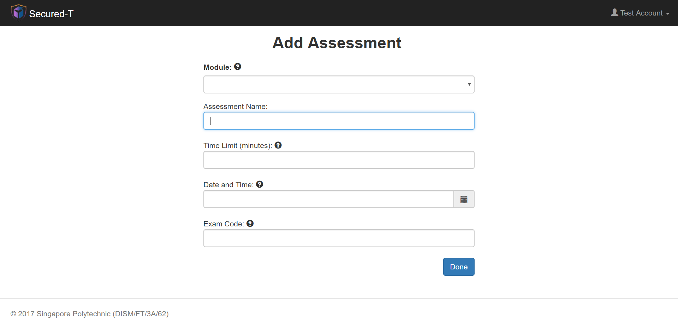

**Figure 17: Add Assessment Page**

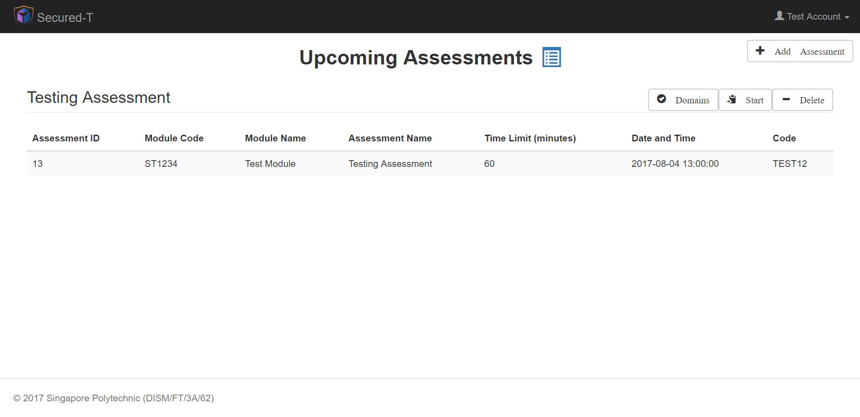

**Figure 18: Remove Assessment in Upcoming Assessments Page**

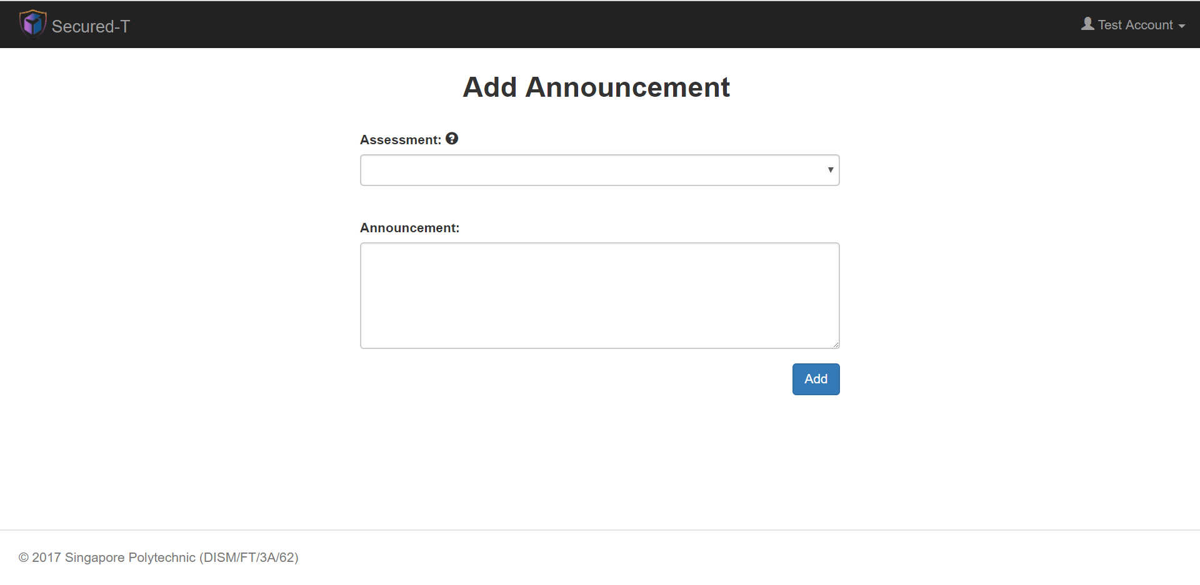

**Figure 19: Add Announcement Page**

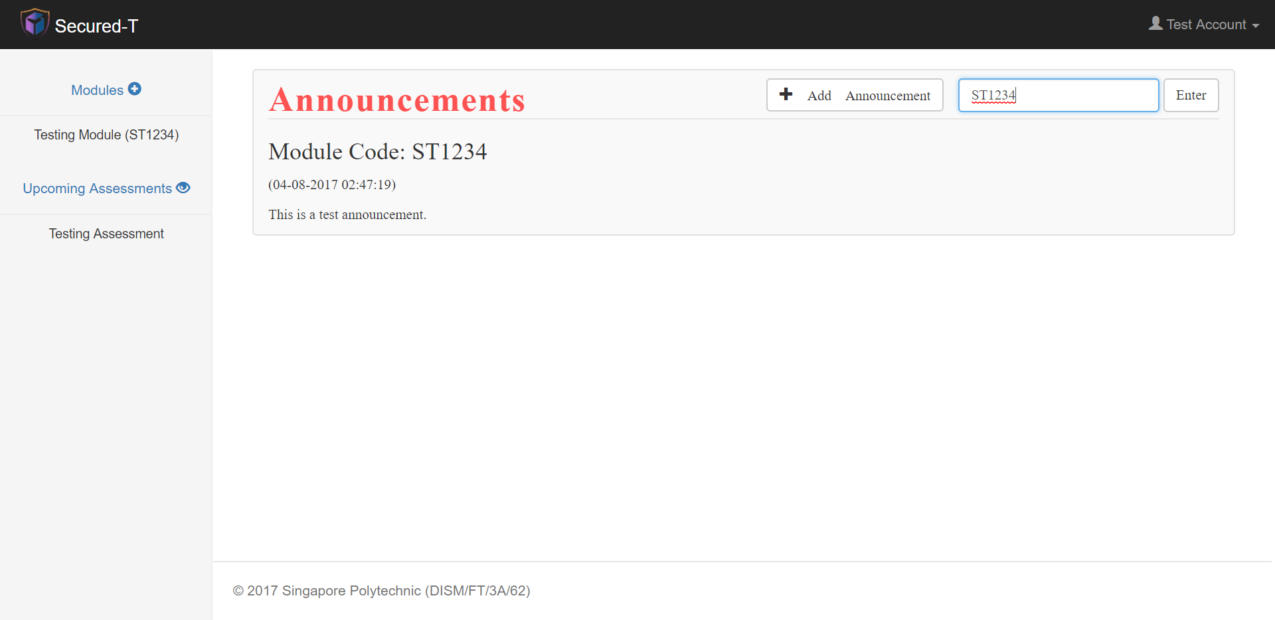

**Figure 20: Search Announcement by Module Code**

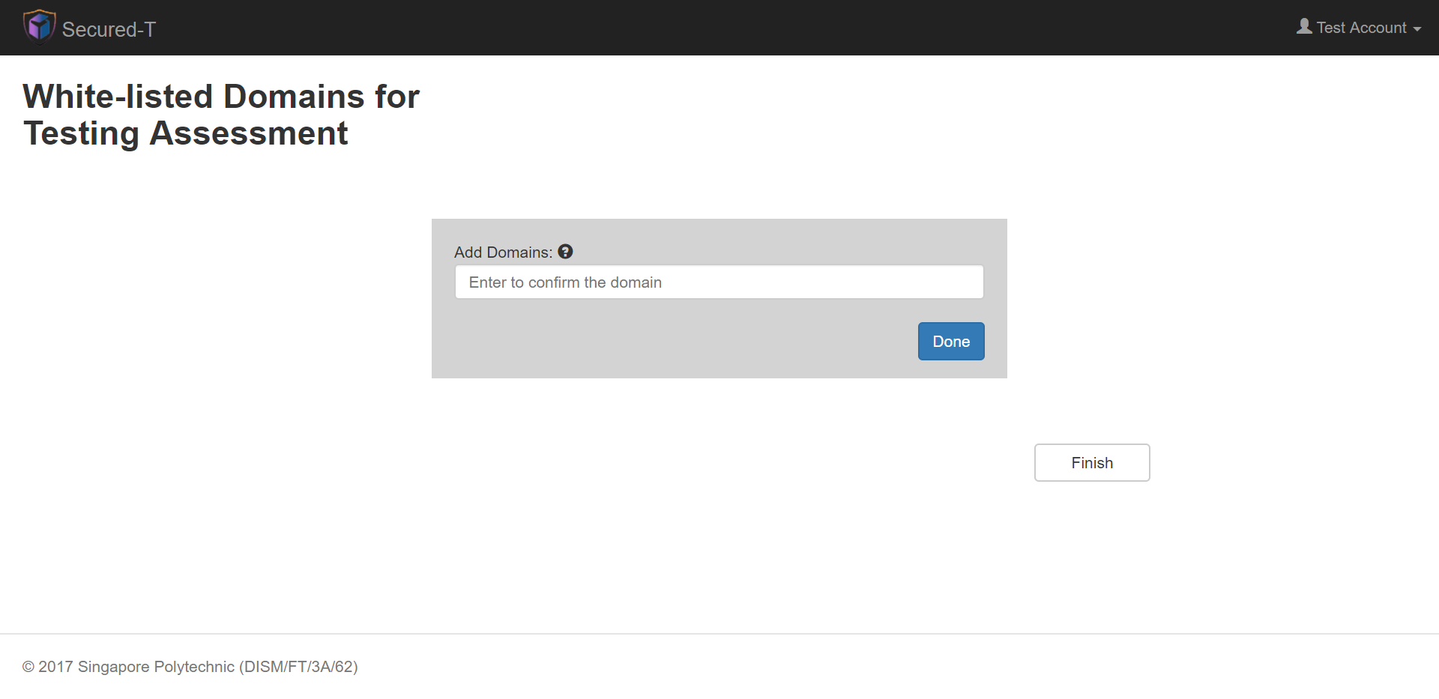

**Figure 21: View Whitelist Domain Page**

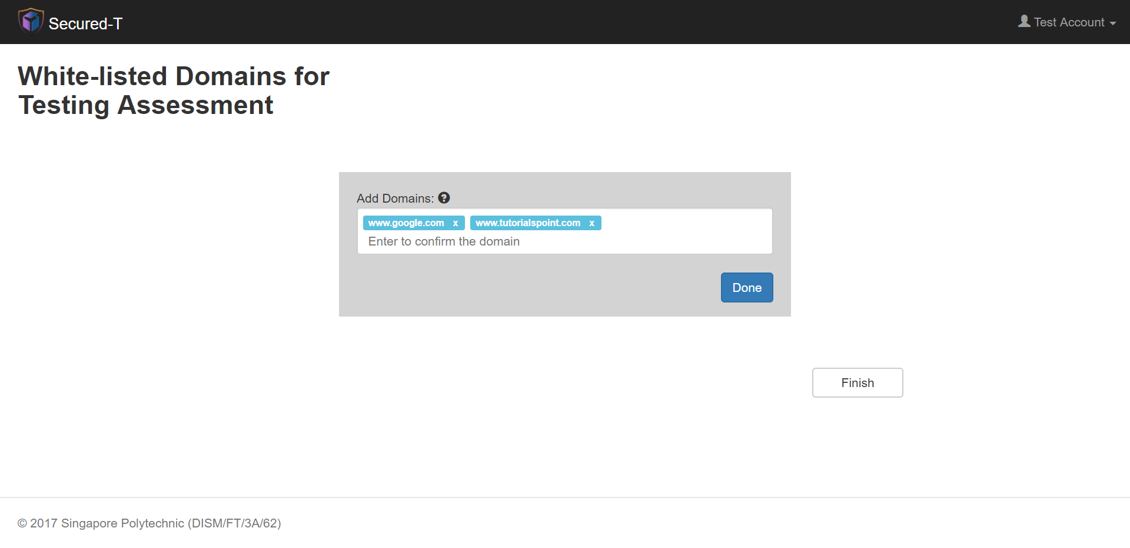

**Figure 22: Add Whitelist Domains Page**

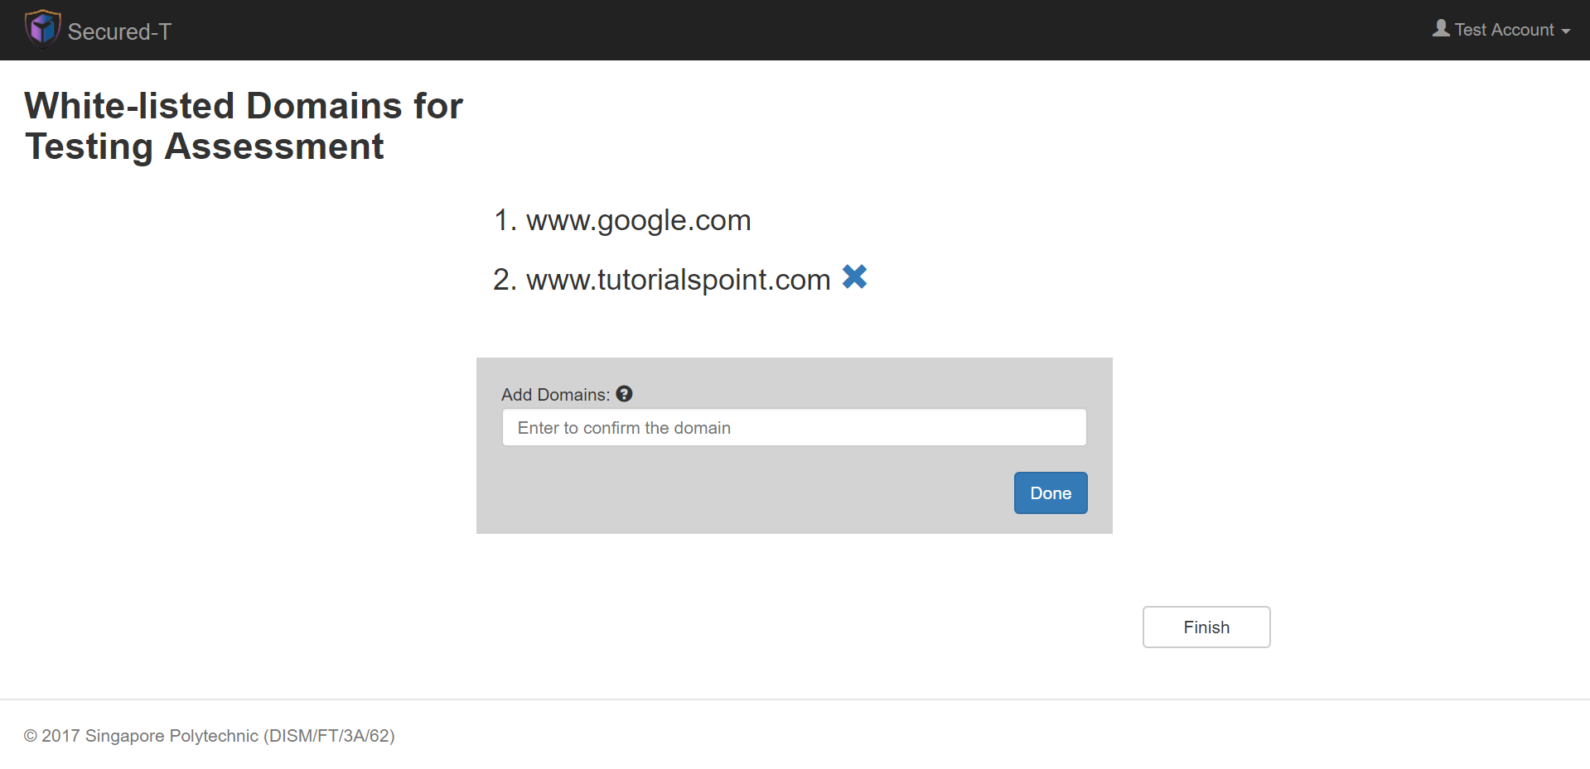

**Figure 23: Remove Whitelist Domains Page**

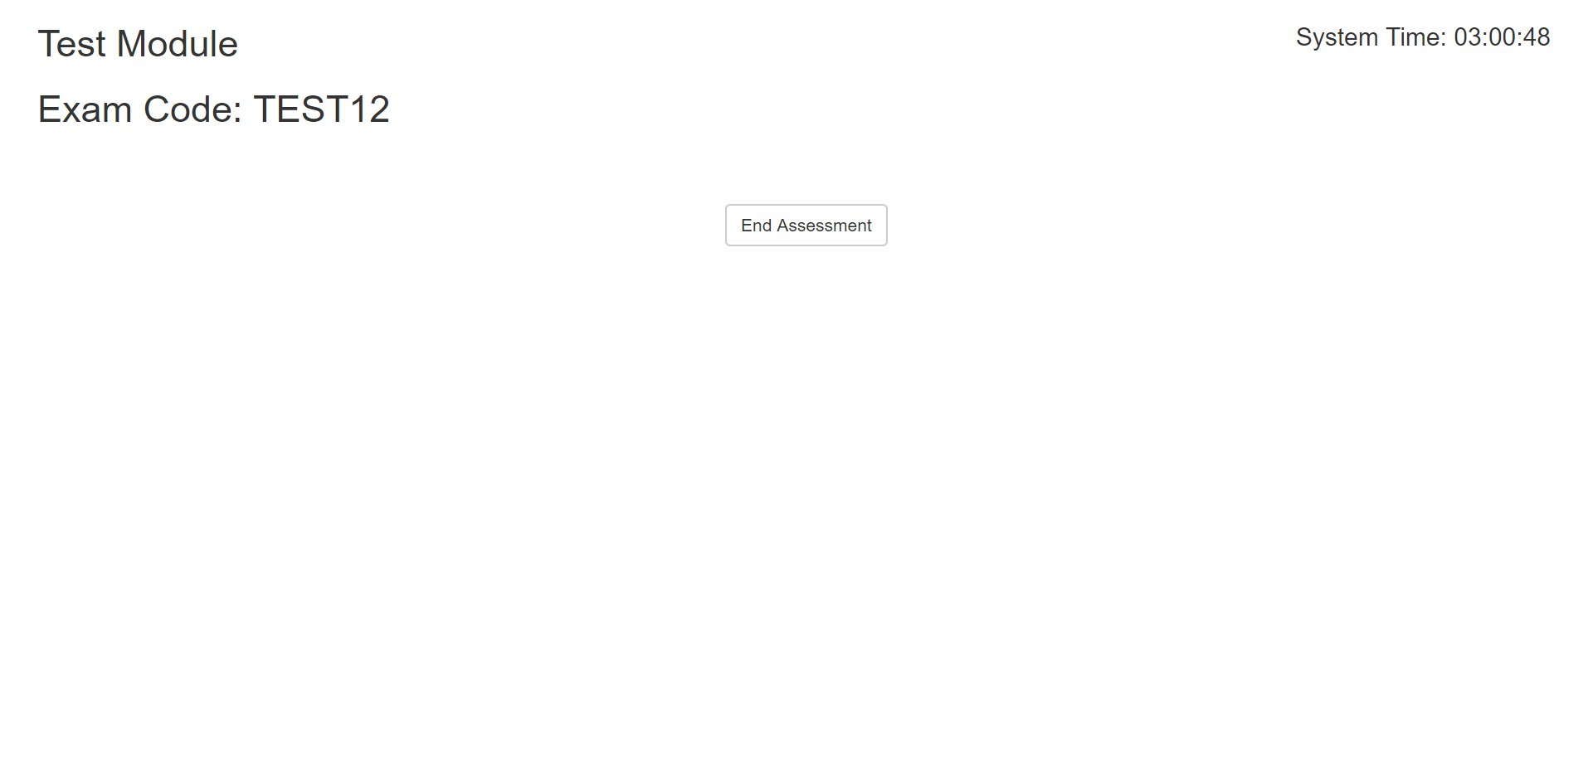

**Figure 24: Monitoring Page**

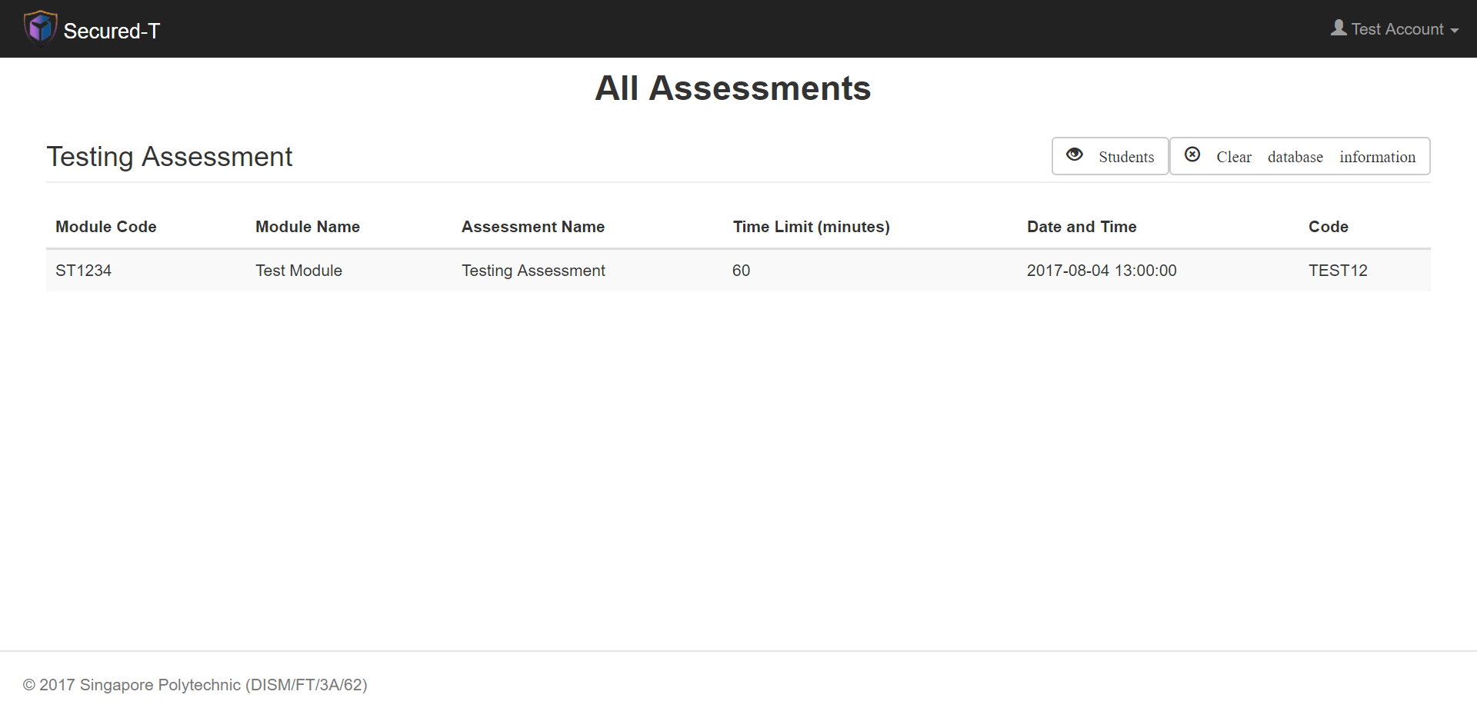

**Figure 25: All Assessments Page**

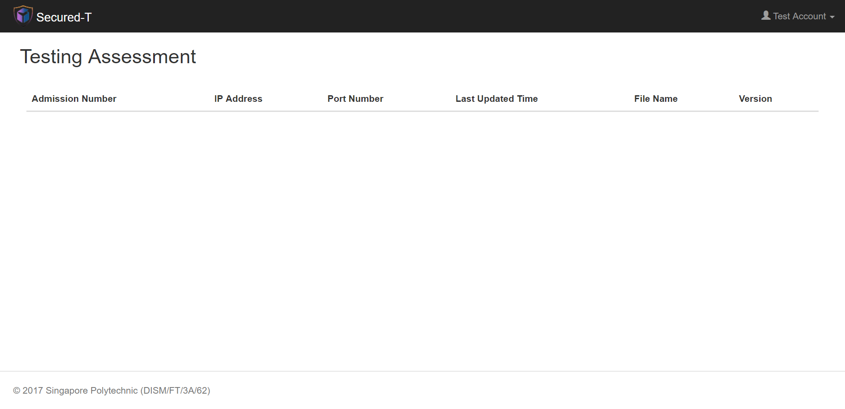

**Figure 26: History View Of All Students Page**

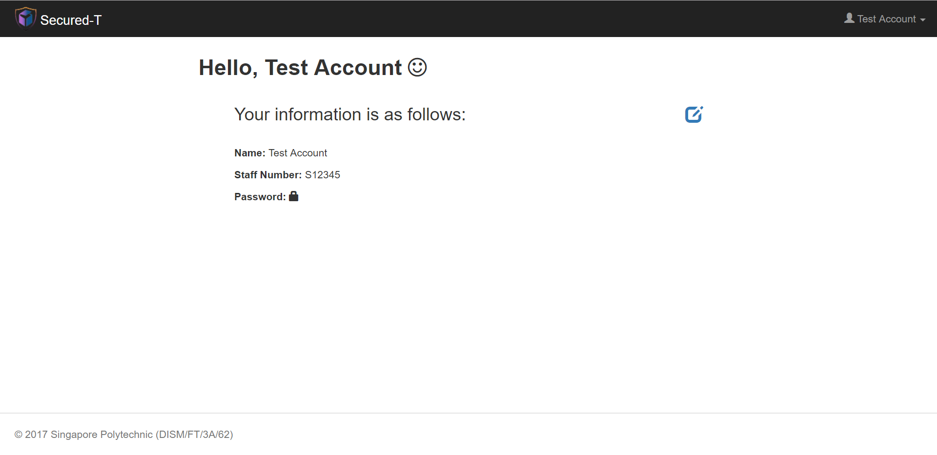

**Figure 27: View Profile Page**

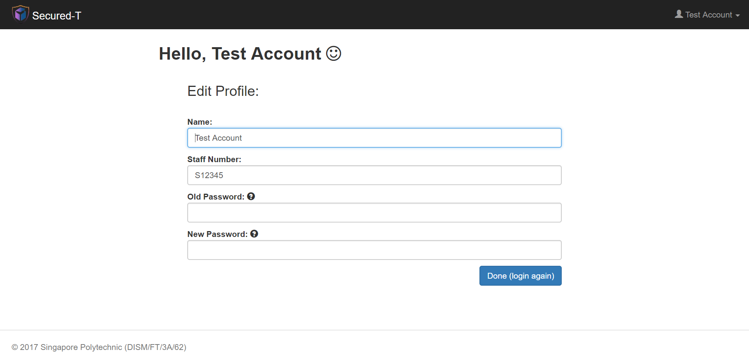

**Figure 28: Edit Profile Page**

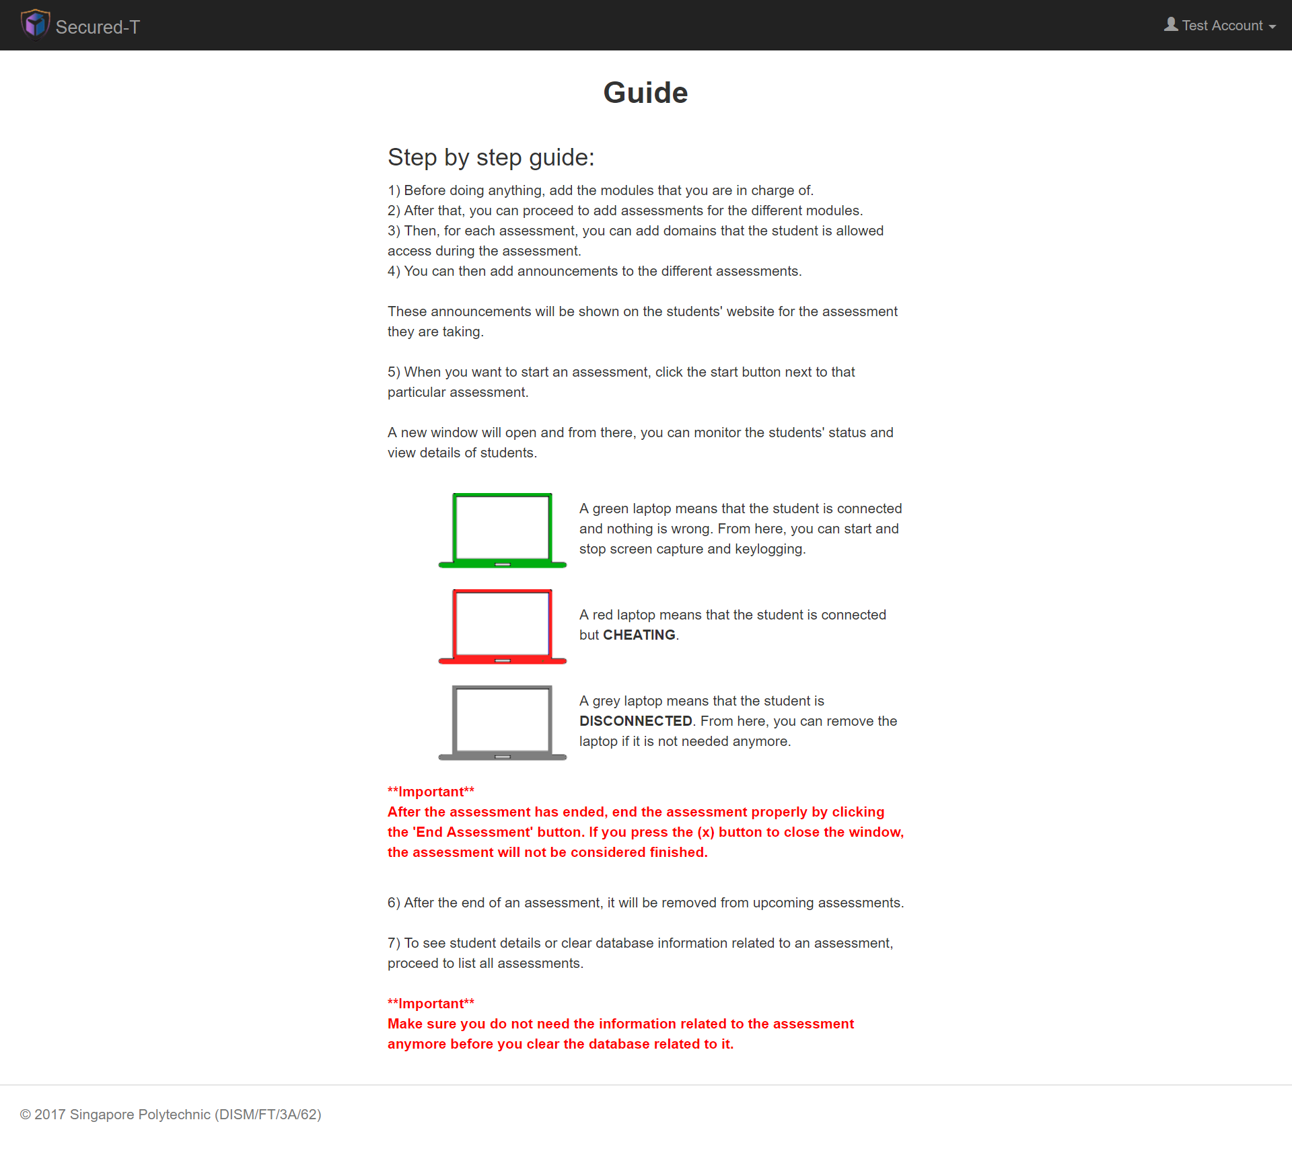

**Figure 29: Detailed Help/Guide Page**

**11.2.2 StudentSecT**

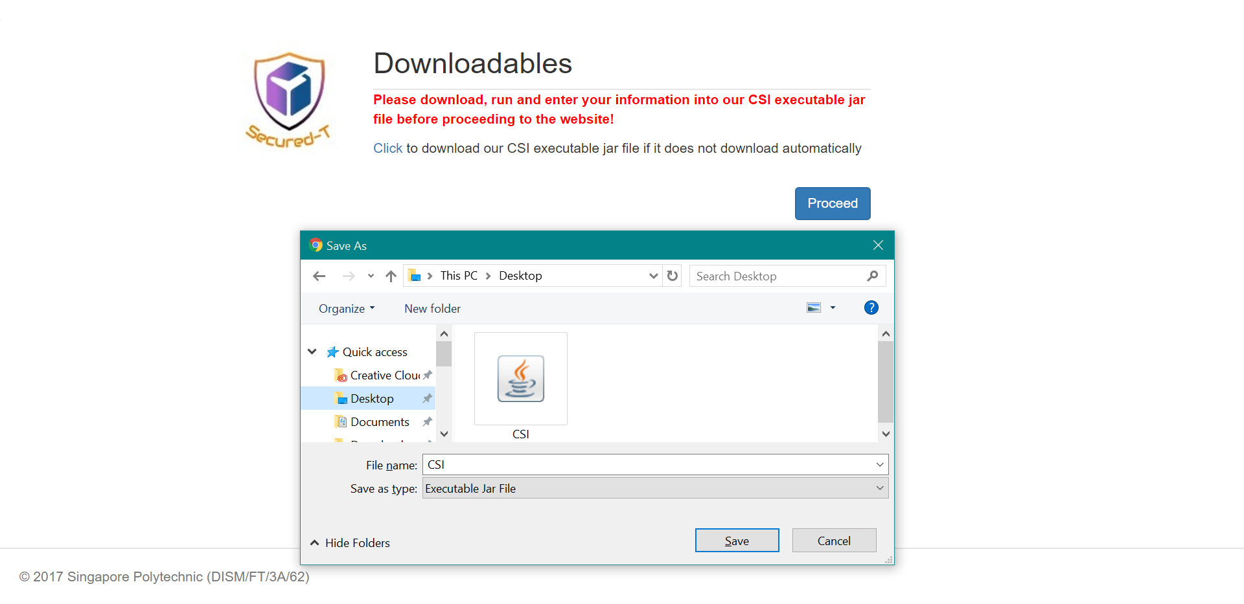

**Figure 30: Automatically Download**

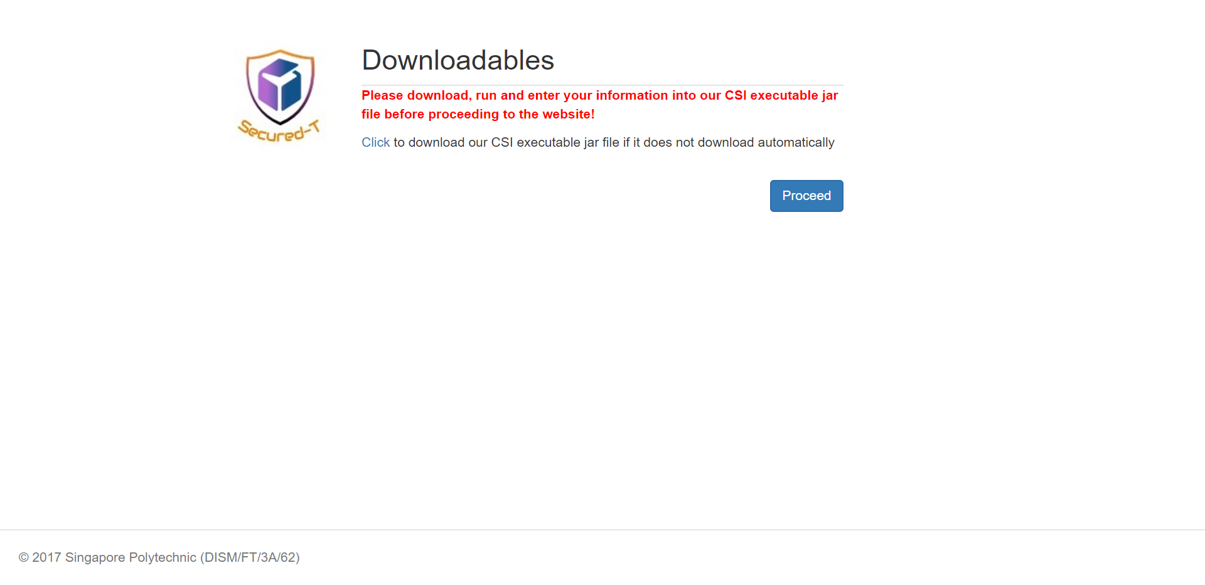

**Figure 31: Click To Download**

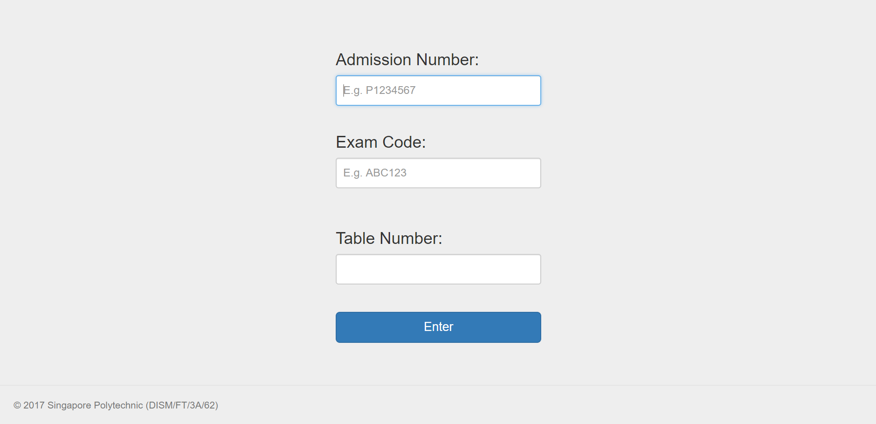

**Figure 32: Login Page**

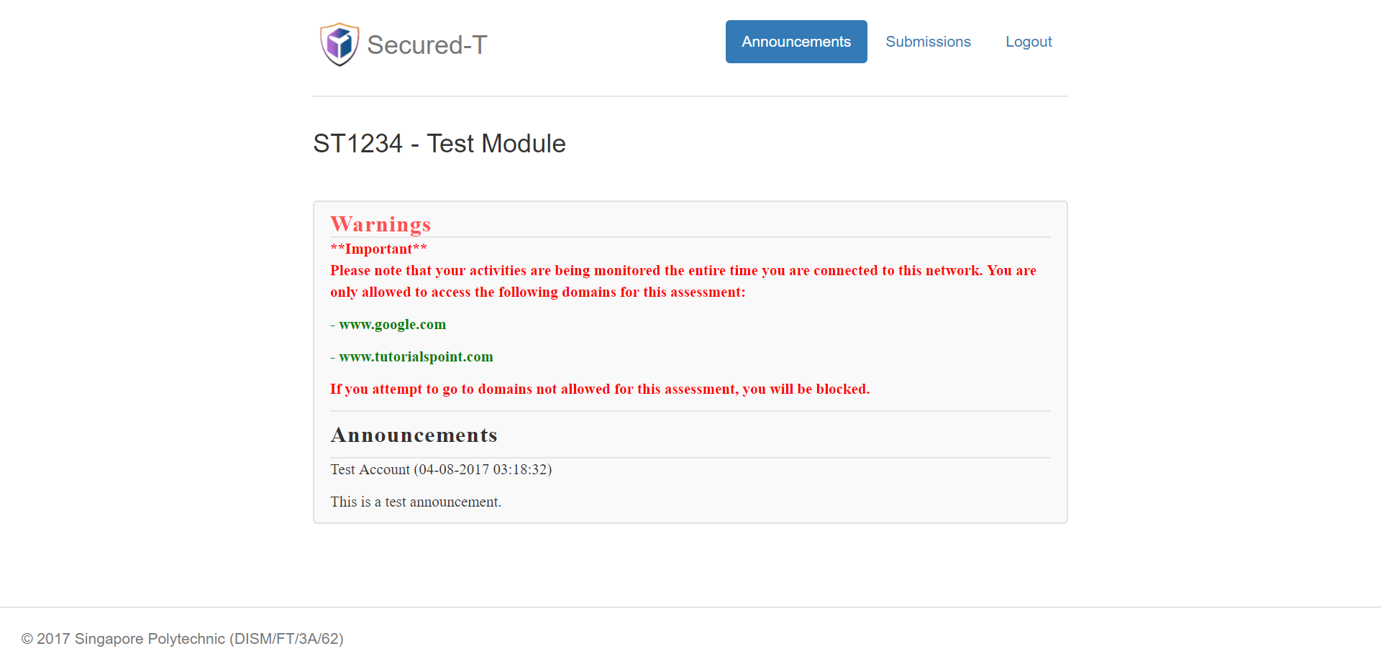

**Figure 33: Announcements Page**

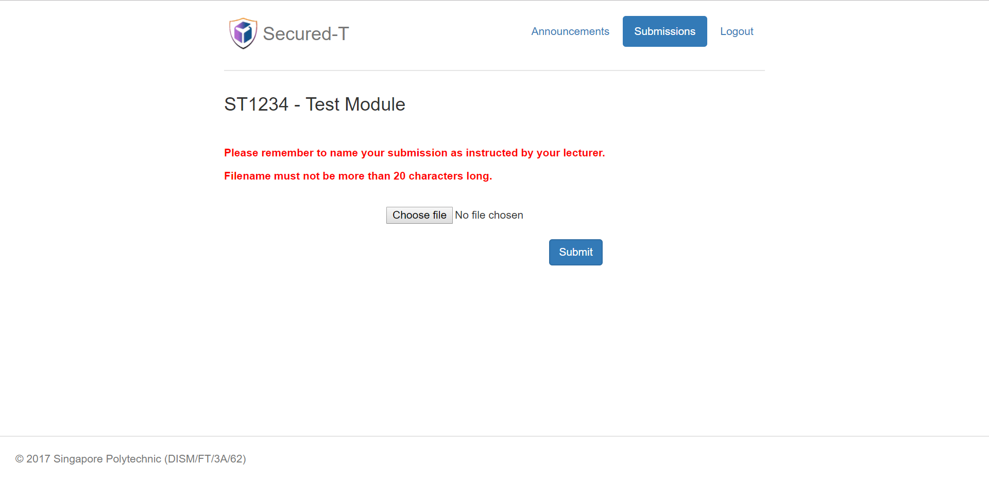

**Figure 34: Submissions Page**

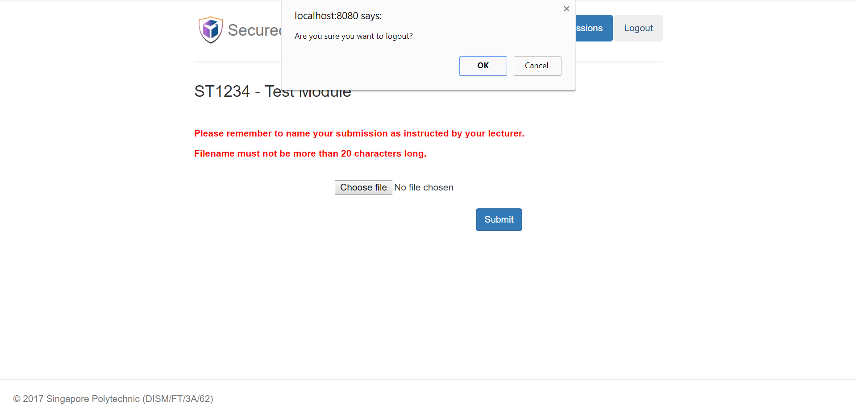

**Figure 35: Logout Warning**

**11.3 Appendix C: Database Details**

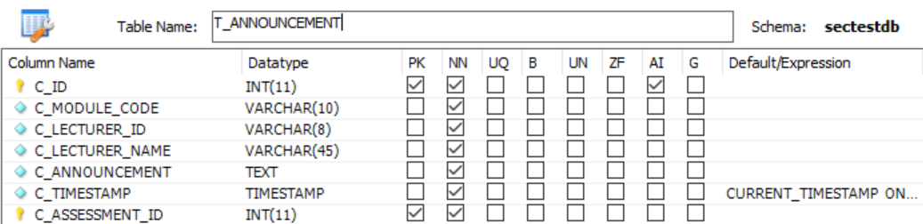

**Figure 36: T_ANNOUNCEMENT**

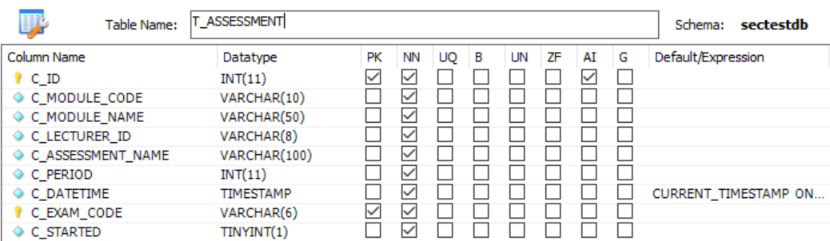

**Figure 37: T_ASSESSMENT**

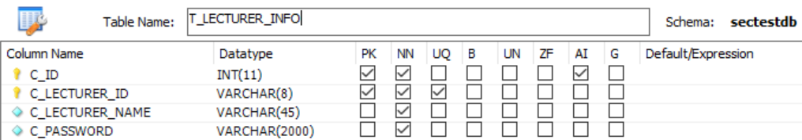

**Figure 38: T_LECTURER_INFO**

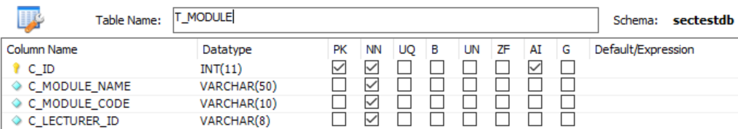

**Figure 39: T_MODULE**

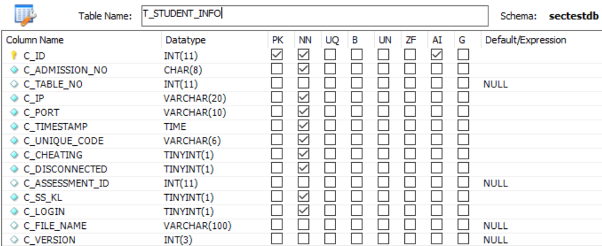

**Figure 40: T_STUDENT_INFO**

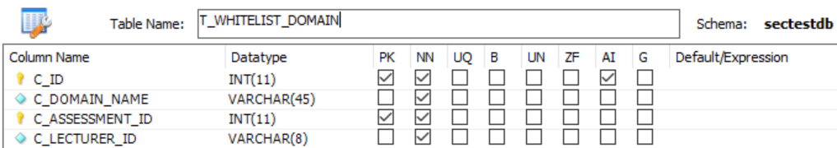

**Figure 41: T_WHITELIST_DOMAIN**

**11.4 Appendix D: Scrum Roles List**

**Table 9 : Scrum Roles**

|  |  |  |  |
| --- | --- | --- | --- |
| **Weeks** | **Product Owner** | **Scrum Master** | **Development Team** |
| Week 8 | Radin | Xin Li | Bavani, Puva |
| Week 9 | Radin | Bavani | Xin Li, Puva |
| Week 10 | Radin | Puva | Xin Li, Bavani |
| Week 11 | Radin | Xin Li | Bavani, Puva |
| Week 12 | Radin | Bavani | Xin Li, Puva |
| Week 13 | Radin | Puva | Xin Li, Bavani |
| Week 14 | Radin | Xin Li | Bavani, Puva |
| Week 15 | Radin | Bavani | Xin Li, Puva |
| Week 16 | Radin | Puva | Xin Li, Bavani |

**11.5 Appendix E: Burndown Chart**

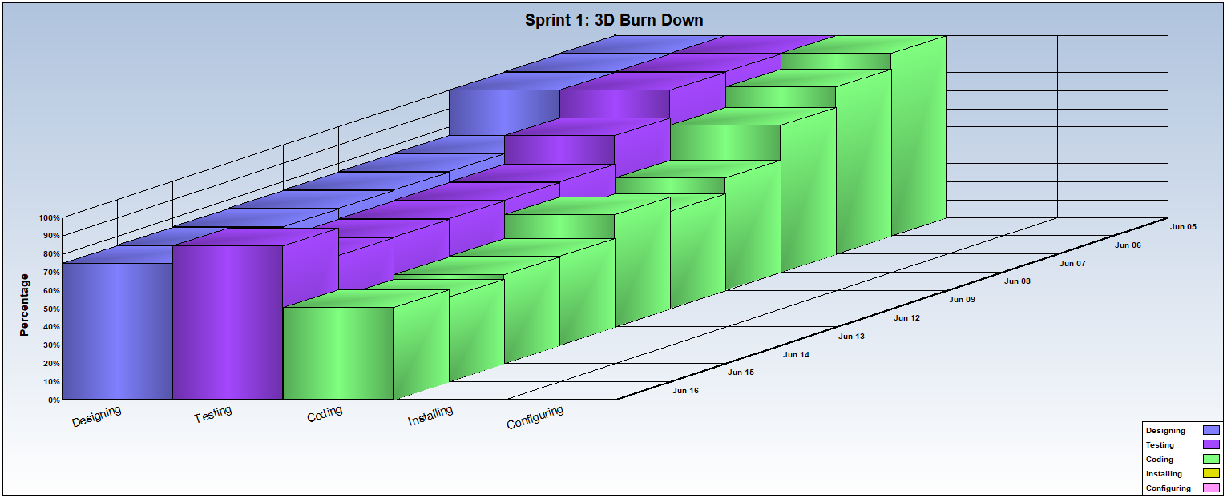

**Figure 42: 3D Burndown Chart - Sprint 1**

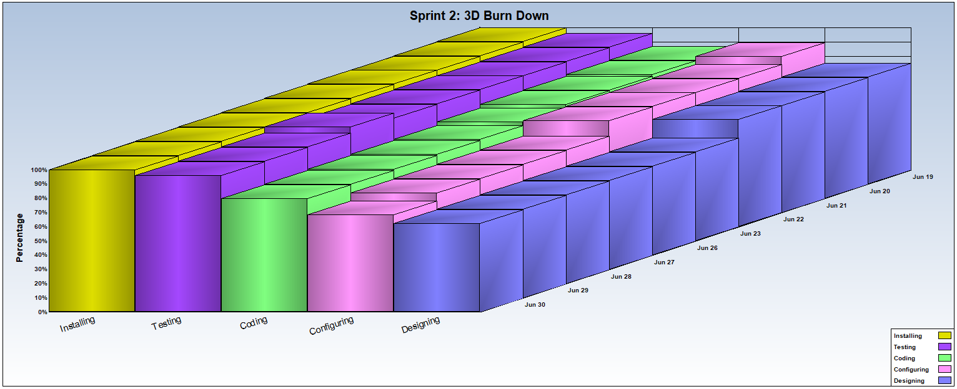

**Figure 43: 3D Burndown Chart - Sprint 2**

**11.6 Appendix F: Weekly Attendances**

# **Weekly Attendance for Group Form 01**

Group No.: Group 62 Date: From 17/04/2017 to 21/04/2017

Name of Project: Secured Online Assessment System via Software Defined Network

Supervisor Name: Mr Karl Kwan

Name Adm. No. Date Time-In Time-out Remarks

|  |  |  |  |  |  |
| --- | --- | --- | --- | --- | --- |
| Radin Ayuwandira Binte Radin Amirmuminin | P1444968 | 17/04 |  |  | No meet up |
| 18/04 | 08:30 | 12:00 |  |
| 19/04 | 11:00 | 13:00 | extra meet up session |
| 20/04 | 09:00 | 12:00 |  |
| 21/04 | 09:00 | 12:00 | Meet up session brought forward |
| Lim Xin Li | P1529546 | 17/04 |  |  | No meet up |
| 18/04 | 08:30 | 12:00 |  |
| 19/04 | 11:00 | 13:00 | extra meet up session |
| 20/04 | 09:00 | 12:00 |  |
| 21/04 | 09:00 | 12:00 | Meet up session brought forward |
| Bavani D/o Raman | P1551271 | 17/04 |  |  | No meet up |
| 18/04 | 08:30 | 12:00 |  |
| 19/04 | 11:00 | 13:00 | extra meet up session |
| 20/04 | 09:00 | 12:00 |  |
| 21/04 | 09:00 | 12:00 |  |
| T. Puvarneswaren Raja | P1551354 | 17/04 |  |  | No meet up |
| 18/04 | 08:30 | 12:00 |  |
| 19/04 | 11:00 | 13:00 | extra meet up session |
| 20/04 | 09:00 | 12:00 |  |
| 21/04 | 09:00 | 12:00 | Meet up session brought forward |

Note:

1. Weekly attendance for group form is to be submitted to your supervisor every Monday morning.

2. Attendance shall be marked according to the time-table.

1. Lateness or absenteeism without acceptable valid reasons or M/C shall be marked as absent.

# 

# 

# **Weekly Attendance for Group Form 02**

Group No.: Group 62 Date: From 24/04/2017 to 28/04/2017

Name of Project: Secured Online Assessment System via Software Defined Network

Supervisor Name: Mr Karl Kwan

Name Adm. No. Date Time-In Time-out Remarks

|  |  |  |  |  |  |
| --- | --- | --- | --- | --- | --- |
| Radin Ayuwandira Binte Radin Amirmuminin | P1444968 | 24/04 |  |  | No meet up |
| 25/04 | 08:30 | 12:15 |  |
| 26/04 |  |  |  |
| 27/04 | 09:00 | 13:00 |  |
| 28/04 | 09:00 | 12:00 |  |
| Lim Xin Li | P1529546 | 24/04 |  |  | No meet up |
| 25/04 | 08:30 | 12:15 |  |
| 26/04 |  |  |  |
| 27/04 | 09:00 | 13:00 |  |
| 28/04 | 09:00 | 12:00 |  |
| Bavani D/o Raman | P1551271 | 24/04 |  |  | No meet up |
| 25/04 | 08:30 | 12:15 |  |
| 26/04 |  |  |  |
| 27/04 | 09:00 | 13:00 |  |
| 28/04 | 09:00 | 12:00 |  |
| T. Puvarneswaren Raja | P1551354 | 24/04 |  |  | No meet up |
| 25/04 | 08:30 | 12:15 |  |
| 26/04 |  |  |  |
| 27/04 | 09:00 | 13:00 |  |
| 28/04 | 09:00 | 12:00 |  |

Note:

1. Weekly attendance for group form is to be submitted to your supervisor every Monday morning.

2. Attendance shall be marked according to the time-table.

1. Lateness or absenteeism without acceptable valid reasons or M/C shall be marked as absent.

# 

# 

# **Weekly Attendance for Group Form 03**

Group No.: Group 62 Date: From 01/05/2017 to 05/05/2017

Name of Project: Secured Online Assessment System via Software Defined Network

Supervisor Name: Mr Karl Kwan

Name Adm. No. Date Time-In Time-out Remarks

|  |  |  |  |  |  |
| --- | --- | --- | --- | --- | --- |
| Radin Ayuwandira Binte Radin Amirmuminin | P1444968 | 01/05 |  |  | *Labour’s Day* |
| 02/05 | 08:30 | 12:00 |  |
| 03/05 |  |  | No meet up |
| 04/05 | 08:30 | 12:30 |  |
| 05/05 | 09:00 | 12:00 |  |
| Lim Xin Li | P1529546 | 01/05 |  |  | *Labour’s Day* |
| 02/05 | 08:30 | 12:00 | **Absent: MC** |
| 03/05 |  |  | No meet up |
| 04/05 | 08:30 | 12:30 |  |
| 05/05 | 09:00 | 12:00 |  |
| Bavani D/o Raman | P1551271 | 01/05 |  |  | *Labour’s Day* |
| 02/05 | 08:30 | 12:00 | **Absent: MC (Came online from home)** |
| 03/05 |  |  | No meet up |
| 04/05 | 08:30 | 12:30 |  |
| 05/05 | 09:00 | 12:00 |  |
| T. Puvarneswaren Raja | P1551354 | 01/05 |  |  | *Labour’s Day* |
| 02/05 | 08:30 | 12:00 |  |
| 03/05 |  |  | No meet up |
| 04/05 | 08:30 | 12:30 |  |
| 05/05 | 09:00 | 12:00 |  |

Note:

1. Weekly attendance for group form is to be submitted to your supervisor every Monday morning.

2. Attendance shall be marked according to the time-table.

3. Lateness or absenteeism without acceptable valid reasons or M/C shall be marked as absent.

# 

# 

# **Weekly Attendance for Group Form 04**

Group No.: Group 62 Date: From 08/05/2017 to 12/05/2017

Name of Project: Secured Online Assessment System via Software Defined Network

Supervisor Name: Mr Karl Kwan

Name Adm. No. Date Time-In Time-out Remarks

|  |  |  |  |  |  |
| --- | --- | --- | --- | --- | --- |
| Radin Ayuwandira Binte Radin Amirmuminin | P1444968 | 08/05 |  |  | No meet up |
| 09/05 | 08:30 | 11:00 |  |
| 10/05 |  |  | **Vesak Day** |
| 11/05 | 09:00 | 12:30 |  |
| 12/05 | 10:30  15:12 | 14:00  16:33 | Morning group meet up  Afternoon meeting with sp |
| Lim Xin Li | P1529546 | 08/05 |  |  | No meet up |
| 09/05 | 08:30 | 11:00 |  |
| 10/05 |  |  | **Vesak Day** |
| 11/05 | 09:00 | 12:30 |  |
| 12/05 | 10:30  15:12 | 14:00  16:33 | Morning group meet up  Afternoon meeting with sp (late) |
| Bavani D/o Raman | P1551271 | 08/05 |  |  | No meet up |
| 09/05 | 08:30 | 11:00 |  |
| 10/05 |  |  | **Vesak Day** |
| 11/05 | 09:00 | 12:30 |  |
| 12/05 | 10:30  15:12 | 14:00  16:33 | Morning group meet up  Afternoon meeting with sp |
| T. Puvarneswaren Raja | P1551354 | 08/05 |  |  | No meet up |
| 09/05 | 08:30 | 11:00 |  |
| 10/05 |  |  | **Vesak Day** |
| 11/05 | 09:00 | 12:30 |  |
| 12/05 | 10:30  15:12 | 14:00  16:33 | Morning group meet up  Afternoon meeting with sp (late) |

Note:

1. Weekly attendance for group form is to be submitted to your supervisor every Monday morning.

2. Attendance shall be marked according to the time-table.

3. Lateness or absenteeism without acceptable valid reasons or M/C shall be marked as absent.

# 

# 

# **Weekly Attendance for Group Form 05**

Group No.: Group 62 Date: From 15/05/2017 to 19/05/2017

Name of Project: Secured Online Assessment System via Software Defined Network

Supervisor Name: Mr Karl Kwan

Name Adm. No. Date Time-In Time-out Remarks

|  |  |  |  |  |  |
| --- | --- | --- | --- | --- | --- |
| Radin Ayuwandira Binte Radin Amirmuminin | P1444968 | 15/05 |  |  | No meet up |
| 16/05 | 08:30 | 11:30 |  |
| 17/05 | 11:00 | 13:00 | Extra meet up |
| 15:30 | 17:30 | **Interim Presentation** |
| 18/05 | 08:30 | 12:10 | Early meet up |
| 19/05 | 10:00 | 14:38 |  |
| Lim Xin Li | P1529546 | 15/05 |  |  | No meet up |
| 16/05 | 08:30 | 11:30 |  |
| 17/05 | 11:00 | 13:00 | Extra meet up |
| 15:30 | 17:30 | **Interim Presentation** |
| 18/05 | 08:30 | 12:10 | Early meet up |
| 19/05 | 10:00 | 14:38 |  |
| Bavani D/o Raman | P1551271 | 15/05 |  |  | No meet up |
| 16/05 | 08:30 | 11:30 |  |
| 17/05 | 11:00 | 13:00 | Extra meet up |
| 15:30 | 17:30 | **Interim Presentation** |
| 18/05 | 08:30 | 12:10 | Early meet up |
| 19/05 | 10:00 | 14:38 |  |
| T. Puvarneswaren Raja | P1551354 | 15/05 |  |  | No meet up |
| 16/05 | 08:30 | 11:30 |  |
| 17/05 | 11:00 | 13:00 | Extra meet up |
| 15:30 | 17:30 | **Interim Presentation** |
| 18/05 | 08:30 | 12:10 | Early meet up |
| 19/05 | 10:00 | 14:38 |  |

Note:

1. Weekly attendance for group form is to be submitted to your supervisor every Monday morning.

2. Attendance shall be marked according to the time-table.

3. Lateness or absenteeism without acceptable valid reasons or M/C shall be marked as absent.

# 

# 

# **Weekly Attendance for Group Form 06**

Group No.: Group 62 Date: From 22/05/2017 to 26/05/2017

Name of Project: Secured Online Assessment System via Software Defined Network

Supervisor Name: Mr Karl Kwan

Name Adm. No. Date Time-In Time-out Remarks

|  |  |  |  |  |  |
| --- | --- | --- | --- | --- | --- |
| Radin Ayuwandira Binte Radin Amirmuminin | P1444968 | 22/05 |  |  | No meet up |
| 23/05 | 08:30 | 12:10 |  |
| 24/05 | 15:22 | 17:50 | General Meeting |
| 25/05 | 09:00 | 12:00 |  |
| 26/05 | 09:00 | 13:00 |  |
| Lim Xin Li | P1529546 | 22/05 |  |  | No meet up |
| 23/05 | 08:30 | 12:10 |  |
| 24/05 | 15:22 | 17:50 | General Meeting |
| 25/05 | 09:00 | 12:00 |  |
| 26/05 | 09:00 | 13:00 |  |
| Bavani D/o Raman | P1551271 | 22/05 |  |  | No meet up |
| 23/05 | 08:30 | 12:10 |  |
| 24/05 | 15:22 | 17:30 | General Meeting |
| 25/05 | 09:00 | 12:00 | from 10-12: Official meeting |
| 26/05 | 09:00 | 13:00 |  |
| T. Puvarneswaren Raja | P1551354 | 22/05 |  |  | No meet up |
| 23/05 | 08:30 | 12:10 |  |
| 24/05 | 15:22 | 17:50 | General Meeting |
| 25/05 | 09:00 | 12:00 |  |
| 26/05 | 09:00 | 13:00 |  |

Note:

1. Weekly attendance for group form is to be submitted to your supervisor every Monday morning.

2. Attendance shall be marked according to the time-table.

3. Lateness or absenteeism without acceptable valid reasons or M/C shall be marked as absent.

# 

# 

# **Weekly Attendance for Group Form 07**

Group No.: Group 62 Date: From 29/05/2017 to 02/06/2017

Name of Project: Secured Online Assessment System via Software Defined Network

Supervisor Name: Mr Karl Kwan

Name Adm. No. Date Time-In Time-out Remarks

|  |  |  |  |  |  |
| --- | --- | --- | --- | --- | --- |
| Radin Ayuwandira Binte Radin Amirmuminin | P1444968 | 22/05 |  |  | *MST week* |
| 23/05 |  |  |  |
| 24/05 |  |  |  |
| 25/05 |  |  |  |
| 26/05 | 14:00 | 15:40 | Official meeting |
| Lim Xin Li | P1529546 | 22/05 |  |  | *MST week* |
| 23/05 |  |  |  |
| 24/05 |  |  |  |
| 25/05 |  |  |  |
| 26/05 | 14:00 | 15:40 | Official meeting |
| Bavani D/o Raman | P1551271 | 22/05 |  |  | *MST week* |
| 23/05 |  |  |  |
| 24/05 |  |  |  |
| 25/05 |  |  |  |
| 26/05 | 14:00 | 15:40 | Official meeting |
| T. Puvarneswaren Raja | P1551354 | 22/05 |  |  | *MST week* |
| 23/05 |  |  |  |
| 24/05 |  |  |  |
| 25/05 |  |  |  |
| 26/05 | 14:00 | 15:40 | Official meeting |

Note:

1. Weekly attendance for group form is to be submitted to your supervisor every Monday morning.

2. Attendance shall be marked according to the time-table.

3. Lateness or absenteeism without acceptable valid reasons or M/C shall be marked as absent.

# 

# 

# **Weekly Attendance for Group Form 08**

Group No.: Group 62 Date: From 26/06/2017 to 30/06/2017

Name of Project: Secured Online Assessment System via Software Defined Network

Supervisor Name: Mr Karl Kwan

Name Adm. No. Date Time-In Time-out Remarks

|  |  |  |  |  |  |
| --- | --- | --- | --- | --- | --- |
| Radin Ayuwandira Binte Radin Amirmuminin | P1444968 | 26/06 |  |  | Holiday due to Eid Mubarak |
| 27/06 | 08:30 | 12:00 |  |
| 28/06 |  |  |  |
| 29/06 | 09:00 | 12:00 |  |
| 30/06 | 09:00 | 13:00 |  |
| Lim Xin Li | P1529546 | 26/06 |  |  | Holiday due to Eid Mubarak |
| 27/06 | 08:30 | 12:00 |  |
| 28/06 |  |  |  |
| 29/06 | 09:00 | 12:00 |  |
| 30/06 | 09:00 | 13:00 |  |
| Bavani D/o Raman | P1551271 | 26/06 |  |  | Holiday due to Eid Mubarak |
| 27/06 | 08:30 | 12:00 |  |
| 28/06 |  |  |  |
| 29/06 | 09:00 | 12:00 |  |
| 30/06 | 09:00 | 13:00 |  |
| T. Puvarneswaren Raja | P1551354 | 26/06 |  |  | Holiday due to Eid Mubarak |
| 27/06 | 08:30 | 12:00 |  |
| 28/06 |  |  |  |
| 29/06 | 09:00 | 12:00 |  |
| 30/06 | 09:00 | 13:00 |  |

Note:

1. Weekly attendance for group form is to be submitted to your supervisor every Monday morning.

2. Attendance shall be marked according to the time-table.

3. Lateness or absenteeism without acceptable valid reasons or M/C shall be marked as absent.

# 

# 

# **Weekly Attendance for Group Form 09**

Group No.: Group 62 Date: From 03/07/2017 to 07/07/2017

Name of Project: Secured Online Assessment System via Software Defined Network

Supervisor Name: Mr Karl Kwan

Name Adm. No. Date Time-In Time-out Remarks

|  |  |  |  |  |  |
| --- | --- | --- | --- | --- | --- |
| Radin Ayuwandira Binte Radin Amirmuminin | P1444968 | 03/07 |  |  | No Meet Up |
| 04/07 | 08:34 | 13:00 |  |
| 05/07 | 11:30 | 13:00 | extra meet up |
| 06/07 | 08:00 | 13:20 |  |
| 07/07 | 09:00 | 13:00 |  |
| Lim Xin Li | P1529546 | 03/07 |  |  | No Meet Up |
| 04/07 | 08:35 | 13:00 |  |
| 05/07 | 11:30 | 13:00 | extra meet up |
| 06/07 | 09:00 | 13:20 |  |
| 07/07 | 09:00 | 13:00 |  |
| Bavani D/o Raman | P1551271 | 03/07 |  |  | No Meet Up |
| 04/07 | 08:15 | 13:00 |  |
| 05/07 | 11:30 | 13:00 | extra meet up |
| 06/07 | 08:35 | 13:20 |  |
| 07/07 | 09:00 | 13:00 |  |
| T. Puvarneswaren Raja | P1551354 | 03/07 |  |  | No Meet Up |
| 04/07 | 08:34 | 13:00 |  |
| 05/07 | 11:30 | 13:00 | extra meet up |
| 06/07 | 08:00 | 13:20 |  |
| 07/07 | 09:00 | 13:00 |  |

Note:

1. Weekly attendance for group form is to be submitted to your supervisor every Monday morning.

2. Attendance shall be marked according to the time-table.

3. Lateness or absenteeism without acceptable valid reasons or M/C shall be marked as absent.

# 

# 

# **Weekly Attendance for Group Form 10**

Group No.: Group 62 Date: From 17/07/2017 to 21/07/2017

Name of Project: Secured Online Assessment System via Software Defined Network

Supervisor Name: Mr Karl Kwan

Name Adm. No. Date Time-In Time-out Remarks

|  |  |  |  |  |  |
| --- | --- | --- | --- | --- | --- |
| Radin Ayuwandira Binte Radin Amirmuminin | P1444968 | 17/07 |  |  | No Meet Up |
| 18/07 | 8:30 | 12:30 |  |
| 19/07 | 11:30 | 13:00 | Extra meet up |
| 20/07 | 09:00 | 13:30 |  |
| 21/07 | 08:10 | 11:10 |  |
| Lim Xin Li | P1529546 | 17/07 |  |  | No Meet Up |
| 18/07 | 8:30 | 12:30 |  |
| 19/07 | 11:30 | 13:00 | Extra meet up |
| 20/07 | 09:00 | 13:30 |  |
| 21/07 | 08:50 | 11:10 |  |
| Bavani D/o Raman | P1551271 | 17/07 |  |  | No Meet Up |
| 18/07 | 8:30 | 12:30 |  |
| 19/07 | 11:30 | 13:00 | Extra meet up |
| 20/07 | 09:00 | 13:30 |  |
| 21/07 | 07:45 | 11:10 |  |
| T. Puvarneswaren Raja | P1551354 | 17/07 |  |  | No Meet Up |
| 18/07 | 8:30 | 12:30 |  |
| 19/07 | 11:30 | 13:00 | Extra meet up |
| 20/07 | 09:00 | 13:30 |  |
| 21/07 | 08:15 | 11:10 |  |

Note:

1. Weekly attendance for group form is to be submitted to your supervisor every Monday morning.

2. Attendance shall be marked according to the time-table.

3. Lateness or absenteeism without acceptable valid reasons or M/C shall be marked as absent.

# 

# 

# **Weekly Attendance for Group Form 11**

Group No.: Group 62 Date: From 24/07/2017 to 28/07/2017

Name of Project: Secured Online Assessment System via Software Defined Network

Supervisor Name: Mr Karl Kwan

Name Adm. No. Date Time-In Time-out Remarks

|  |  |  |  |  |  |
| --- | --- | --- | --- | --- | --- |
| Radin Ayuwandira Binte Radin Amirmuminin | P1444968 | 24/07 | 08:00 | 10:00 |  |
| 25/07 | 8:50 | 12:10 |  |
| 26/07 |  |  | No meetup |
| 27/07 | 09:00 | 13:00 |  |
| 28/07 | 08:00 | 15:00 |  |
| Lim Xin Li | P1529546 | 24/07 | 08:00 | 10:00 |  |
| 25/07 | 8:50 | 12:10 |  |
| 26/07 |  |  | No meetup |
| 27/07 | 09:00 | 13:00 |  |
| 28/07 | 08:00 | 15:00 |  |
| Bavani D/o Raman | P1551271 | 24/07 | NIL | NILL | Wake Up Late |
| 25/07 | 8:45 | 12:10 |  |
| 26/07 |  |  | No meetup |
| 27/07 | 09:00 | 13:00 |  |
| 28/07 | NIL | NIL | Didn’t attend due to medical reasons |
| T. Puvarneswaren Raja | P1551354 | 24/07 | 08:00 | 10:00 |  |
| 25/07 | 8:30 | 12:10 |  |
| 26/07 |  |  | No meetup |
| 27/07 | 09:00 | 13:00 |  |
| 28/07 | 08:00 | 15:00 |  |

Note:

1. Weekly attendance for group form is to be submitted to your supervisor every Monday morning.

2. Attendance shall be marked according to the time-table.

3. Lateness or absenteeism without acceptable valid reasons or M/C shall be marked as absent.

# **Weekly Attendance for Group Form 12**

Group No.: Group 62 Date: From 31/07/2017 to 04/08/2017

Name of Project: Secured Online Assessment System via Software Defined Network

Supervisor Name: Mr Karl Kwan

Name Adm. No. Date Time-In Time-out Remarks

|  |  |  |  |  |  |
| --- | --- | --- | --- | --- | --- |
| Radin Ayuwandira Binte Radin Amirmuminin | P1444968 | 31/07 | 13:00 | 16:30 |  |
| 01/08 | 08:30 | 11:30 |  |
| 02/08 |  |  | No meetup |
| 03/08 | 08:47 | 15:50 |  |
| 04/08 | 08:30 |  | Virtually present (Not well) |
| Lim Xin Li | P1529546 | 31/07 | 13:00 | 16:30 |  |
| 01/08 | 08:40 | 09:00 | Left for a photoshoot |
| 02/08 |  |  | No meetup |
| 03/08 | 09:13 | 15:50 |  |
| 04/08 | 09:15 | 17:00 |  |
| Bavani D/o Raman | P1551271 | 31/07 | 13:00 | 15:30 |  |
| 01/08 | 08:30 | 11:30 |  |
| 02/08 |  |  | No meetup |
| 03/08 | 08:48 | 15:50 |  |
| 04/08 | 07:30 | 11:00 |  |
| T. Puvarneswaren Raja | P1551354 | 31/07 | 13:00 | 16:30 |  |
| 01/08 | 08:39 | 11:30 |  |
| 02/08 |  |  | No meetup |
| 03/08 | 08:54 | 15:50 |  |
| 04/08 | 08:10 | 17:00 |  |

Note:

1. Weekly attendance for group form is to be submitted to your supervisor every Monday morning.

2. Attendance shall be marked according to the time-table.

3. Lateness or absenteeism without acceptable valid reasons or M/C shall be marked as absent.

**11.7 Appendix G: Weekly Monitoring Reports**

# **Weekly Monitoring Report 01**

Group No.: Group 62 Date: From 17/04/2017 to 21/04/2017

Name of Project: Secured Online Assessment System via Software Defined Network

Supervisor Name: Mr Karl Kwan

**1. Student weekly performance summary**

|  |  |  |  |  |
| --- | --- | --- | --- | --- |
| Adm. No. | Name | No. of hours present | Progress1 | Remarks |
| 1. P1444968 | Radin Ayuwandira Binte Radin Amirmuminin | 11hrs 30mins | - Task 1 done  - Research on possible solutions / existing solutions  - Notes Compilation #1 |  |
| 1. P1529546 | Lim Xin Li | 11hrs 30mins | - Task 2 done  - Research on ways to cheat  - Research on problems that led to this project  - Significance of this project  - Objectives of this project  - Notes Compilation #1 |  |
| 1. P1551271 | Bavani D/o Raman | 11hrs 30mins | - Task 2 done  - Research on the background  - Research on possible solutions / existing solutions  - Objectives of this project  - Research on routers |  |
| 1. P1551354 | T.Puvarneswaren Raja | 11hrs 30mins | - Task 1 done  - Research on ways to cheat  - Research on problems that led to this project  - Significance of this project  - Research on routers |  |

1 State whether: A=On Schedule B=Ahead Schedule for no. of days C=Behind Schedule for no. of days

# **Weekly Monitoring Report 02**

Group No.: Group 62 Date: From 24/04/2017 to 28/04/2017

Name of Project: Secured Online Assessment System via Software Defined Network

Supervisor Name: Mr Karl Kwan

**1. Student weekly performance summary**

|  |  |  |  |  |
| --- | --- | --- | --- | --- |
| Adm. No. | Name | No. of hours present | Progress1 | Remarks |
| 1. P1444968 | Radin Ayuwandira Binte Radin Amirmuminin | 10hrs 30mins | - Task 1 done  - Notes Compilation #1 done  - Research on possible solutions / existing solutions  - Executable java as client  - Design webpage |  |
| 1. P1529546 | Lim Xin Li | 10hrs 30mins | - Task 2 done  - Notes Compilation #1 done  - Link server to database  - Research on ways to cheat  - Research on problems that led to this project  - Significance of this project  - Objectives of this project  - Policing program  - Executable java as client |  |
| 1. P1551271 | Bavani D/o Raman | 10hrs 30minss | - Task 2 done  - Research on routers done  - Link server to database  - Research on the background  - Research on possible solutions / existing solutions  - Objectives of this project  - Screen capture |  |
| 1. P1551354 | T.Puvarneswaren Raja | 10hrs 30mins | - Task 1 done  - Research on routers done  - Research on ways to cheat  - Research on problems that led to this project  - Significance of this project  - Design webpage |  |

1 State whether: A=On Schedule B=Ahead Schedule for no. of days C=Behind Schedule for no. of days

# **Weekly Monitoring Report 03**

Group No.: Group 62 Date: From 01/05/2017 to 05/05/2017

Name of Project: Secured Online Assessment System via Software Defined Network

Supervisor Name: Mr Karl Kwan

**1. Student weekly performance summary**

|  |  |  |  |  |
| --- | --- | --- | --- | --- |
| Adm. No. | Name | No. of hours present | Progress1 | Remarks |
| 1. P1444968 | Radin Ayuwandira Binte Radin Amirmuminin | 10hrs 30mins | **Done:**  **-** Think of type of users and what they can do  - Risk Analysis  **Ongoing:**  - Presentation Slides  - Policing program  - Design webpage  **All the time:**  **-** Notes compilation  - Attendance  - Monitoring report |  |
| 1. P1529546 | Lim Xin Li | 7hrs  (Wednesday (3hr 30 mins) wasn’t present due to MC) | **Done:**  - Link server to database  **Ongoing:**  **-** Presentation Slides  - Task 2 improving  - Policing program |  |
| 1. P1551271 | Bavani D/o Raman | 10hrs 30mins  (Wednesday (3hr 30 mins) wasn’t present physically due to MC but was online from home) | **Done:**  **-** Research on routers  **-** Think of type of users and what they can do  - Risk Analysis  **Ongoing:**  - Presentation Slides  - Task 2 improving  - Screen capture |  |
| 1. P1551354 | T.Puvarneswaren Raja | 10hrs 30mins | **Done:**  - Research on routers  **Ongoing:**  **-** Presentation Slides  - Design webpage  - Screen capture  - Further research of forum / disallow forum typing |  |

1 State whether: A=On Schedule B=Ahead Schedule for no. of days C=Behind Schedule for no. of days

# **Weekly Monitoring Report 04**

Group No.: Group 62 Date: From 08/05/2017 to 12/05/2017

Name of Project: Secured Online Assessment System via Software Defined Network

Supervisor Name: Mr Karl Kwan

**1. Student weekly performance summary**

|  |  |  |  |  |
| --- | --- | --- | --- | --- |
| Adm. No. | Name | No. of hours present | Progress1 | Remarks |
| 1. P1444968 | Radin Ayuwandira Binte Radin Amirmuminin | 11hrs | **Done:**  - Logo creation  **Ongoing:**  - Policing program  - Design webpage  - Finalise slides  **Not started:**  **-** Database design (outlook)  **All the time:**  **-** Notes compilation  - Attendance  - Monitoring report |  |
| 1. P1529546 | Lim Xin Li | 11hrs | **Done:**  **Ongoing:**  - Task 2 improving  - Policing program  - Finalise slides  **Not started:**  - Database design (outlook) |  |
| 1. P1551271 | Bavani D/o Raman | 11hrs | **Done:**  **Ongoing:**  - Task 2 improving  - Screen capture  - Finalise slides |  |
| 1. P1551354 | T.Puvarneswaren Raja | 11hrs | **Done:**  **Ongoing:**  - Mockup website Design  - Screen capture  - Finalise slides  **Not started:**  - Further research of forum / disallow forum typing  - Look into keylogger |  |

1 State whether: A=On Schedule B=Ahead Schedule for no. of days C=Behind Schedule for no. of days

# **Weekly Monitoring Report 05**

Group No.: Group 62 Date: From 15/05/2017 to 19/05/2017

Name of Project: Secured Online Assessment System via Software Defined Network

Supervisor Name: Mr Karl Kwan

**1. Student weekly performance summary**

|  |  |  |  |  |
| --- | --- | --- | --- | --- |
| Adm. No. | Name | No. of hours present | Progress1 | Remarks |
| 1. P1444968 | Radin Ayuwandira Binte Radin Amirmuminin | 13hr 18 Mins (Excluding of 2hrs of Interim Presentation) | **Done:**  - Interim Presentation  **Ongoing:**  Complete functional/feature list of the web application  - Database design (outlook)  **Not started:**  **-** Heartbeat program (java)  - Ryu OpenFlow configurations (ovs)  **All the time:**  **-** Notes compilation  - Attendance  - Monitoring report | C - due to interim presentation |
| 1. P1529546 | Lim Xin Li | 13hr 18 Mins (Excluding of 2hrs of Interim Presentation) | **Done:**  - Interim Presentation  **Ongoing:**  - Complete functional/feature list of the web application  - Policing program  - Database design (outlook)  **Not started:**  - Heartbeat program version 1.2 (py) | C - due to interim presentation |
| 1. P1551271 | Bavani D/o Raman | 13hr 18 Mins (Excluding of 2hrs of Interim Presentation) | **Done:**  - Interim Presentation  **Ongoing:**  - Complete functional/feature list of the web application  - Screen capture research (py)  **Not started:**  **-** Identify firewall configurations on a router, as many as possible that suits our system | C - due to interim presentation |
| 1. P1551354 | T.Puvarneswaren Raja | 13hr 18 Mins (Excluding of 2hrs of Interim Presentation) | **Done:**  - Interim Presentation  **Ongoing:**  **-** Complete functional/feature list of the web application  - Screen capture research (java)  - Keylogger research  **Not started:**  - Complete the design and implementation of web application  - Identify firewall configurations on a router, as many as possible that suits our system | C - due to interim presentation |

1 State whether: A=On Schedule B=Ahead Schedule for no. of days C=Behind Schedule for no. of days

# **Weekly Monitoring Report 06**

Group No.: Group 62 Date: From 22/05/2017 to 26/05/2017

Name of Project: Secured Online Assessment System via Software Defined Network

Supervisor Name: Mr Karl Kwan

**1. Student weekly performance summary**

|  |  |  |  |  |
| --- | --- | --- | --- | --- |
| Adm. No. | Name | No. of hours present | Progress1 | Remarks |
| 1. P1444968 | Radin Ayuwandira Binte Radin Amirmuminin | 13hr 08 Mins | **Done:**  - Complete functional/feature list of the web application  - Database design (outlook)  - Report writing discussion  **Ongoing:**  - Finalise database design (outlook)  **Not started:**  **-** Heartbeat program (java)  - Ryu Openflow configurations (ovs)  - Complete the design and implementation of web application (Student side)  **All the time:**  **-** Notes compilation  - Attendance  - Monitoring report | A |
| 1. P1529546 | Lim Xin Li | 13hr 08 Mins | **Done:**  - Complete functional/feature list of the web application  - Database design (outlook)  - Report writing discussion  **Ongoing:**  - Policing program  - Finalise database design (outlook)  **Not started:**  - Heartbeat program version 1.2 (py)  - Complete the design and implementation of web application (Student side) | A |
| 1. P1551271 | Bavani D/o Raman | 12hr 48 Mins | **Done:**  - Complete functional/feature list of the web application  - Screen capture research (py)  - decided to not be used  - Report writing discussion  **Ongoing:**  - Report writing  - Keylogger research  **Not started:**  **-** Identify firewall configurations on a router, as many as possible that suits our system | A |
| 1. P1551354 | T.Puvarneswaren Raja | 13hr 08 Mins | **Done:**  **-** Complete functional/feature list of the web application  - Screen capture research (java)  - Report writing discussion  **Ongoing:**  - Keylogger research  - Report writing  **Not started:**  - Complete the design and implementation of web application (lecturer side)  - Identify firewall configurations on a router, as many as possible that suits our system | A |

1 State whether: A=On Schedule B=Ahead Schedule for no. of days C=Behind Schedule for no. of days

# **Weekly Monitoring Report 07**

Group No.: Group 62 Date: From 29/05/2017 to 02/06/2017

Name of Project: Secured Online Assessment System via Software Defined Network

Supervisor Name: Mr Karl Kwan

**1. Student weekly performance summary**

|  |  |  |  |  |
| --- | --- | --- | --- | --- |
| Adm. No. | Name | No. of hours present | Progress1 | Remarks |
| 1. P1444968 | Radin Ayuwandira Binte Radin Amirmuminin | 1hr 40 mins | **Done:**  - Finalise database design (outlook)  **Ongoing:**  - DNS block program  **Not started:**  **-** Heartbeat program (java)  - Complete the design and implementation of web application (Student side)  **All the time:**  **-** Notes compilation  - Attendance  - Monitoring report | C - Will be delayed due to MST week |
| 1. P1529546 | Lim Xin Li | 1hr 40 mins | **Done:**  - Finalise database design (outlook)  **Ongoing:**  - Policing program  **Not started:**  - Heartbeat program version 1.2 (py)  - Complete the design and implementation of web application (Student side) | C - Will be delayed due to MST week |
| 1. P1551271 | Bavani D/o Raman | 1hr 40 mins | **Done:**  - Keylogger research  **-** Identify firewall configurations on a router, as many as possible that suits our system  - will be taken out  **Ongoing:**  - Report writing  **Not started:** | C - Will be delayed due to MST week |
| 1. P1551354 | T.Puvarneswaren Raja | 1hr 40 mins | **Done:**  **-** Identify firewall configurations on a router, as many as possible that suits our system  - will be taken out  - Keylogger research  **Ongoing:**  **Not started:**  - Configure FYP Notebook  - Complete the design and implementation of web application (lecturer side) | C - Will be delayed due to MST week |

1 State whether: A=On Schedule B=Ahead Schedule for no. of days C=Behind Schedule for no. of days

# **Weekly Monitoring Report 08**

Group No.: Group 62 Date: From 26/06/2017 to 30/06/2017

Name of Project: Secured Online Assessment System via Software Defined Network

Supervisor Name: Mr Karl Kwan

**1. Student weekly performance summary**

|  |  |  |  |  |
| --- | --- | --- | --- | --- |
| Adm. No. | Name | No. of hours present | Progress1 | Remarks |
| 1. P1444968 | Radin Ayuwandira Binte Radin Amirmuminin | 10hrs 30mins | **Done:**  - DNS program  **Ongoing:**   * Heartbeat program v3 (java) * Heartbeat server program v1 (python)   **Not started:**  **All the time:**  - Notes compilation  - Attendance  - Monitoring report | C - delayed |
| 1. P1529546 | Lim Xin Li | 10hrs 30mins | **Done:**   * Announcement page (student) * Sign up page * Home page * Screen monitoring page   **Ongoing:**  - web application (Student side)  - Lecturer can add modules and assessments  - Lecturer profile, settings, help  **Not started:** | C - delayed |
| 1. P1551271 | Bavani D/o Raman | 10hrs 30mins | **Done:**  **Ongoing:**  - Report writing  - Documentation update  **Not started:** | C - delayed |
| 1. P1551354 | T.Puvarneswaren Raja | 10hrs 30mins | **Done:**  - DNS block program (additional feature)  - Lecturer site: login page  - Lecturer site: home page  - Lecturer site: screen monitoring page  **Ongoing:**  - Router configuration  - Error Redirection page (configure message on page)  - FYP notebook configuration  **Not started:** | C - delayed |

1 State whether: A=On Schedule B=Ahead Schedule for no. of days C=Behind Schedule for no. of days

# **Weekly Monitoring Report 09**

Group No.: Group 62 Date: From 03/07/2017 to 07/07/2017

Name of Project: Secured Online Assessment System via Software Defined Network

Supervisor Name: Mr Karl Kwan

**1. Student weekly performance summary**

|  |  |  |  |  |
| --- | --- | --- | --- | --- |
| Adm. No. | Name | No. of hours present | Progress1 | Remarks |
| 1. P1444968 | Radin Ayuwandira Binte Radin Amirmuminin | 11h 47mins | **Done:**  **Ongoing:**  **-** SPAIv4 program (java)  - CIv2 server (python)  **Not started:**  **All the time:**  **-** Notes compilation  - Attendance  - Monitoring report | C - working to be on track |
| 1. P1529546 | Lim Xin Li | 10 hrs | **Done:**   * display default announcement on student site * Screen capture and keylog on demand and alert when started * lecturer can view, add and search for announcements * lecturer can add assessment, module * lecturer can view and edit profile, view help and logout * Password encryption added for lecturer's account   **Ongoing:**  - web application (Student side)  **Not started:** | C - working to be on track |
| 1. P1551271 | Bavani D/o Raman | 11h 47mins | **Done:**  **Ongoing:**  - Report writing  - On demand logging  - Documentation update  **Not started:** | A |
| 1. P1551354 | T.Puvarneswaren Raja | 11h 47mins | **Done:**  - Router configuration  **Ongoing:**  - fyp notebook configuration  - Error Redirection page (website redirection to this page)  - password encryption  **Not started:**  - research on uploading files | C - delayed, configuration should be done |

1 State whether: A=On Schedule B=Ahead Schedule for no. of days C=Behind Schedule for no. of days

# **Weekly Monitoring Report 10**

Group No.: Group 62 Date: From 17/07/2017 to 21/07/2017

Name of Project: Secured Online Assessment System via Software Defined Network

Supervisor Name: Mr Karl Kwan

**1. Student weekly performance summary**

|  |  |  |  |  |
| --- | --- | --- | --- | --- |
| Adm. No. | Name | No. of hours present | Progress1 | Remarks |
| 1. P1444968 | Radin Ayuwandira Binte Radin Amirmuminin | 13hrs | **Done:**  **Ongoing:**  **-** CSI v6 agent (java)  - CI v3 server (python)  **Not started:**  **All the time:**  - Attendance  **-** Notes compilation  - Monitoring report | A - with slight delay |
| 1. P1529546 | Lim Xin Li | 12hrs 20mins | **Done:**  - lecturer view, add, delete whitelist domain  - lecturer can clear database  - lecturer can view student details after the end of assessment  - student file upload and version  - student download CSI  - student need to enter table number  **Ongoing:**  **Not started:**  - Poster making in photoshop | A |
| 1. P1551271 | Bavani D/o Raman | 13hrs 25mins | **Done:**  - On demand logging  **Ongoing:**  - Report writing  - Documentation update  **Not started:** | A |
| 1. P1551354 | T.Puvarneswaren Raja | 12hrs 55mins | **Done:**  - research on uploading files  - fyp notebook configuration  - password encryption  - - Error Redirection page (website redirection to this page)  - DNS Program (additional feature)  **Ongoing:**  - Update Read-me documentation  - Search for ways on how to cheat  **Not started:** | A |

1 State whether: A=On Schedule B=Ahead Schedule for no. of days C=Behind Schedule for no. of days

# **Weekly Monitoring Report 11**

Group No.: Group 62 Date: From 24/07/2017 to 28/07/2017

Name of Project: Secured Online Assessment System via Software Defined Network

Supervisor Name: Mr Karl Kwan

**1. Student weekly performance summary**

|  |  |  |  |  |
| --- | --- | --- | --- | --- |
| Adm. No. | Name | No. of hours present | Progress1 | Remarks |
| 1. P1444968 | Radin Ayuwandira Binte Radin Amirmuminin | 16hrs 20mins | **Done:**  **-** CSI v6 agent (java)  - CI v3 server (python)  **-** Notes compilation  **Ongoing:**  - Testing  - Update Gantt Chart  - Report writing  - Reflection Journal  **Not started:**  - video  **All the time:**  - Attendance  - Monitoring report | A |
| 1. P1529546 | Lim Xin Li | 16hrs 20mins | **Done:**  - Poster  **Ongoing:**  - Lecturer guide  - Report writing  - Testing  **Not started:**  - Student Guide  - Reflection Journal | A |
| 1. P1551271 | Bavani D/o Raman | 7hrs 25mins | **Done:**  **Ongoing:**  - Report writing  - Documentation update  **Not started:**  - Reflection Journal  - video | A |
| 1. P1551354 | T.Puvarneswaren Raja | 16hrs 50mins | **Done:**  **Ongoing:**  - Update installation guide  - Search for ways on how to cheat  **Not started:**  - Reflection Journal  - video | A |

1 State whether: A=On Schedule B=Ahead Schedule for no. of days C=Behind Schedule for no. of days

# 

# 

# **Weekly Monitoring Report 12**

Group No.: Group 62 Date: From 31/07/2017 to 04/08/2017

Name of Project: Secured Online Assessment System via Software Defined Network

Supervisor Name: Mr Karl Kwan

**1. Student weekly performance summary**

|  |  |  |  |  |
| --- | --- | --- | --- | --- |
| Adm. No. | Name | No. of hours present | Progress1 | Remarks |
| 1. P1444968 | Radin Ayuwandira Binte Radin Amirmuminin |  | **Done:**  **-** CSI v6 agent (touch-up)  - CI v3 server (touch-up)  - Report writing  - Gantt Chart  - Reflection Journal  - Testing  **Ongoing:**  **Not started:**  - video  **All the time:**  - Attendance  - Monitoring report | A |
| 1. P1529546 | Lim Xin Li |  | **Done:**  - Poster  - Lecturer guide  - Report writing  - Student Guide  - Reflection Journal  - Report writing  - Testing  **Ongoing:**  **Not started:**  - Video | A |
| 1. P1551271 | Bavani D/o Raman |  | **Done:**  - Report writing  - Documentation update  - Reflection Journal  - Testing  **Ongoing:**  **Not started:**  - video | A |
| 1. P1551354 | T.Puvarneswaren Raja |  | **Done:**  - Reflection Journal  - Report writing  - Updated installation guide  - Search for ways on how to cheat  - Testing  **Ongoing:**  **Not started:**  - video | A |

1 State whether: A=On Schedule B=Ahead Schedule for no. of days C=Behind Schedule for no. of days

**11.8 Appendix H: Minutes Meetings**

**11.8.1 Official Minutes Meetings**

|  |  |
| --- | --- |
| **#OM001** | |
| **Vetted by:** | Radin Ayuwandira Binte Radin Amirmuninin |
| **Signed by:** | Radin Ayuwandira Binte Radin Amirmuninin, Team Leader |
| **Minuted by:** | Lim Xin Li |
| **Date:** | 20th April 2017 (Week 1) |
| **Time:** | 10:20am - 12:00pm |
| **Duration:** | 1 hour 40 minutes |
| **Venue:** | Hilltop Library (Meeting Room) |
| **Present:** | Mr Karl Kwan  Radin Ayuwandira Binte Radin Amirmuninin  Lim Xin Li  Bavani D/o Raman  T.Puvarneswaren Raja |
| **Absentee(s):** | - |
| **Secretary:** | Bavani D/o Raman |

**Agenda:**

* Update of what has been done
* Resolve queries
  + Discuss or counsel with supervisor if unresolved
* Discuss about task progression
  + Give demonstration
  + Share any problems encountered
  + Discuss about what is next

**Agenda from Mr Karl Kwan:**

* Briefing on the meeting format, protocols and requirement
* Discussion on researching suitable wireless router

|  |  |  |  |
| --- | --- | --- | --- |
| **1.** | **CONFIRMATION OF PREVIOUS MINUTES** None | **Action By** | **Due Date** |
| **2.** | **DISCUSSION**  * DNS block does not have to be dynamic after start up * Not sufficient to block at DNS level, need to move on to OVS to block at IP address level * More information of the student is needed (e.g. Name, IP address, reporting time, station number, admission number) * Server needs to link to database * Need to prepare response/solution for connection/network problems   + Screen capture can be a good add-on when disconnected * Executable file working on Windows platform is fine but better if it can work on all platforms * All things captured need to be recorded in the database * Router with firewall feature is needed   + All clients must connect to a router allocated to that room |  |  |
| **3.** | **ISSUES ENCOUNTERED** None |  |  |
| **4.** | **FEEDBACKS** **Administrative related:**  (Radin) Is meeting mintues important for every meeting with group member or just with supervisor?   * It is up to you to do meeting minutes during meetings with just your group members * Sponsor meetings, supervisor meetings need to have meeting minutes * However a meeting without meeting minutes is not considered a meeting   (Radin) What is the reference number on the meeting minutes?   * It is just something you can come up with yourself, acts like a sequence number for your meeting minutes   (Radin) Was the weekly attendance done correctly?   * Nobody knows what to do for that, just do in the way that you want   **Project related:**  (Xin Li) How is the executable file going to be deployed?   * Executable file will be downloaded from the website before the test * Further discussion on how to deploy the executable file is needed   (Puva) What if forums are used to cheat?   * Solution to go through webpage level is needed   + Keep logs of all captured packets   (Xin Li) Does the executable file just has to work on Windows platform? What if the students are using Mac?   * For now we will work with Windows * Can use javascript to do the heartbeat (on other platforms)   (Xin Li) When we capture the screen every 10 seconds, must we save it for future reference?   * Yes, it will be useful for the lecturers to go through to see what happens after the student is disconnected   (Xin Li) Are there any criterias for the website?   * One Notebook will use wifi to connect to sp network and all the controls will happen in one notebook * VM, OVS, OpenFlow, etc and one router need to allow 20/40/50 students to connect to it * One page will show all the connectivity (green and red) |  |  |
| **5.** | **ASSIGNMENT OF DUTIES** **Tasks to do:**   * Notes compilation #1 * Plan the design of the webpage (outlook/colour scheme/theme) * Connect server to database to record whatever is captured * Research on routers | Radin, Xin Li  Radin, Puva, Xin Li  Xin Li, Bavani  Bavani, Puva | 23rd April (Sun)  2nd May (Tue)  4th May (Thu)  27th April (Thu) |
| **6.** | **ADDITIONAL NOTES** Updated Mr Karl Kwan on what we have done and task progression in the first general meeting |  |  |
| **7.** | **ANY OTHER BUSINESS (AOB)** Send request to loan notebook.  Queries about the weekly attendance | Xin Li  Radin |  |
| **8.** | Next official meeting will be on Thursday, 10.30 am. |  |  |

|  |  |
| --- | --- |
| **#OM002** | |
| **Vetted by:** | Radin Ayuwandira Binte Radin Amirmuninin |
| **Signed by:** | Radin Ayuwandira Binte Radin Amirmuninin, Team Leader |
| **Minuted by:** | T.Puvarneswaren Raja |
| **Date:** | 27th April 2017 (Week 2) |
| **Time:** | 11:00am -12:02pm |
| **Duration:** | 1hr 2mins |
| **Venue:** | Hilltop Library (Meeting Room) |
| **Present:** | Mr Karl Kwan  Radin Ayuwandira Binte Radin Amirmuninin  Lim Xin Li  Bavani D/o Raman  T.Puvarneswaren Raja |
| **Absentee(s):** | - |

**Agenda:**

* Confirmation of previous minutes
* Routers research
* Notes compilation #1
* Website design suggestion
* Presentations
  + Details about the presentations
  + Resolve queries

|  |  |  |  |  |
| --- | --- | --- | --- | --- |
|  |  | **Action By** | **Due Date** | **Noted**  **By** |
| **1.** | **CONFIRMATION OF PREVIOUS MINUTES**   * **Item 2: DISCUSSION**   + OVS     - Mr Kwan has to talk about the OVS switch   + Server needs to link to database   + Router with firewall feature is needed     - All clients must connect to a router allocated to that room * **Item 3: ISSUES ENCOUNTERED**   + **none** * **Item 4: FEEDBACK**   + Administrative related: **cleared**   + Project related:     - Asked to try screen capture * **Item 5: ASSIGNMENT OF DUTIES**   + Notes compilation #1     - Supervisor will get back in the next meeting abt notes compilation   + Plan the design of the webpage (outlook/colour scheme/theme)   + Connect server to database to record whatever is captured     - KK explained about the server portion       * Policing program       * Server     - All things captured need to be recorded in the database   + Research on routers     - extended * **Item 6: ADDITIONAL NOTES**   + **cleared** * **Item 7: AOB**   + **cleared** | Mr Kwan  Xin li  Mr Kwan  Bavani  Mr Kwan  Everyone  Xin li  Xin li & Radin  Mr Kwan  Bavani & Puva | Wed 3rd may, 4pm  update  4th May  4th May  Update  Update  Update  KIV  4th May | everyone  everyone  everyone  everyone  everyone  Everyone  Everyone |
| **2.** | **DISCUSSION**   * Discussion needs conclusion * Minutes must not be second hand * Need to capture who answer our questions * Need to learn mistakes from previous minutes * Organize minute according to topic before distributing to everyone * Update the forum question from meeting (cannot really prevent it) * Disallow forum typing * Lecturer need to have a portable notebook for the website * Lecturer can update announcement for the students to see in the middle of the exam * When a new module is created it will become available for everyone to use * Nice to have website to display during presentation * Need to block at IP level * Do risk analysis of program (rate chances of happening, and how) * Need solution to detect student trying to access forums * Write a javascript client to talk to the python server   + Executable file working on Windows platform is fine but better if it can work on all platforms * Status of connected users should be from policing program * Think how many different type of users use our system * Think of alternative ways to log in * Exam can be conducted anywhere with the laptop * Lecturer should be able to see his/her previous set record(need profile ID) * Announcement can be used to send a mass message to students during their test(idea) * Can demo to show completion of web design not in depth of the website * Student log in to download client program * Need to decide more control for admin or convenient for students * Thorough study of router operation and report again * Talk about problem ,help needed ,suggestion, implementation, design and how it’s done * Talk about problem faced by the user * Need to think of remedy for potential risk * Rate the chances of the risk | Xin li  Radin & Xin Li  everyone  Mr.Karl Kwan  Puva & Bavani | Throughout  Update in Future meeting  Update next week  Update next week  Ongoing  Next Meeting | Everyone  Everyone  Everyone  Everyone  Everyone  Everyone  Everyone |
| **3.** | **ISSUES ENCOUNTERED**  Program is not fully developed   * When disconnected from the network, the server will not receive any signal |  |  |  |
| **4.** | **FEEDBACKS**  **Project related:**  (Xin Li) Is it one table for each exam?  **Reply:** Yes, table will be wiped for each exam  (Xin Li) is unique ID entered by the student?  **Reply:** Nope, it's computer generated (AI)  (Puva) Where is the exam going to happen?  **Reply:** Anywhere, lecturer will carry a notebook.    (Bavani) What does the background part in the presentation mean? Is it about how this project came about or what the outline stated?  **Reply:** The key word is “Test”. Talk about the test. How lecturer experience students cheating  (Xinli) Can we include the existing solutions?  **Reply:** If there is existing solution you can include it. | All answered by Mr Karl Kwan |  |  |
| **5.** | **ASSIGNMENT OF DUTIES**  Legend: 🌟 ⇒ Important  **Tasks to do:**   * Server need to link to database * Executable java as client * Improve the design of the webpage (outlook/colour scheme/theme) * Read the router's’ manual and find out how to set the firewall rules & how it work * Need to do research on screen capture and policing program * Presentation for interim in week 5 | Xinli & Bavani  Xinli & Radin  Puva & Radin  Bavani & Puva  Xinli & Radin  All members | Update  Update  Update  Update  Next week  9th May |  |
| **6.** | **ADDITIONAL NOTES**    Updated Mr Karl Kwan on what we have done and task progression in the second general meeting |  |  |  |
| **7.** | **ANY OTHER BUSINESS (AOB)**    Note book already loaned out  Meetup with Mr Karl Kwan on 3rd May, Wednesday (4pm - 6pm) for explanation on OVS. | Mr Karl Kwan |  |  |
| **8.** | Next official meeting will be on Thursday, 10.30 am. |  |  |  |

|  |  |
| --- | --- |
| **#OM003** | |
| **Vetted by:** | Radin Ayuwandira Binte Radin Amirmuninin |
| **Signed by:** | Radin Ayuwandira Binte Radin Amirmuninin, Team Leader |
| **Minuted by:** | T.Puvarneswaren Raja |
| **Date:** | 4th May 2017 (Week 3) |
| **Time:** | 10:47am - 11:45am |
| **Duration:** | 58mins |
| **Venue:** | Server Room |
| **Present:** | Mr Karl Kwan  Radin Ayuwandira Binte Radin Amirmuninin  Lim Xin Li  Bavani D/o Raman  T.Puvarneswaren Raja |
| **Absentee(s):** | - |

**Agenda:**

* Confirmation of previous minutes
* Router research
* Notes compilation

|  |  |  |  |
| --- | --- | --- | --- |
| **1.** | **CONFIRMATION OF PREVIOUS MINUTES** ITEM 3:   1. Heartbeat program is not fully developed    1. When disconnected from the network, the server will not receive any signal       1. e.g. Record IP address every 10 seconds to the database   ITEM 5:   1. Consider using java as a client for screen capture (suggested by Mr Karl Kwan)   ITEM 7:   1. Explanation on OVS not done | **Action By**  Xin Li, Radin  Radin, Puva  Mr Karl Kwan | **Due Date**  Ongoing  Ongoing  Week 6 |
| **2.** | **DISCUSSION**  1. Temporarily look at the $200 router, still waiting for the budget to be approved    1. Router should provide packet to packet filtering    2. Try to look out for other router as well    3. Do not need router until later    4. Decide where to acquire the router 2. Notes Compilation:    1. Maintain the notes compilation    2. Add in more contents for notes compilation #2       * Not enough content for OVS (should provide source codes on how to control the flow) 3. Further research of forum / disallow forum typing 4. Think how many different type of users use our system and what they can do    1. Imagine how your system should work    2. student - do not need login    3. admin - create mod and create staff acc    4. staff - login to define mod test and domain/ip addr limitation 5. System works with ip address but the staff will input in the domain name. So there should be the translation of domain and ip addr. 6. Lecturer should be able to see his/her previous set record(need profile ID)    1. mod name, test number? 7. Suggest:    1. use numbering for the minutes    2. remind minute need to be well organised    3. verify photoshop installation    4. check out the FYP notebook    5. Study the source codes | Mr Karl Kwan  Puva  Radin  Radin  Puva  Radin & Bavani  Everyone  Mr Karl Kwan  suggested | Week 6  Week 11  On-going  On-going  next week  next week |
| **3.** | **ISSUES ENCOUNTERED**  1. Action by column mixed up, minute not organized properly |  |  |
| **4.** | **FEEDBACKS** **Project related:**   1. (Bavani) Can we install software in the FYP notebook?    1. Should be able to install 2. (Bavani) For the week 5 presentation, should our attire be formal?    1. Proper formal wear to give a good impression | Answered by Mr Karl kwan |  |
| **5.** | **ASSIGNMENT OF DUTIES** **Tasks to do:**   * Presentation for interim in week 5 * Create mock up screen of the website * Need to do research on screen capture * Policing program (Server need to link to database) * Write a javascript/java client to talk to the python server   + Executable file working on Windows platform is fine but better if it can work on all platforms * Risk Analysis (rate chances of happening, and how)   + rate chances of risk     - eg. router fail, notebook failure   + think of remedy for potential risk     - e.g. backup router | Everyone  Radin, Puva  Radin, Bavani  Xin Li, Radin  Xin Li, Radin  Radin, Bavani | 9th May  Next week  Ongoing  Next week |
| **6.** | **ADDITIONAL NOTES** Mr Karl Kwan suggested that we can change the order of the agenda depending on the importance. |  |  |
| **7.** | **ANY OTHER BUSINESS (AOB)** Mr Karl Kwan will upload 3 source codes.  Meetup with Mr Karl Kwan on 3rd May, Wednesday (4pm - 6pm) for explanation on OVS was postponed to Thursday (8:30am - 10am)  Mr Karl Kwan will give second round of OVSwitch discussion | Mr Karl Kwan | Today  Week 6 |
| **8.** | Next official meeting will be on Friday, 3pm |  |  |

|  |  |
| --- | --- |
| **#OM004** | |
| **Vetted by:** | Lim Xin Li |
| **Signed by:** | Lim Xin Li, Assistant Team Leader |
| **Minuted by:** | Radin Ayuwandira Binte Radin Amirmuninin |
| **Date:** | 12th May 2017 (Week 4) |
| **Time:** | 15:12pm - 16:33pm |
| **Duration:** | 1h 25mins |
| **Venue:** | T2241 |
| **Present:** | Mr Karl Kwan  Radin Ayuwandira Binte Radin Amirmuninin  Lim Xin Li  Bavani D/o Raman  T.Puvarneswaren Raja |
| **Absentee(s):** | - |

**Agenda:**

* Presentation Slide
* Risk Analysis
* Website
* Confirmation of previous minutes

|  |  |  |  |
| --- | --- | --- | --- |
| **1.** | **CONFIRMATION OF PREVIOUS MINUTES** Minutes 002 ITEM 3:   1. If server can update database, policing just read 2. Server just listen for heartbeat, policing is reading the database looking for a timestamp.    1. Heartbeat (client-side) use java/windows       1. JRE run the program       2. Javac to compile    2. Still need to explore java based client   Minutes 002 ITEM 5:   1. More research on java screen capture program (AutoPy)   Minutes 003 ITEM 2:   1. Temporarily look at the $200 router, still waiting for the budget to be approved    1. Router should provide packet to packet filtering    2. Try to look out for other router as well    3. Do not need router until later    4. Decide where to acquire the router 2. Notes Compilation:    1. Maintain the notes compilation    2. Add in more contents for notes compilation #2       * Not enough content for OVS (should provide source codes on how to control the flow) 3. Instead of further research of forum / disallow forum typing, look into keyboard logger 4. Lecturer should be able to see his/her previous set record(need profile ID) - history    1. mod name, test number?    2. Database design (outlook) | **Action By**  Xin Li, Radin  Bavani, Puva  Radin  Puva  Radin, Xin Li | **Due Date**  Week 7  Week 7  KIV  Week 6  Week 7 |
| **2.** | **DISCUSSION** WEBSITE   1. Backup by mod table, backup by student table 2. They can get any ad-hoc announcement/notification message from 3. Lecturer can upload test paper 4. Can answer qn and submit source code.    1. Could be possible. But I never ask for it.    2. As long as there is a place for someone to submit and upload can already    3. If can cater to individual    4. OVS can only handle up to HOST level       1. Cannot help with    5. When uploading is different       1. Could do thumbdrive       2. Could do from website       3. Can omit. Just provide a secured environment    6. Everyone has a particular IP address       1. Heartbeat can be useful.       2. Mayb website randomly generated a particular code. When uploading, should put that code.       3. When the last part, zip up file, zip with that particular code, upload on bb. Every station will get their own code. 5. Consider language: Python, java, PHP 6. Consider using Python to create website using FLASK framework    1. Define which port to host the website    2. Learn how to accept file upload    3. Not a good idea to make a complicated website using FLASK 7. Look into keyboard logger    1. Hacking program    2. See if there is a open source that can be used    3. Idea for forum |  |  |
| **3.** | **ISSUES ENCOUNTERED** |  |  |
| **4.** | **FEEDBACKS** **Project related:**  **Technical related:** |  |  |
| **5.** | **ASSIGNMENT OF DUTIES** **Tasks to do:**   * Research on keylogger * Finalise the database design (outlook) * Re-adjust and finalise of interim presentation | Puva  Xin Li, Radin  Everyone | Week 6  Week 7  Week 5 |
| **6.** | **ADDITIONAL NOTES** |  |  |
| **7.** | **ANY OTHER BUSINESS (AOB)** From ITEM 5 of Minutes 003 onwards, will have to be reviewed in the next meeting. |  |  |
| **8.** | Next official meeting will be on Thursday, 9am |  |  |

|  |  |
| --- | --- |
| **#OM005** | |
| **Vetted by:** | Lim Xin Li |
| **Signed by:** | Lim Xin Li, Assistant Team Leader |
| **Minuted by:** | Radin Ayuwandira Binte Radin Amirmuninin |
| **Date:** | 18th May 2017 (Week 5) |
| **Time:** | 08:40am - 10:00am |
| **Duration:** | 1h 20mins |
| **Venue:** | Hilltop Meeting Room |
| **Present:** | Mr Karl Kwan  Radin Ayuwandira Binte Radin Amirmuninin  Lim Xin Li  Bavani D/o Raman  T.Puvarneswaren Raja |
| **Absentee(s):** | - |

**Agenda:**

* Interim Presentation
* Confirmation of previous minutes #004
* Confirmation of previous minutes #003

|  |  |  |  |
| --- | --- | --- | --- |
| **1.** | **CONFIRMATION OF PREVIOUS MINUTES** Minutes 002 ITEM 3:   1. Policing program:    1. Server just listen for heartbeat, policing is reading the database looking for a timestamp.    2. Policing program can be displayed on the website 2. Still need to explore heartbeat java based client (in case the student cannot run the python executable file - using MAC)   Minutes 002 ITEM 5:   1. More research on java screen capture program (AutoPy/pyscreenshot)   Minutes 003 ITEM 2:   1. Confirm the router we need    1. Router should provide packet to packet filtering    2. Try to look out for other router as well    3. Do not need router until later    4. Decide where to acquire the router    5. Feature that disallows cross-peer talk 2. Research on keylogger   Minutes 003 ITEM 7:   1. Explanation on OVS | **Action By**  Xin Li  Radin  Puva, Bavani  Puva, Bavani  Puva  Karl Kwan | **Due Date**  Ongoing  Ongoing  Week 8  Week 7  22nd May  Ongoing |
| **2.** | **DISCUSSION** Split the big task into smaller tasks  Think of alternate solution to monitor students after being disconnected  Notes Compilation:   * Maintain the notes compilation   Website can have different folders with unique password for each student to upload their source codes  Allow lecturers to edit the websites they want the students to access in the middle of the examination | Noted by everyone |  |
| **3.** | **ISSUES ENCOUNTERED**  1. Need to finish up the outstanding items | Noted by everyone |  |
| **4.** | **FEEDBACKS** **Project related:**  INTERIM PRESENTATION**:**   1. Didn’t talk about the venue 2. Q & A    1. Answer questions confidently and clearly, do not need to provide the perfect answer 3. Block diagram may not be relatable to outside people 4. Demo would provide a clearer picture to outside people 5. Roleplay could be done using a video 6. Got stuck in between presentation    1. If got stuck, other team member can just take over | Noted by everyone |  |
| **5.** | **ASSIGNMENT OF DUTIES** **Tasks to do:**   * Research on keylogger * Finalise the database design (outlook) * Screen capture (Find on JAVA) * Policing Program * Heartbeat Program (java) * Complete functional/feature list of the web application (what the different users can do) * Complete the design and implementation of the web application * Identify firewall configurations on a router, as many as possible that suits our system | Puva  Xin Li, Radin  Puva, Bavani  Xin Li  Radin  Everyone  Puva  Puva, Bavani | 22nd May  Week 7  Week 8  Ongoing  Ongoing  21st May  Ongoing  Week 9 |
| **6.** | **ADDITIONAL NOTES** |  |  |
| **7.** | **ANY OTHER BUSINESS (AOB)** Start setting up the environment in the FYP notebook  Explanation on OVS started at 10:30am and ended at 12pm | Puva  Karl Kwan | Ongoing  Ongoing |
| **8.** | Next official meeting will be on Thursday, 10am |  |  |

|  |  |
| --- | --- |
| **#OM006** | |
| **Vetted by:** | Lim Xin Li |
| **Signed by:** | Lim Xin Li, Assistant Team Leader |
| **Minuted by:** | Bavani D/o Raman |
| **Date:** | 25th May 2017 (Week 6) |
| **Time:** | 10:00am - 12:00pm |
| **Duration:** | 2hrs |
| **Venue:** | Hilltop Meeting Room |
| **Present:** | Mr Karl Kwan  Radin Ayuwandira Binte Radin Amirmuninin  Lim Xin Li  Bavani D/o Raman  T.Puvarneswaren Raja |
| **Absentee(s):** | - |

**Agenda:**

* Website Features and Functionality List
* Database Design
* Screen Capture update
* Confirmation of previous minutes meeting #005

|  |  |  |  |
| --- | --- | --- | --- |
| **1.** | **CONFIRMATION OF PREVIOUS MINUTES** Minutes 002 ITEM 3:   1. Policing program:    1. Server just listen for heartbeat, policing is reading the database looking for a timestamp.    2. Policing program can be displayed on the website 2. Still need to explore heartbeat java based client (in case the student cannot run the python executable file - using MAC)   Minutes 002 ITEM 5:   1. More research on java screen capture program (AutoPy/pyscreenshot)   Minutes 003 ITEM 2:   1. Confirm the router we need    1. Router should provide packet to packet filtering    2. Try to look out for other router as well    3. Do not need router until later    4. Decide where to acquire the router    5. Feature that disallows cross-peer talk   Minutes 003 ITEM 7:   1. Explanation on OVS | **Action By**  Xin Li  Radin  Puva, Bavani  Puva, Bavani  Karl Kwan | **Due Date**  Ongoing  Ongoing  Week 8  Week 7  Ongoing |
| **2.** | **DISCUSSION**  1. Executable file    1. Client Program       1. Avoid student to switch network and cheat       2. Act as heartbeat - Ensure connection       3. Ad-Hoc/ random screen capture       4. Randomly check if can connect to other client       5. Randomly check if can connect to external blocked website 2. Submission of assessments (3 Attempts)    1. Student can still submit as long as the student is still in the venue    2. Once student walk out of venue, he/she can’t come back to submit again    3. Students has to enter their code for every submission    4. Last submission from the 3 attempts will be taken for grading 3. Java client heartbeat program    1. Must make the student information appear 4. OVS    1. Use dictionary instead of list for whitelist because list search sequentially which is slower | Noted By Everyone  Noted By Everyone |  |
| **3.** | **ISSUES ENCOUNTERED** |  |  |
| **4.** | **FEEDBACKS** **Website:**   1. Mr Kwan suggest students to download the assessment instead of using the website from to view the assessment 2. Mr Kwan said that not to assume that students will stay in the website 3. Mr Kwan suggested that lecturers may not want students to have a copy of the assessment questions. 4. Mr Kwan suggested that students can download the heartbeat program but not the assessment since some lecturers may be old fashion and give the hard copy paper. 5. Mr Kwan said that it is generic for students to upload and download supplement, documents, assessments. 6. Mr Kwan said that changing of website during the assessment can be complicated as the website will be keep changing. 7. Heartbeat will be the one carrying the unique code. 8. Mr Kwan suggested to gear more to cheater during the final year presentation 9. Student_info table    1. Not generated by the lecturers       1. Mr Kwan said that if lecturers have to key in the information of the students in the students table it will be troublesome    2. Must detect duplicate admission number    3. Ensure the admission number matches the student 10. Mr Kwan suggested to download in subfolders for submission     1. So that answers be won’t mixed 11. Mr Kwan said that don’t need to keep the files in database. 12. Mr Kwan ask to add another column for lecturer ID under Domain table   **Screen capture:**   1. Mr Kwan said to use IDE instead of notepad 2. Mr Kwan said to download Ubuntu netbean in our sectest_Ubuntu 3. Mr Kwan suggested to use package and constructor 4. Mr Kwan added thread to run a particular method in the same class 5. Based on the screen capture & Hbeat_jFrame (can implement the heartbeat program)    1. Make frame fixed sized    2. Remove the buttons (close, minimize, extend)    3. Make sure students can’t stop or close the program    4. Instead of the stop button make the student admission number appear | Noted By Everyone  Noted By Everyone |  |
| **5.** | **ASSIGNMENT OF DUTIES** **Tasks to do:**   * Explore if students can use bluetooth to another student bluetooth (from students notebook)   + This is where screen capture comes in handy * Verify that the image can change to a buffered byte to send screenshot through the network * (Use JAVA) Client heartbeat program with JFRAME * Keylogger (Both Python & JAVA) * Make few changes in database (from Mr Kwan suggestion) * Confirm the router (DIR-868L) features   + IP filtering | Puva, Bavani  Puva, Bavani  Xin Li  Puva, Bavani  Radin, Xin Li  Puva | Week 8  Week 8  Ongoing  Week 8  Week 8  Week 8 |
| **6.** | **ADDITIONAL NOTES**  1. Mr Kwan: If you already have the ip address why do you need the unique code?    1. Radin: the unique code is for a 2nd factor authentication 2. Xin Li: Are we still using python for server side?    1. Mr Kwan: Stick with python as it is easier to write but no GUI. |  |  |
| **7.** | **ANY OTHER BUSINESS (AOB)** Start setting up the environment in the FYP notebook  Explanation on OVS started at 10:30am and ended at 12pm  Confirmation of Minutes #005 will be postponed to next Meeting | Puva  Karl Kwan  Karl Kwan | Ongoing  Ongoing  Week 7 |
| **8.** | Next official meeting will be on Friday, 14:00pm |  |  |

|  |  |
| --- | --- |
| **#OM007** | |
| **Vetted by:** | Radin Ayuwandira Binte Radin Amirmuminin |
| **Signed by:** | Radin Ayuwandira Binte Radin Amirmuminin, Team Leader |
| **Minuted by:** | Bavani D/o Raman |
| **Date:** | 3rd June 2017 (Week 7) |
| **Time:** | 14:00pm - 15:40pm |
| **Duration:** | 1hr 40 mins |
| **Venue:** | Hilltop Library Meeting Room |
| **Present:** | Mr Karl Kwan  Radin Ayuwandira Binte Radin Amirmuninin  Lim Xin Li  Bavani D/o Raman  T.Puvarneswaren Raja |
| **Absentee(s):** | - |

**Agenda:**

* Confirmation of previous minutes meeting #005
* Confirmation of previous minutes meeting #006
* Router
* Keylogger

|  |  |  |  |
| --- | --- | --- | --- |
| **1.** | **CONFIRMATION OF PREVIOUS MINUTES** Minutes 005:   1. Keylogger    1. Focus on one programming language (Java)    2. Have a keylogger certify program before exam       1. If run and cannot pass, the machine is not ready to run your heartbeat 2. Policing Program → Status Page    1. Server Side runs on Python program while Status page runs on JSP    2. Student info table will refresh very often (10 seconds)    3. Watch out for:       1. Port number:          * can change when the client closes the connection and open again to send a heartbeat       2. IP address:          * may or may not change if the connection is lost and reconnect. TCP/IP will try to keep it to same IP.    4. The trigger alert will make the web page red    5. The web page will auto refresh (30 seconds) using javascript but the ssid and password will remain the same    6. Policing is part of the website    7. The color red or green depends on the timestamp       1. If less than 10 sec it will stay green and more that 10 sec it it will be red    8. Lecturers can click on a student and it opens another window with more details about the student status 3. Heartbeat Client Program (java)    1. Send heartbeat every 8 secs       1. Report OK       2. Report CHEATING    2. Take screenshot       1. When disconnected (every 3 secs)       2. On demand (from server every 3 secs)          * Once server say enough of screenshot, stop screenshot       3. On cheating    3. Upload screenshot + keylogger       1. On demand    4. Check connection       1. To non-whitelist side       2. To cross talk with clients (if can ping to the client means can cross talk)    5. Keylogger (same as part (b))    6. Cross-talk can be done in heartbeat client program 4. Complete functional/feature list of the web application (what the different users can do)    1. Minor touch-up 5. Complete the design and implementation of the web application    1. Status Page       1. Retrieve all records from Student_info       2. Refresh every 30 seconds       3. Conditional trigger alert          * When timestamp expire (compare with current time)   Minutes 006:   1. Verify that the image can change to a buffered byte to upload screenshot through the network to the server    1. Client java heartbeat program (Minutes 5, 5c) 2. (Use JAVA) Client heartbeat program with JFRAME 3. Keylogger    1. Focus on one programming language (Java) 4. Make few changes in database (from Mr Kwan suggestion)    1. Modify student_info table       1. Add 1 more column: cheating       2. Modify code_match to code_mismatch | **Action By**  Puva, Bavani  Xin Li  Noted by everyone  Xin Li, Radin, Bavani  Puva, Bavani  Puva  Bavani, Puva  Xin Li | **Due Date**  Week 8  Ongoing  Ongoing  Ongoing  Ongoing  13th June  3rd June |
| **2.** | **DISCUSSION**  1. Currently not looking into making the website dynamic (lecturer can change the whitelist during the assessment period) | Noted by everyone |  |
| **3.** | **ISSUES ENCOUNTERED** |  |  |
| **4.** | **FEEDBACKS**  1. Mr Kwan suggested to implement policing program as a webpage called status page, on the website 2. Screenshot timing depends on us. 3. Mr Kwan suggested to add one more field under Student_info called “Cheating” 4. Check if the bluetooth gives out IP address    1. Mr kwan suggested if cannot stop students using bluetooth, explain it in the report 5. URL filtering can be done in OVS switch 6. We can use any router as we don’t need need cross-talk filtering function as we can use the heartbeat program 7. Students can download test paper from our website or from some other website but highly recommended to download from our website. 8. Mr Kwan said that changing of whitelist during the test can be complicated 9. Screen capture should be done in the same manner as submission of answers from the students to be safe    1. under subfolders (folder can be student admin number) 10. Mr Kwan suggest that in the main page, the lecturers could have made announcement to say “Any form of cheating via bluetooth will be …..” |  |  |
| **5.** | **ASSIGNMENT OF DUTIES** **Tasks to do:**   * (Use JAVA) Client heartbeat program * Server policing program - Python (insert/update database) * Status page policing program - JSP (retrieve from database) * Keylogger (JAVA) * Make few changes in database (from Mr Kwan suggestion) * Complete the design and implementation of the web application (lecturer) * Student website * Configure the router (DIR-868L) without any particular features and start using it * DNS blocking * Demo what we have done so far | Xin Li, Radin  Xin Li  Xin Li  Puva, Bavani  Xin Li  Puva  Xin Li, Radin  Puva  Radin, Puva  Everybody | Ongoing  Ongoing  Ongoing  13th June  3rd June  Ongoing  Ongoing  Ongoing  Ongoing  13th June |
| **6.** | **ADDITIONAL NOTES** Start configuring and using FYP notebook | Puva | Ongoing |
| **7.** | **ANY OTHER BUSINESS (AOB)** |  |  |
| **8.** | Next official meeting will be on Thursday, 10:30am |  |  |

|  |  |
| --- | --- |
| **#OM008** | |
| **Vetted by:** | Radin Ayuwandira Binte Radin Amirmuninin |
| **Signed by:** | Radin Ayuwandira Binte Radin Amirmuninin, Team Leader |
| **Minuted by:** | Bavani D/o Raman |
| **Date:** | 29th June 2017 (Week 11 ) |
| **Time:** | 10:30am - 12:10pm |
| **Duration:** | 1hr 30mins |
| **Venue:** | Hilltop Meeting Room 2 |
| **Present:** | Mr Karl Kwan  Radin Ayuwandira Binte Radin Amirmuninin  Lim Xin Li  Bavani D/o Raman  T.Puvarneswaren Raja |
| **Absentee(s):** | - |

**Agenda:**

* Confirmation of previous minutes meeting #007
  + Update on heartbeat program*
  + Router*
  + DNS blocking*

|  |  |  |  |
| --- | --- | --- | --- |
| **1.** | **CONFIRMATION OF PREVIOUS MINUTES** Minutes 005:   1. Policing Program → Status Page    1. Server Side runs on Python program while Status page runs on JSP    2. Student info table will refresh very often (10 seconds)    3. Watch out for:       1. Port number:          * can change when the client closes the connection and open again to send a heartbeat       2. IP address:          * may or may not change if the connection is lost and reconnect. TCP/IP will try to keep it to same IP.    4. The trigger alert will make the web page red    5. The web page will auto refresh (30 seconds) using javascript but the ssid and password will remain the same    6. Policing is part of the website    7. The color red or green depends on the timestamp       1. If less than 10 sec it will stay green and more that 10 sec it it will be red    8. Lecturers can click on a student and it opens another window with more details about the student status 2. Heartbeat Client Program (java)    1. Send heartbeat every 8 secs       1. Report OK       2. Report CHEATING    2. Take screenshot       1. When disconnected (every 3 secs)       2. On demand (from server every 3 secs)          * Once server say enough of screenshot, stop screenshot       3. On cheating    3. Upload screenshot + keylogger       1. On demand    4. Check connection       1. To non-whitelist side       2. To cross with clients (if can ping to the client means can cross talk)    5. Keylogger (same as part (b))    6. Cross-talk can be done in heartbeat client program 3. Complete functional/feature list of the web application (what the different users can do)    1. Minor touch-up 4. Complete the design and implementation of the web application    1. Status Page       1. Retrieve all records from Student_info       2. Refresh every 30 seconds       3. Conditional trigger alert          * When timestamp expire (compare with current time) | **Action By**  Xin Li, Puva  Noted by everyone  Xin Li, Radin, Bavani  Puva, Bavani  Puva | **Due Date**  Ongoing  Ongoing  Ongoing  Ongoing |
| **2.** | **DISCUSSION** 192.168.137.2 → IP address of VMWare Gateway → Internet | Everyone |  |
| **3.** | **ISSUES ENCOUNTERED** |  |  |
| **4.** | **FEEDBACKS** Don't need to rush on database program as in by don't start many task one on go.  Router - all our current setup must work in linux level   * Use windows level bridging * VM bridge can work but it had problem due to systematic problem. * Firewall can be the reason for the router.   OVS Switch - any src or des address that end with 255 we should let it through. (whitelist nothing to do with routing)  Heartbeat and policing is more important | Everyone  Everyone |  |
| **5.** | **ASSIGNMENT OF DUTIES** **Tasks to do:**   * (Use JAVA) Client heartbeat program * Server policing program - Python (insert/update database) * Status page policing program - JSP (retrieve from database) * Complete the design and implementation of the web application (lecturer) * Student website * Configure the router (DIR-868L) without any particular features and use it | Radin  Radin, Bavani  Xin Li  Puva  Xin Li  Puva | Ongoing  Ongoing  Ongoing  Ongoing  Ongoing  5th July |
| **6.** | **ADDITIONAL NOTES** Review Scrum Meeting (Saturday, 1st July 2017, 11am)   * Should show only what can be done. * Once consider done must not make any changes. | Everyone |  |
| **7.** | **ANY OTHER BUSINESS (AOB)** Confirmation on Saturday 1st July 2017 (11am)  PM Assignment must submit by next week  Retrospective Report   * All attend the same meeting and capture what happening in the meeting * Write your own point of view * Capture down new suggestion   Look for usb-ethernet adapter from dels  Update readme documentation on Tomcat  Join Smart FYP Poly - Register once Mr Kwan send out form | Everyone  Everyone  Puva  Radin  Everyone |  |
| **8.** | Next official meeting will be on Thursday, 10:30am |  |  |

**Appendix**

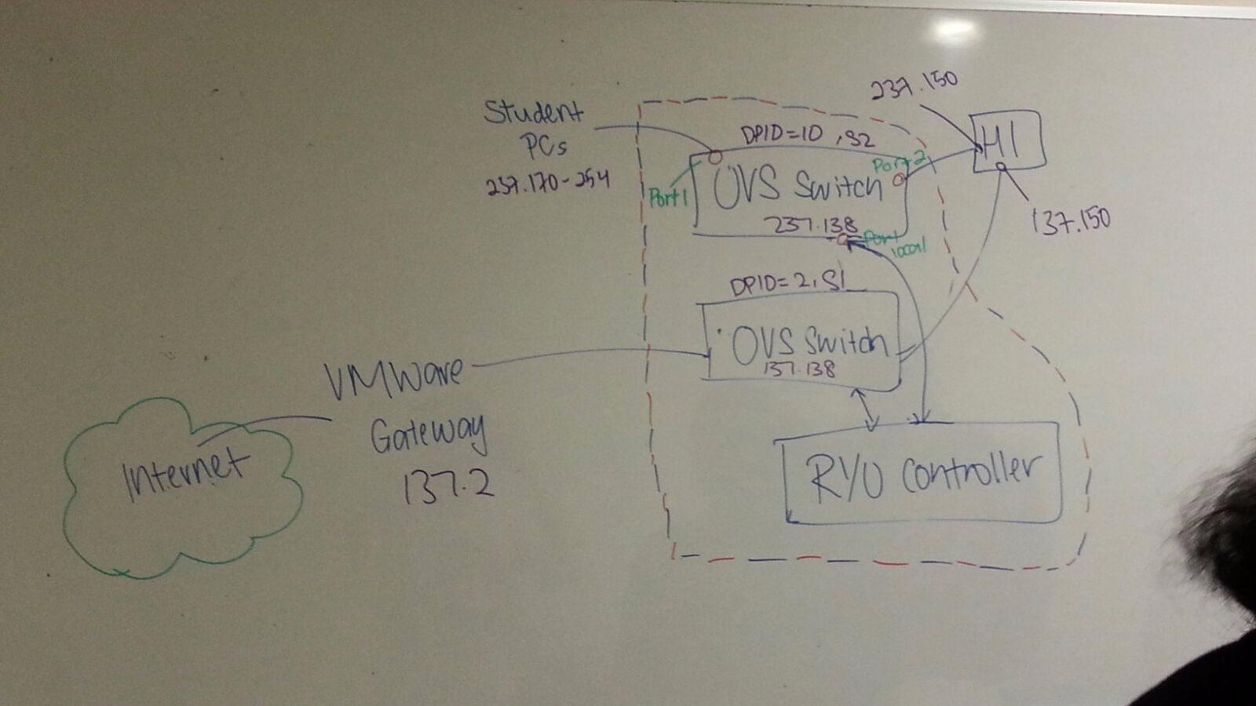

|  |  |
| --- | --- |
| **#OM009** | |
| **Vetted by:** | Lim Xin Li |
| **Signed by:** | Lim Xin Li, Assistant Leader |
| **Minuted by:** | Bavani D/o Raman |
| **Date:** | 6th July 2017 (Week 12 ) |
| **Time:** | 10:30am - 12:20pm |
| **Duration:** | 1hr 50mins |
| **Venue:** | Hilltop Meeting Room 2 |
| **Present:** | Mr Karl Kwan  Radin Ayuwandira Binte Radin Amirmuninin  Lim Xin Li  Bavani D/o Raman  T.Puvarneswaren Raja |
| **Absentee(s):** | - |

**Agenda:**

* ELP Briefing
* Report Details
* Confirmation of previous minutes meeting #008

|  |  |  |  |
| --- | --- | --- | --- |
| **1.** | **CONFIRMATION OF PREVIOUS MINUTES** Minutes 005:   1. Policing Program → Status Page    1. Server Side runs on Python program while Status page runs on JSP    2. Student info table will refresh very often (10 seconds)    3. Watch out for:       1. Port number:          * can change when the client closes the connection and open again to send a heartbeat       2. IP address:          * may or may not change if the connection is lost and reconnect. TCP/IP will try to keep it to same IP.    4. The trigger alert will make the web page red    5. The web page will auto refresh (30 seconds) using javascript but the ssid and password will remain the same    6. Policing is part of the website    7. The color red or green depends on the timestamp       1. If less than 10 sec it will stay green and more that 10 sec it it will be red    8. Lecturers can click on a student and it opens another window with more details about the student status 2. Heartbeat Client Program (java)    1. Send heartbeat every 8 secs       1. Report OK       2. Report CHEATING    2. Take screenshot       1. When disconnected (every 3 secs)       2. On demand (from server every 3 secs)          * Once server say enough of screenshot, stop screenshot       3. On cheating    3. Upload screenshot + keylogger       1. On demand    4. Check connection       1. To non-whitelist side       2. To cross with clients (if can ping to the client means can cross talk)    5. Keylogger (same as part (b)) 3. Complete the design and implementation of the web application    1. Status Page       1. Retrieve all records from Student_info       2. Refresh every 30 seconds       3. Conditional trigger alert          * When timestamp expire (compare with current time) | **Action By**  Radin, Bavani  Noted by everyone  Radin, Bavani  Xin Li | **Due Date**  Week 13  12th July  Week 14 |
| **2.** | **DISCUSSION**  1. Policing Program    1. Client send “Hello” server send back “hello” to keep track till server demand for screenshot       1. Request → ack → request → ack 2. Puva will be doing the Router and FYP notebook configuration till then Xin Li will be doing Student and Lecturer website 3. Admin number is not the unique ID 4. If got “cheating” server side must check the database to find the details and auto start screen capture. And if the student not cheating lecturer can demand to stop screen capture. 5. Open one new task to keep track of the progress of functional/feature list of the web application and update the team and to Supervisor (Mr Karl Kwan). | Noted by Everyone  Noted by Everyone |  |
| **3.** | **ISSUES ENCOUNTERED** FYP Notebook configuration - Errno 98 | Puva | 7th July |
| **4.** | **FEEDBACKS** If we are not confident in completing the FYP in time, remove some features. | Noted by Everyone |  |
| **5.** | **ASSIGNMENT OF DUTIES** **Tasks to do:**   * Use JAVA) Client heartbeat program * Server policing program - Python (insert/update database) * Status page policing program - JSP (retrieve from database and monitoring status) * Website * Screen Capture when demand * Configure FYP Notebook * Maintain, update, and monitor the functional/feature list of the web application (checklist) * Come out with new architecture (diagram) | Radin, Bavani  Radin, Bavani  Xin Li  Xin Li  Bavani, Radin  Puva  Bavani  Bavani | 10th July  14th July  12th July  19th July  12th July  9th July  Week 14  Week 15 |
| **6.** | **ADDITIONAL NOTES** Karl Kwan gave us an ELP briefing.  Report Details will have to look out at Blackboards  Karl Kwan went through the system architecture.  Configuration of the new router (ASUS RT-AC55UHP) | Noted by Everyone  Puva | Done |
| **7.** | **ANY OTHER BUSINESS (AOB)** Uploaded Architecture   * Look at the architecture and come out with a new diagram using that as sample. * Client Agent   + Register to network   + Report   + Detect   + Logging of client activities   What we want to achieve:   * Secure network traffic * Provide monitoring of target client   Report   * Write down finding from the current project on the Final Report * Security (Good / Limited / Bad)   + Limited: Detect cheating but cannot stop * Compare to LANschool (or existing commercial solution) * Our Solution:   + May have dashboard view advantage   + Customizable   + Potential on - Network logging, adaptive control, etc   Create video and poster to explain the Project  Week 13: Home Based Learning   * IT showcasing Briefing (Look out in Blackboard) * Official Meeting   + Hangout Meeting * Learn how to use | Noted by Everyone  Noted by everyone  Noted By everyone |  |
| **8.** | Next official meeting will be on Thursday, 10:30am (Hangout) |  |  |

|  |  |
| --- | --- |
| **#OM010** | |
| **Vetted by:** | Lim Xin Li |
| **Signed by:** | Lim Xin Li, Assistant Leader |
| **Minuted by:** | T.Puvarneswaren Raja |
| **Date:** | 13th July 2017 (Week 13 - HBL) |
| **Time:** | 10:30am - 11:50am |
| **Duration:** | 1hr 20mins |
| **Venue:** | Hilltop Breakout Space |
| **Present:** | Mr Karl Kwan (**Virtually Present**)  Radin Ayuwandira Binte Radin Amirmuninin  Lim Xin Li  Bavani D/o Raman  T.Puvarneswaren Raja |
| **Absentee(s):** | - |

**Agenda:**

* Update on Progress
* Confirmation of previous minutes meeting #009
* Report and poster briefing

|  |  |  |  |
| --- | --- | --- | --- |
| **1.** | **CONFIRMATION OF PREVIOUS MINUTES**  * Server policing program - Python (insert/update database) * Website * Screen Capture when demand * Maintain, update, and monitor the functional/feature list of the web application (checklist) * Come out with new architecture (diagram) | **Action By**  Radin, Bavani  Xin Li  Bavani, Radin  Bavani  Bavani | **Due Date**  17th July  19th July  17th July  17th July  Week 15 |
| **2.** | **DISCUSSION**  * Explanation should not be done on the poster (cannot be too wordy) * Body is the main context of the project * Separate Result and Conclusion   + Conclusion of the project (Successfully done?)   + Result is to describe what is working * Program listing is the source codes   + Source codes are not included in the report   + Index the program file names, like a preview (ex. refer to DVD archive) * User guide can be lecturer guide * During the IT showcase, play the video non-stop   + Video needs to capture attention, self explain and retain the audience * In the conclusion of the report, include what are the potential usages other than what we planned   + Ex. Network traffic analysing * Poster in report in jpg format * Poster for submission in photoshop format | Noted by everyone |  |
| **3.** | **ISSUES ENCOUNTERED** |  |  |
| **4.** | **FEEDBACKS** **Database**   * Add event log table in database for logging purposes   + Every time client update status change, need to log it   + When server side send and when java client send     - Time     - From whom     - What is it   + Log is for investigating after the exam is over   **Website: Screen Monitoring Page**   * People will ask about paging since there is no limit.   + Suggestion: Put limit size so that you can tell that the system is only for small size examination * Need text label under image on the monitor screen without the mouse hovering * Use the last number of the ip address as the client number (no need to be in proper order, just need to be unique.)   **Architecture Diagram**   * When explaining different portions of the system, need to zoom in the architecture (have different diagrams) * Use the diagram as part of the poster   **Client Program**   * When java program started, it will create a temp folder and all file created will be inside. Just have to provide file path information * Have another folder named keylog, another program will create it * Lecturer can stop screen capture for cheating and disconnected after they are checked by the lecturer   **FYP notebook configuration**   * Don’t change interface name of Ubuntu image   **Questions**  When just on will there be any screen?   * Xin Li: No, the screen monitoring page will be empty till students join.   Why are there so many information displayed?   * Xin Li: When the lecturer sign up, the website will be empty * Xin Li: Lecturer needs to add the information in order to start the assessment   Who is going to clean the database after the examination?   * No answer   Which have not been completed?   * Xin Li: Lecturer can add whitelist domains   Can lecturer delete disconnected client?   * Xin Li: Yes   Is a screenshot and keylog folder created when started?   * Radin: Yes   Radin: How to hide the folder for screenshot and keylogger since it is created on the desktop of the students’ laptop if they were to keep the client program in their desktop?   * Karl Kwan: No choice, it is seen by them. If the student tamper with the folder, you will know that he/she may have cheated | Noted by everyone  Questions asked by Karl Kwan |  |
| **5.** | **ASSIGNMENT OF DUTIES** **Tasks to do:**   * Use JAVA) Client heartbeat program   + Keylogger * Server policing program - Python (insert/update database) * Website   + Display last number of ip address on the computer   + [Additional] Allow lecturer to input time limit to refresh the page * Screen Capture when demand * Maintain, update, and monitor the functional/feature list of the web application (checklist) * Come out with many architecture diagram   + Zoom in for different portion of the system for presentation * Configure and install a new image from scratch | Radin, Bavani  Radin, Bavani  Xin Li  Bavani, Radin  Bavani  Bavani  Puva | 16th July  17th July  19th July  17th July  17th July  Week 15  17th July |
| **6.** | **ADDITIONAL NOTES**  * Demo will be done on 17th July between 1-3pm * Demo to be done in the FYP notebook | Noted by everyone |  |
| **7.** | **ANY OTHER BUSINESS (AOB)** |  |  |
| **8.** | Next official meeting will be on Thursday, 10:30am |  |  |

|  |  |
| --- | --- |
| **#OM011** | |
| **Vetted by:** | Lim Xin Li |
| **Signed by:** | Lim Xin Li, Assistant Leader |
| **Minuted by:** | Bavani D/o Raman |
| **Date:** | 20th July 2017 (Week 14) |
| **Time:** | 09:35am - 11:50am |
| **Duration:** | 2hr 15mins |
| **Venue:** | Hilltop Meeting Room 1 |
| **Present:** | Mr Karl Kwan  Radin Ayuwandira Binte Radin Amirmuninin  Lim Xin Li  Bavani D/o Raman  T.Puvarneswaren Raja |
| **Absentee(s):** | - |

**Agenda:**

* Update/Demo on Progress
* Confirmation of previous minutes meeting #010

|  |  |  |  |
| --- | --- | --- | --- |
| **1.** | **CONFIRMATION OF PREVIOUS MINUTES**  * Server policing program - Python (insert/update database) * Website * Screen Capture when demand * Maintain, update, and monitor the functional/feature list of the web application (checklist) * Come out with new architecture (diagram) | **Action By**  Radin, Bavani  Xin Li  Bavani, Radin  Bavani  Bavani | **Due Date**  17th July  19th July  17th July  17th July  Week 15 |
| **2.** | **DISCUSSION**  * Make sure in Source code have comments   + Understand what is happening * Future plans can be included in the report under conclusion * If you have event log table in can be useful   + Put this as last criteria | Noted by Everyone |  |
| **3.** | **ISSUES ENCOUNTERED**  * Screen capture didn’t work when the server showed ‘Cheating’ * Tomcat cannot restart * Ubuntu image version 17 still gives error no 98   + Will try out version 16.04 | Noted by Everyone |  |
| **4.** | **FEEDBACKS** **Web Application**   * Feature to allow lecturer to clear the table * Feature to wipe all the database tables * Ensure student run the CSI executable jar file first before logging in the website | Noted by Everyone |  |
| **5.** | **ASSIGNMENT OF DUTIES** **Tasks to do:**   * Website   + Display last number of ip address on the computer   + [Additional] Allow lecturer to input time limit to refresh the page * Server policing program - Python (insert/update database) * Come out with many architecture diagram   + Zoom in for different portion of the system for presentation * FYP Poster   + Actual due date is 1st August 2017 * FYP Report   + Actual due date 4th August 2017 * FYP Video | Xin Li  Radin  Bavani  Everyone  Bavani  Everyone | 23rd July    24nd July  Week 15  27th July  27th July  10th August |
| **6.** | **ADDITIONAL NOTES**  * Finish all source codes by Monday   **Questions:**  When to delete the database?   * Before the next assignment, use the delete command | Noted by Everyone  Questions asked by Karl Kwan | 24th July |
| **7.** | **ANY OTHER BUSINESS (AOB)**  * Resolving notebook problem   + Radin use FYP notebook   + Puva use his own notebook * Meet Mr Kwan on Monday, 24th July 2017, 1pm-3pm   + Try book Meeting Room 1 or Meeting Room 2 (Hilltop) | Noted by Everyone |  |
| **8.** | No Next official meeting |  |  |

**11.8.2 General Minutes Meetings**

**Date** : 18 Apr 2017 (Tuesday)

**Time** : 8.30 am – 12:00 pm

**Venue** : Meeting Room (Hilltop Library)

**Reference No.** : #GM001

**Present** : Team Leader RADIN AYUWANIDRA BINTE RADIN AMIRMUMININ

Assistant Leader LIM XIN LI

Members BAVANI D/O RAMAN

T.PUVARNESWAREN RAJA

**Absent with apologies** :

**Minuted by** : LIM XIN LI

**Vetted by** : RADIN AYUWANIDRA BINTE RADIN AMIRMUMININ

**Signed by** : Date: 18 April 2017

RADIN AYUWANIDRA BINTE RADIN AMIRMUMININ, Team Leader

Cc : Mr. Karl Kwan, Project Supervisor

Mr. Karl Kwan, Sponsor

|  |  |  |
| --- | --- | --- |
|  |  | **Action** |
| **1.** | **REVIEW OF PREVIOUS MINUTES** |  |
| **2.** | **ISSUES ENCOUNTERED**  1. Miscellaneous questions on both administrative and project aspect. | Xin Li |
| **3.** | **ASSIGNMENT OF DUTIES** **Radin**  **Tasks done:**   * Ran through administrative things   + Went through the Project Handbook   + Define roles and responsibilities   + Delegate tasks to each member * Re-ensure our understanding of our project   + Understanding the components involved   **Tasks to do:**   * Solving errors in task 1   + work with Puva to solve code errors * Research on possible solutions * Research on existing solutions   **Xin Li**  **Tasks done:**   * Finished task 2   + shared source codes with team   **Tasks to do:**   * Research on ways to cheat * Research on problems that led to this project * Significance of this project * Objectives of this project (aim to achieve)   **Bavani**  **Tasks done:**   * Finished task 2   **Tasks to do:**   * Research on the background * Research on possible solutions * Research on existing solutions * Objectives of this project (aim to achieve)   **Puva**  **Tasks to do:**   * Solving errors in task 1   + work with Puva to solve code errors * Research on ways to cheat * Research on problems that led to this project * Significance of this project * Objectives of this project (aim to achieve) |  |
| **4.** | **ADDITIONAL NOTES** Do up the installation setup steps |  |
| **5** | **ANY OTHER BUSINESS (AOB)** Questions:   1. What is the reference no. in the minutes of meeting? 2. How will the students get the executable file? (is it from the website after logging in?) 3. Is there a better way such that the students do not need to download and run the executable file themselves? (like logging in the website and have it automatically downloaded and ran in the background?) 4. Does the project have to be able to work in all platforms? 5. How can we prevent using forums to cheat if the lecturer is the one who grants access to the websites? 6. If use screen capture, do we need to save it for future references? | Xin Li |
| **6.** | Next meeting will be on Thursday, 9.00 am. |  |

|  |  |
| --- | --- |
| **#GM002** | |
| **Vetted by:** | Radin Ayuwandira Binte Radin Amirmuninin |
| **Signed by:** | Radin Ayuwandira Binte Radin Amirmuninin, Team Leader |
| **Minuted by:** | Lim Xin Li |
| **Date:** | 22th May 2017 (Week 6) |
| **Time:** | 03:22pm - 05:50pm |
| **Duration:** | 1hr |
| **Venue:** | Server Room (Between (T2033 & T2034) |
| **Present:** | Radin Ayuwandira Binte Radin Amirmuninin  Lim Xin Li  Bavani D/o Raman  T.Puvarneswaren Raja |
| **Absentee(s):** | - |
| **Left Early** | Bavani D/o Raman (17: 30) |

**Agenda:**

* FYP Report Plan Layout
* Website Functional List Review
* Database Design Overview
* Screen Capture & Keylogging - research
* Review Product Backlog
* Installation of Software on FYP Notebook
* Confirmation of Previous Minutes #001

|  |  |  |  |
| --- | --- | --- | --- |
| **1.** | **CONFIRMATION OF PREVIOUS MINUTES**  1. All done, no outstanding | **Action By** | **Due Date** |
| **2.** | **DISCUSSION**  1. Announcement display can be either a pop up format or a notification format 2. ~~Padlock appear when a student submission link got locked (due to attempt unique code for more than 3 times)~~ → Decided to change to 1 try 3. Could save as draft if student wants to submit early in case he/she could not send in on time. 4. Puva suggest that the students cannot submit past the last 10 mins mark. 5. Puva suggested if network went down, there could a backup cloud for the students to store or submit their answers. 6. Backup cloud should be secured. 7. If the students finish up last minute, saving as a draft will not be helpful. 8. After submission & logout it will be grey 9. After the student submitted and disconnected from the network, the student cannot connect to the network again. | Everyone |  |
| **3.** | **ISSUES ENCOUNTERED** |  |  |
| **4.** | **FEEDBACKS** **Report:**   1. Use page break instead of enter 2. Puva suggested to write “Develop a secured environment for online assessment” for our project purpose 3. Xin Li suggested the title of solution to be changed to Our Solution 4. Radin suggested said that Our Solution is Secured-T and not Software Defined Network 5. Xin Li suggested that Appendix A: Website to be changed to Website Features 6. Radin suggested to change the Appendix A: Website Features to Web Application Features 7. Xin Li suggested that the Chapters to be changed to Serial Number 8. Radin suggested that there should be indentation in the content page 9. Bavani and Xinli suggested that it should remain like the original content page 10. Radin suggested to bold the main sections 11. Radin suggested that she would like to have the contents of solution in the content page as well 12. Radin suggested that there should be more content in risk analysis 13. Website images and database images should be separated and change from website to web application 14. Puva suggested in depth details for lecturer’s and student’s point of view 15. Bavani suggested do an interview for the both students & lecturer point of views 16. Risk analysis introduction and existing solutions to be improved 17. Put finalized router research link, project research links, notes compilation links under references 18. Finish source codes by week 13 and use remaining time to do trial and error 19. Scrum role list should be added to the report 20. Need to differentiate website features and functions   **Web Function & Features List**   1. Change monitor heartbeat to monitor students remotely and put the futures as sub points and explain it in it’s subpoint 2. Puva suggested to change of color monitor when student submit | Everyone  Everyone |  |
| **5.** | **ASSIGNMENT OF DUTIES** **Tasks to do:**   * Gantt chart * Burndown chart * Source codes * Readme document * Meeting Minutes * Insert announcement table in mysql   + ID   + Module code   + Module name   + Lecturer’s name   + Timestamp   + Announcement | Radin  Everybody  Everybody  Xin Li  Bavani  Radin & Xin Li | Week 14  Week 14  Week 13  Week 13  Ongoing  Week 6 |
| **6.** | **ADDITIONAL NOTES** |  |  |
| **7.** | **ANY OTHER BUSINESS (AOB)**  * Ask KK if need to include Work Time Availability (WTA) chart in the report * Review Product Backlog * Relook at database design | Xin Li  Radin  Everyone | 25th May  Next meeting  26th May |

**12 Programs Listing**

**Web Application:**

StudentSecT.war

SecT.war

**Ryu Controller:**

sim_switch.py

sim_switch_rest.py

my_switch.py

my_db.py

**OpenFlow Virtual Switch (OVS):**

miniedit.py

sectestTopo.py

**Domain Name Server (DNS):**

dnsProxy.py

**Central Intelligence (CI):**

CI.py

**Controlled System Intelligence (CSI):**

CSI.jar

**Other**

routeadd.bat

startAll.sh

**13 Guides**

**13.1 Installation Guide**



**SECURED-T**

**Installation Guide**

**Version 2.0**

**[03 August 2017]**

**Contents**

**LIST OF ILLUSTRATIONS G3**

**Overview of Secured-T G6**

**Pre-requisites G6**

**Setting up VMware Workstation & Virtual Machine G6**

**Install The Prerequisites Of Secured-T G12**

**Mininet guide G15**

**Create the Mininet topology with Miniedit G15**

**Editing the Mininet Topology file for Secured-T System G17**

**RYU Controller Guide G21**

**Download The Required Ryu Controller Scripts G21**

**DNS Proxy Guide G22**

**Creating and Configuring the DNS Proxy G22**

**Tomcat Installation and Configuration G23**

**Prepare a tomcat management account G24**

**Setting Up mod_JK G24**

**MySQL Workbench Installation guide G25**

**Adding Connection On MySQL Workbench G25**

**Create Database Tables G28**

**Deployment guide G29**

**Create a shell script G29**

**Deploying websites G30**

#### **LIST OF ILLUSTRATIONS**

**Figures**

Figure 1: Ubuntu ISO 16.04.2 LTS Download Page

Figure 2: Create A New Virtual Machine

Figure 3: Type Of Configuration

Figure 4: Install From Location

Figure 5: Specify Disk Capacity

Figure 6: Ready To Create Virtual Machine

Figure 7: Add A New Network Adaptor

Figure 8: Add A Custom Network (VMnet0)

Figure 9: Edit Settings For NAT

Figure 10: Check Network Adaptor Configuration

Figure 11: Compare MAC Address to Device

Figure 12: Set IP Address Of Bridged Mode

Figure 13: Take Snapshot

Figure 14: Extract Mininet Archive

Figure 15: Edit Interfaces In ISC-DHCP-Server (Before)

Figure 16: Edit Interfaces In ISC-DHCP-Server (After)

Figure 17: Comment Lines In DHCPD Configuration (Before)

Figure 18: Comment Lines In DHCPD Configuration (After)

Figure 19: Uncomment A Line In DHCPD Configuration (Before)

Figure 20: Uncomment A Line In DHCPD Configuration (After)

Figure 21: Add Lines In DHCPD Configuration

Figure 22: Checking IP Address And Subnet Of NAT And Bridged

Figure 23: Topology

Figure 24: MiniEdit Properties

Figure 25: Add External Interface Eth0

Figure 26: Import OVSSwitch (Before)

Figure 27: Import OVSSwitch (After)

Figure 28: Define Switch (Before)

Figure 29: Define Switch (After)

Figure 30: Change To Ryu Controller (Before)

Figure 31: Change To Ryu Controller (After)

Figure 32: Edit The Switches (Before)

Figure 33: Edit The Switches (After)

Figure 34: Edit The Host (Before)

Figure 35: Edit The Host (After)

Figure 36: Edit The Controllers (Before)

Figure 37: Edit The Controllers (After)

Figure 38: Configure Switches and Hosts (Before)

Figure 39: Configure Switches and Hosts (After)

Figure 40: Closed Mininet Settings (Before)

Figure 41: Closed Mininet Settings (After)

Figure 42: Disable DNS Cache (Before)

Figure 43: Disable DNS Cache (After)

Figure 44: Edit System Name And Path

Figure 45: Change Port Number Of Tomcat

Figure 46: Edit Tomcat Configuration File

Figure 47: Remove Connector

Figure 48: Define A Real Worker With Properties

Figure 49: JkWorkersFile Properties

Figure 50: Configure Apache2 Web Server

Figure 51: Users and Privileges

Figure 52: Database Account Credentials

Figure 53: Grant Rights To Perform All Tasks

Figure 54: Add Database Connection

Figure 55: Add Schema

Figure 56: Create Schema

Figure 57: Set Schema As Default Schema

Figure 58: T_ANNOUNCEMENT

Figure 59: T_ASSESSMENT

Figure 60: T_LECTURER_INFO

Figure 61: T_MODULE

Figure 62: T_STUDENT_INFO

Figure 63: T_WHITELIST_DOMAIN

Figure 64: Script To Run All Four Programs

Figure 65: All Four programs running

Figure 66: Tomcat8 Default Page

Figure 67: Tomcat8 Login

Figure 68: Deploy War File

Figure 69: Webapp Manager

**Tables**

Table 1: Software/Program And The Corresponding Filename

#### 

#### **Overview of Secured-T**

Secured-T provides a secured and controlled test environment which allows the students to use their personal notebook during an assessment to access online resources while preventing them from cheating.

#### **Pre-requisites**

* VMware Workstation
* Mininet
* Python IDLE 2.7
* RYU Controller
* DNS Proxy
* MySQL Workbench
* Apache Tomcat 8
* Apache2 Web Server
* Netbeans IDE 8.2
* Mars Eclipse

#### **Setting up VMware Workstation & Virtual Machine**

1. Download VMware Workstation Pro and install it.

(<http://www.vmware.com/ap/products/workstation/workstation-evaluation.html>)

1. Download Ubuntu ISO 16.04.2 LTS file. This will be used as the Virtual Machine base.

(<https://www.ubuntu.com/download/desktop>)

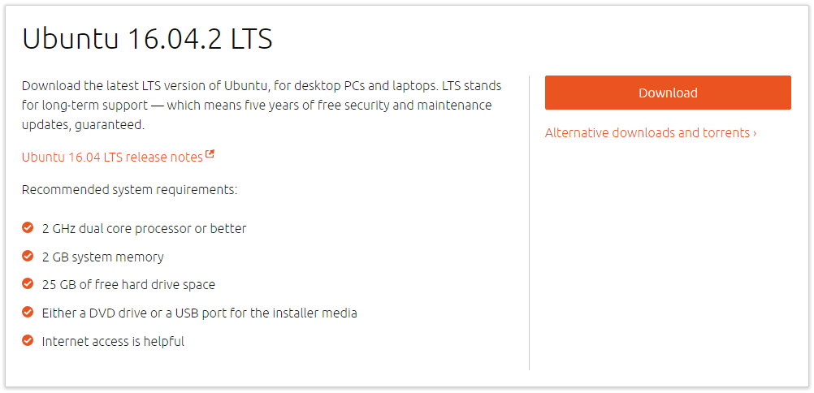

**Figure 1: Ubuntu ISO 16.04.2 LTS Download Page**

1. Launch VMware Workstation after downloading the ISO file.
2. Select “**Create a New Virtual Machine”**

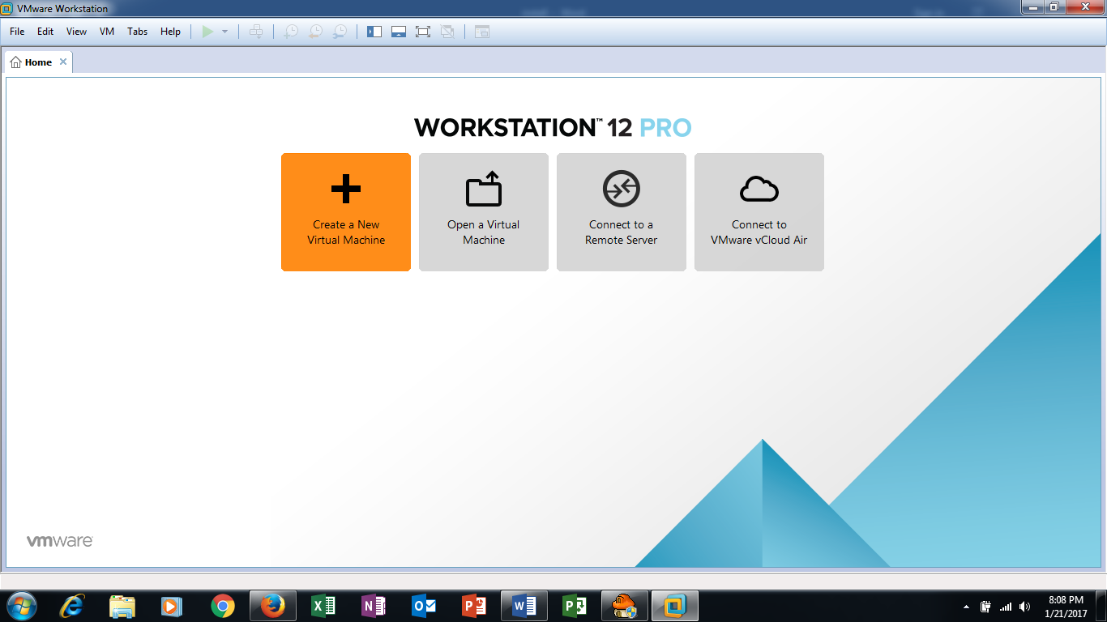

**Figure 2: Create A New Virtual Machine**

1. Select the “**Typical**” Option.

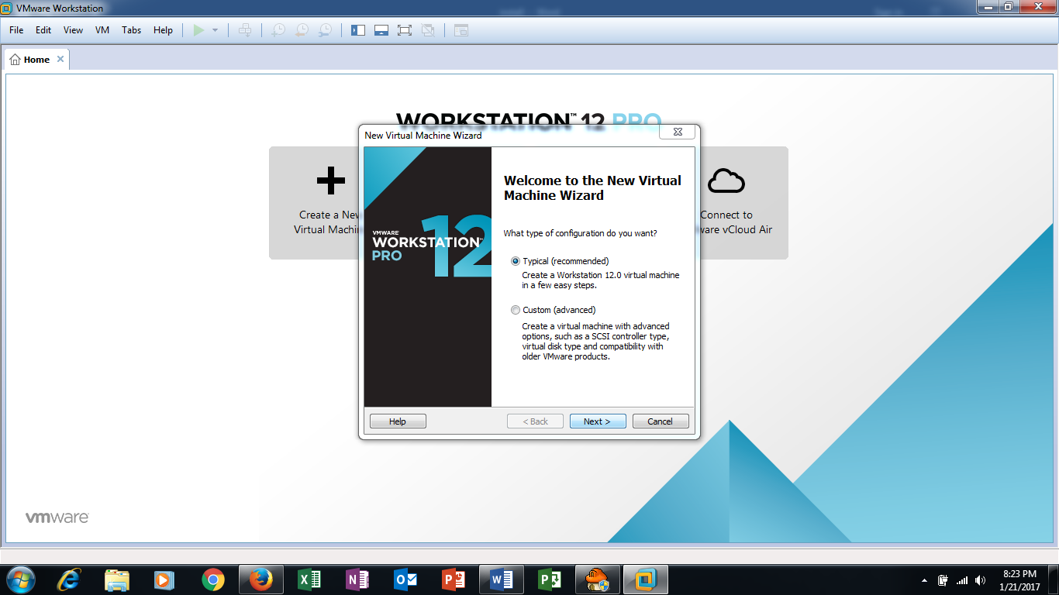

**Figure 3: Type Of Configuration**

1. Select “**Installer disc image file (iso)**” and browse for the Ubuntu ISO file downloaded earlier.

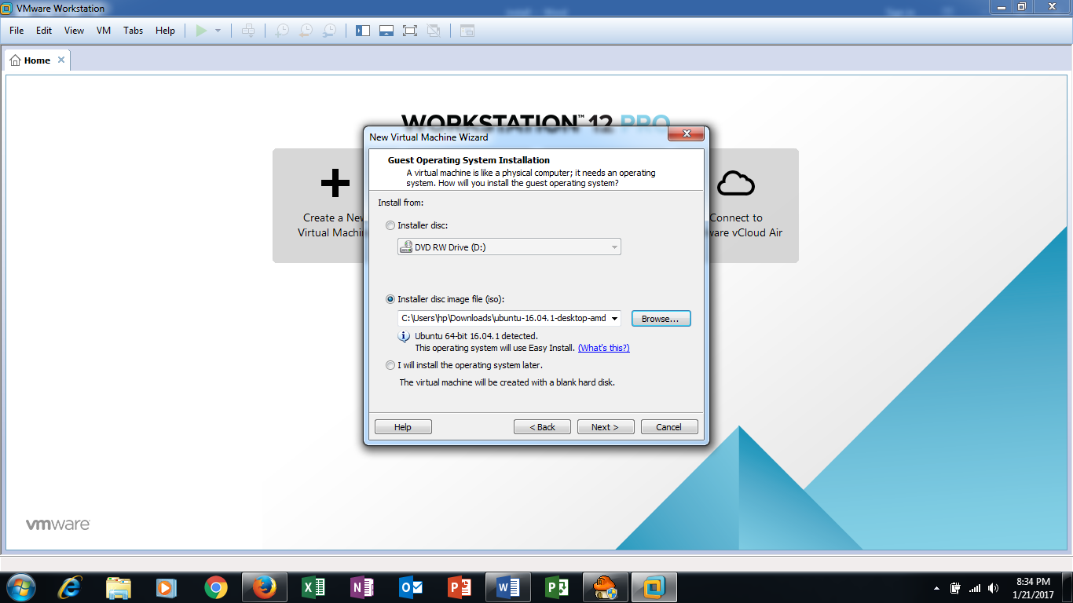

**Figure 4: Install From Location**

1. Give the Virtual Machine a name, username and password. The username and password would be used for your account. Take note that username should only contain lowercase letters (a-z) and/or numbers (0-9).
2. Leave the Virtual machine name and location alone unless otherwise specified.
3. Leave the maximum disc size at **20.0 GB** and let it to **Split virtual disc into multiple files**.

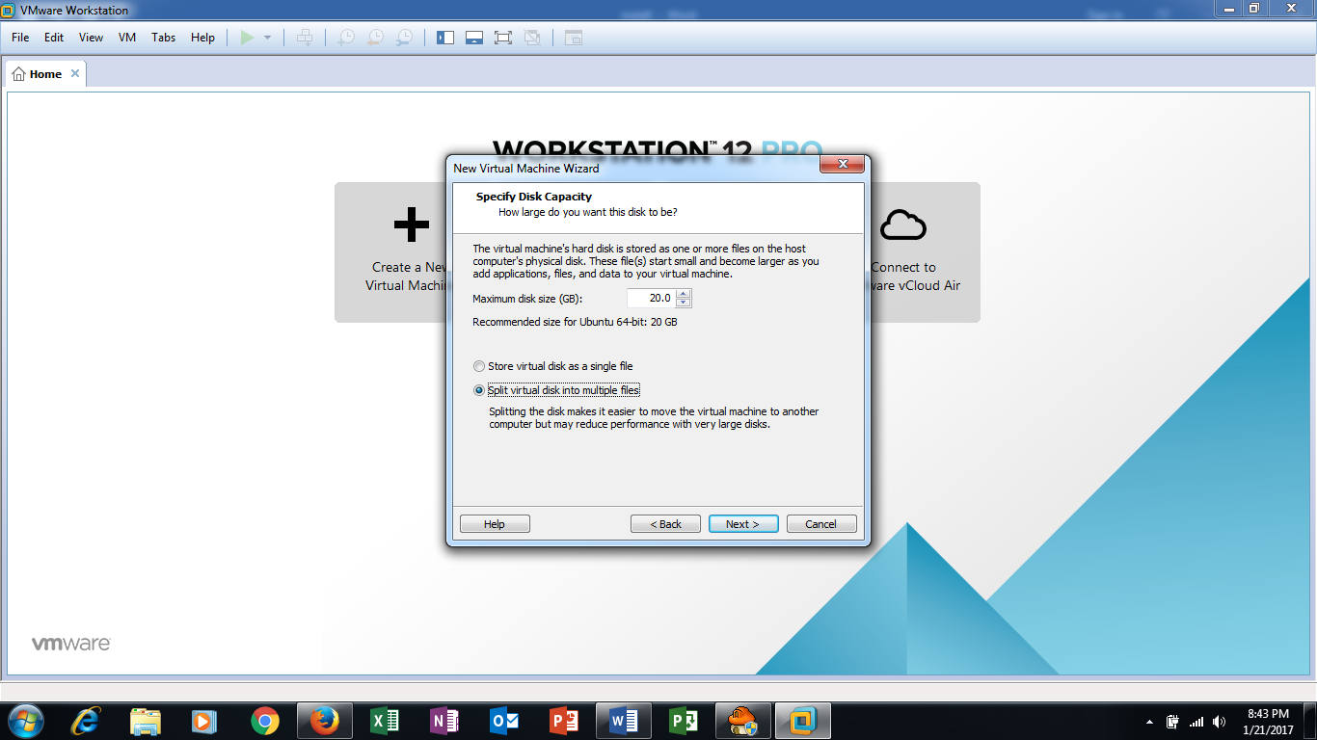

**Figure 5: Specify Disk Capacity**

1. Uncheck “**Power on this virtual machine after creation**” and click **Customize Hardware**.

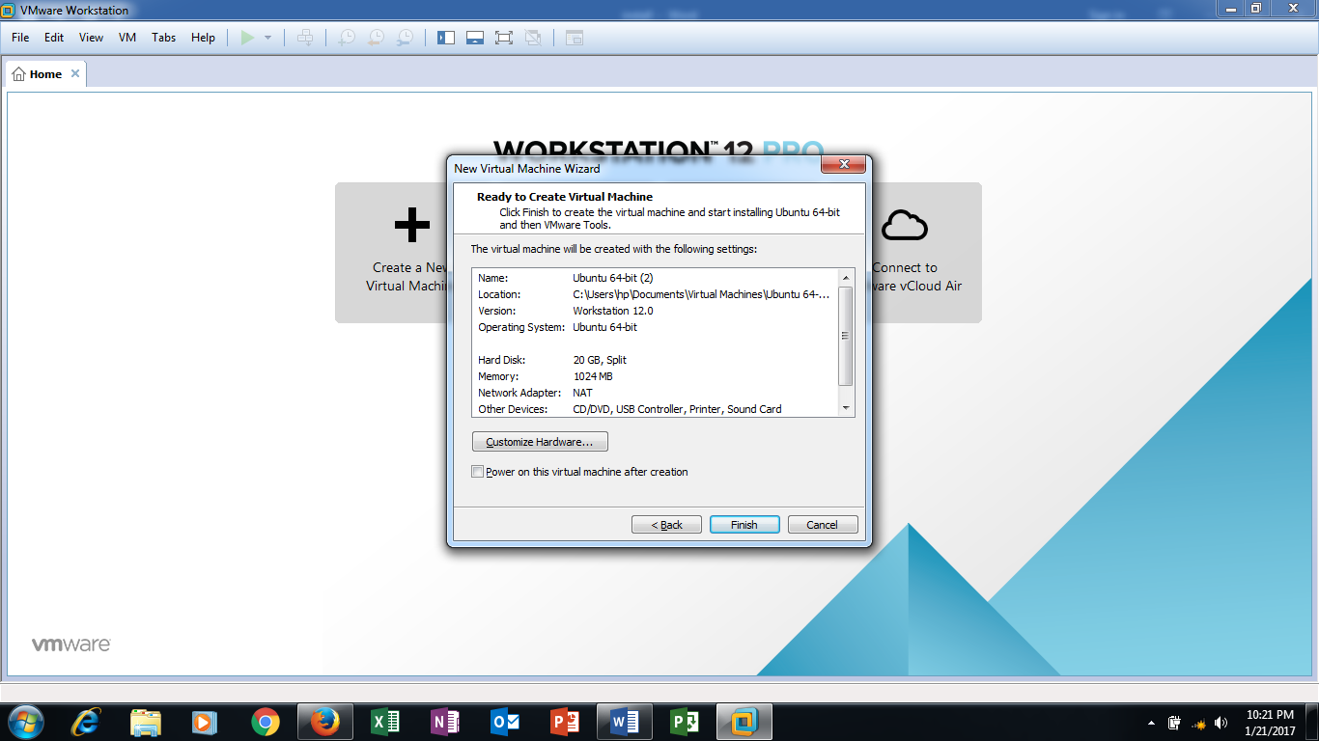

**Figure 6: Ready To Create Virtual Machine**

1. Add a new **Network Adapter** and set the memory to **2GB**. Finish the creating of the Virtual Machine.

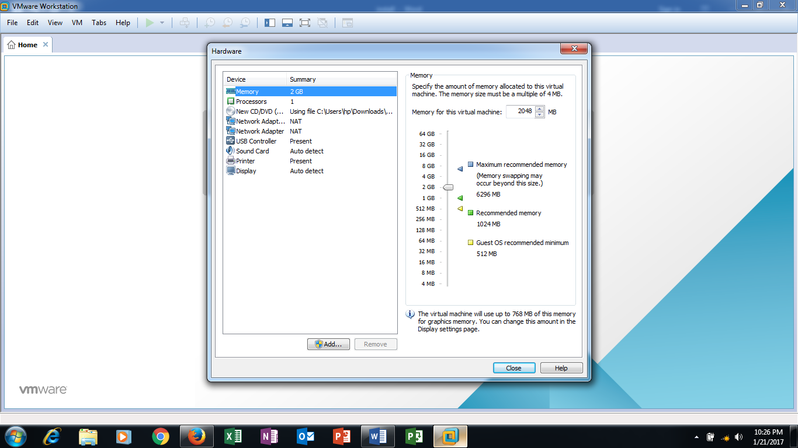

**Figure 7: Add A New Network Adaptor**

1. Change the hardware setting of the Virtual Machine. Set the first Network Adaptor to be **VMnet8** with type set as **NAT** and the second Network Adaptor **VMnet0** to be in **Bridged** for vm bridge mode (recommended) or **Host Only** for windows bridge mode.
   1. Go to **Edit > Virtual Network Editor**.
   2. Add a custom network, **VMnet0**, with type set as **Bridged**. This custom network will be used to connect to the router.
   3. Select your base machine’s ethernet port that is going to be connected to the router in the bridged to drop down box

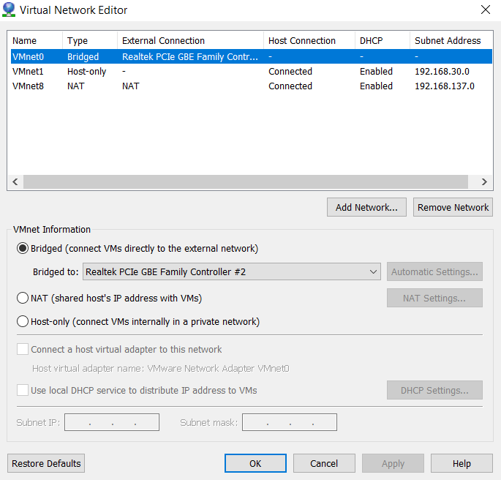

**Figure 8: Add A Custom Network (VMnet0)**

* 1. Edit the settings for NAT like the image below

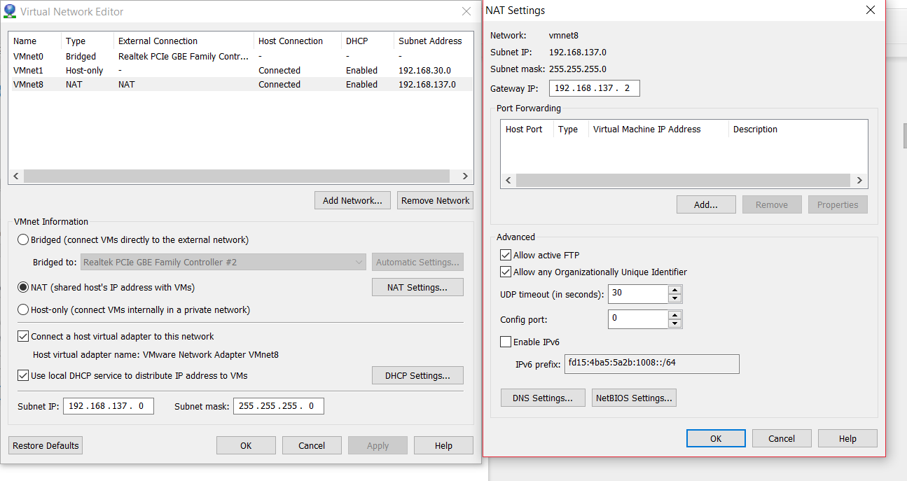

**Figure 9: Edit Settings For NAT**

* 1. The Second Network Adaptor must be set to use a static IP address. To determine which network adapter is configured for NAT and which is for Bridged mode is easy.
  2. Go to **Edit > Virtual Network Editor**.
  3. Under Network Adapter 2, go to Advanced.

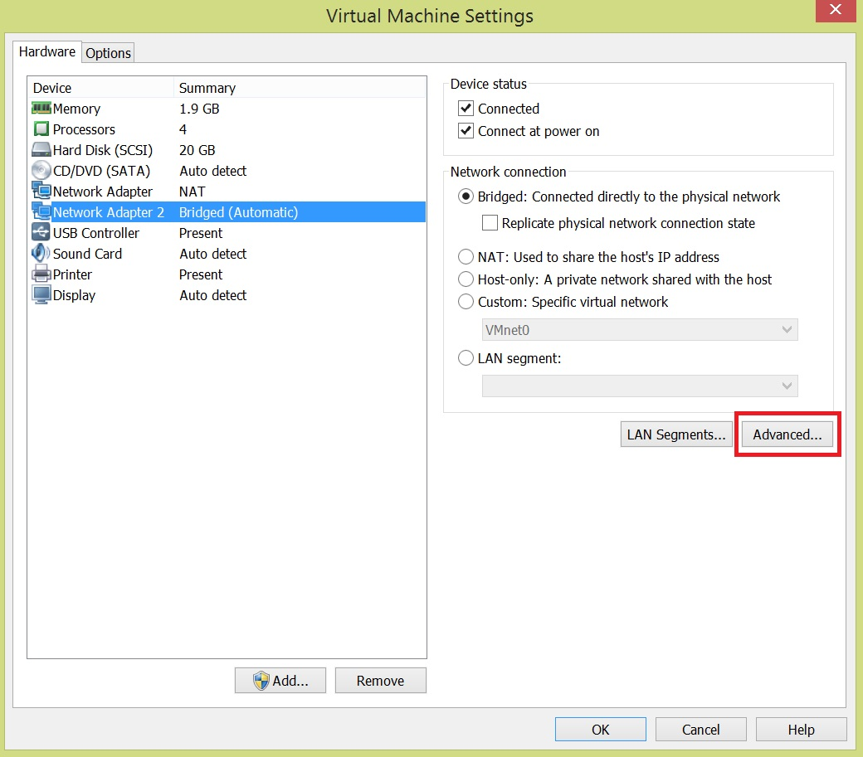

**Figure 10: Check Network Adaptor Configuration**

* 1. Compare the MAC Address in the Network Adaptor Advanced Settings with the wired connection’s device found in system settings menu.

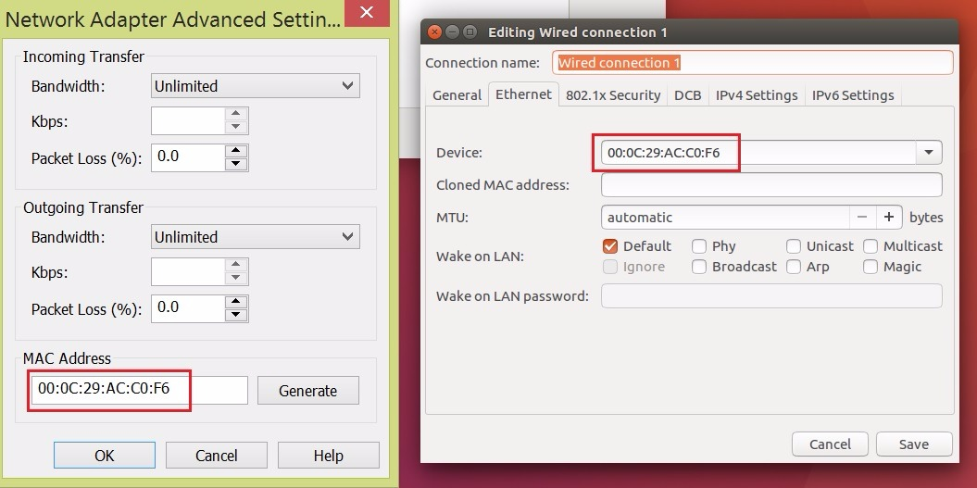

**Figure 11: Compare MAC Address to Device**

* 1. After finding out which wired connection is the Bridged mode, set the IP address of the Bridged mode to: ***192.168.237.138***.
  2. For this interface, you do not need to set the DNS nor the gateway.

.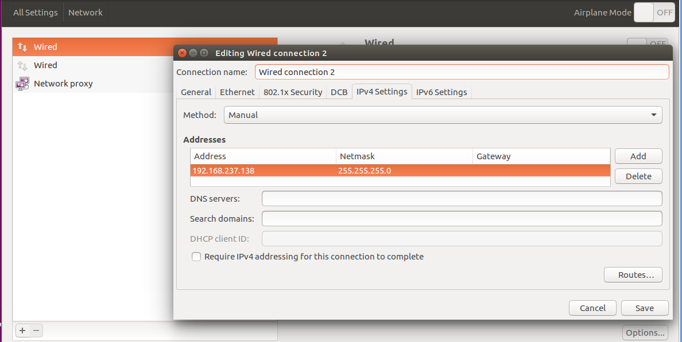

**Figure 12: Set IP Address Of Bridged Mode**

1. Power on the Virtual Machine and let it fully install.
2. Login as the user account you have created at (g) and take a snapshot. A snapshot is used as a backup to fall back on if an irremovable error were to occur.

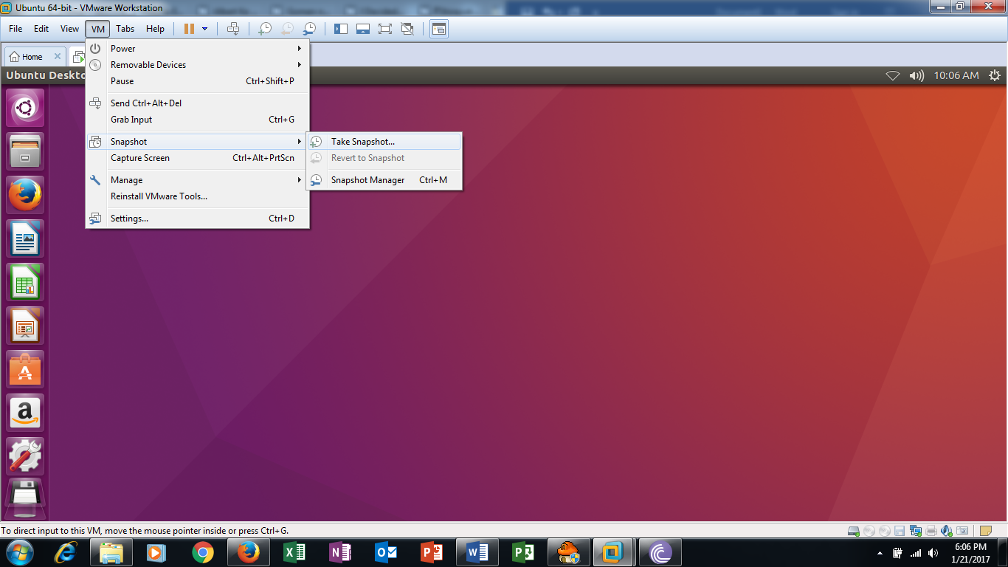

**Figure 13: Take Snapshot**

1. After the snapshot has finished backing up, restart the Virtual Machine.

#### **Install The Prerequisites Of Secured-T**

1. Open a terminal.
2. Make a submission folder for students to be able to upload their assessment to the server.
   1. Command: ***mkdir submission***
3. Install any updates that Ubuntu may had missed out during the installation. Use the following commands one-by-one.
   1. Command: ***sudo apt-get update***

***sudo apt-get upgrade***

***sudo apt-get dist-upgrade***

1. Install pip and git. They are needed to install certain programs easier than apt-get.
   1. Command: ***sudo apt-get install python-pip***

***sudo apt-get install git***

1. Install Mininet. This is used to craft a topology for bridging between the NAT and bridged network.
   1. Command: ***sudo apt-get install mininet***
2. Move an archived file to the home. This archived file is used to easily craft the topology used for the Mininet.
   1. Command: ***cp /usr/share/doc/mininet/examples/miniedit.py.gz ./***
3. Open file explorer and extract the archive in the home tab.

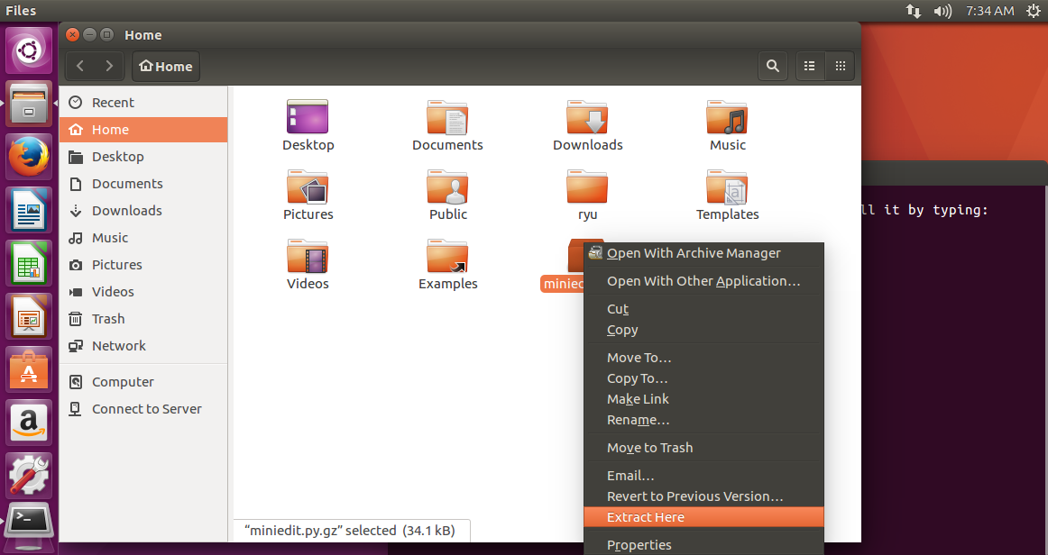

**Figure 14: Extract Mininet Archive**

1. Install python 2.7 IDLE editor.
   1. Command: ***sudo apt-get install idle***
2. Install the Ryu library. The controller for switches runs on Ryu for the setup. Ensure you are in the home directory when running the commands.
   1. Command: ***pip install ryu***

***sudo pip install ryu faucet***

***sudo git clone*** [***https://github.com/osrg/ryu.git***](https://github.com/osrg/ryu.git)

1. Install the dnslib library and dpkt. These are required as we will implement our own DNS server in our system.
   1. Command: ***pip install dnslib***

***pip install dpkt***

1. Install the pymysql library. This is required as it will connect DNS to mysql database.
   1. Command: ***sudo pip install pymysql***
2. Install the following as they are prerequisites for running python programs.
   1. Command: ***sudo apt-get install python-tk***

***sudo pip install datetime***

1. Install the Apache2 web server. This is used to host the default web page.
   1. Command: ***sudo apt-get install apache2***
2. Install the DHCP server. This is used to provide DHCP addresses to student notebooks.
   1. Command: ***sudo apt-get install isc-dhcp-server***
3. Get the interface name of the host-only network with *ifconfig*. For this guide, it is ***eth1\****. Edit the ***isc-dhcp-server*** file in ***/etc/default***.
   1. Command: ***sudo gedit /etc/default/isc-dhcp-server***

**BEFORE**

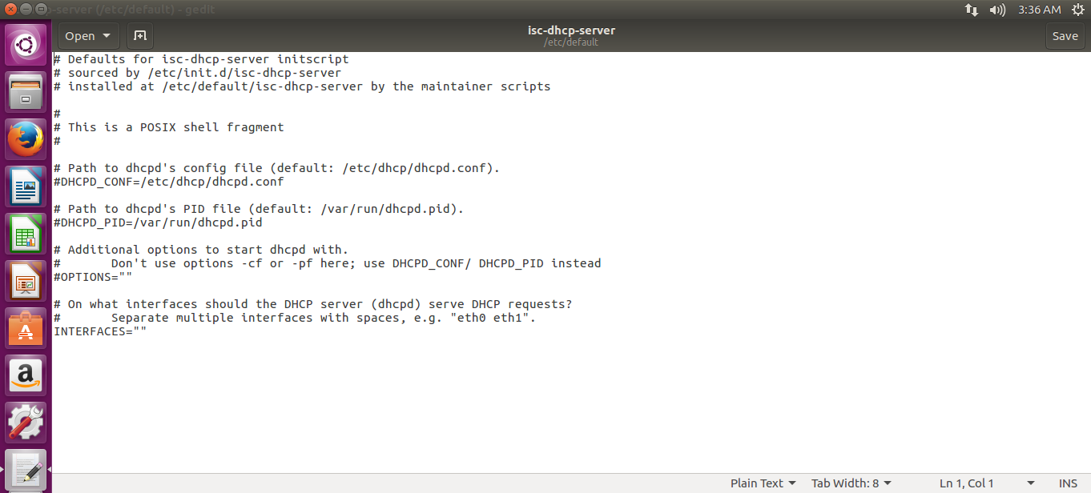

**Figure 15: Edit Interfaces In ISC-DHCP-Server (Before)**

**AFTER**



**Figure 16: Edit Interfaces In ISC-DHCP-Server (After)**

***\*****You need to identify the correct network interface name using ifconfig, it may be ens34.*

1. Edit the ***dhcpd.conf*** in ***/etc/dhcp***. For this guide, assume that the bridged subnet is **192.168.237.0/24**.
   1. Command: ***sudo gedit /etc/dhcp/dhcpd.conf***
   2. Comment out the domain name and domain name server option

**BEFORE**

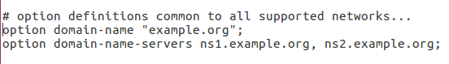

**Figure 17: Comment Lines In DHCPD Configuration (Before)**

**AFTER**

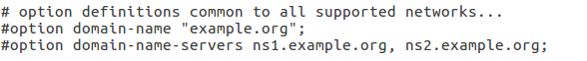

**Figure 18: Comment Lines In DHCPD Configuration (After)**

* 1. Uncomment the last line: authoritative

**BEFORE**

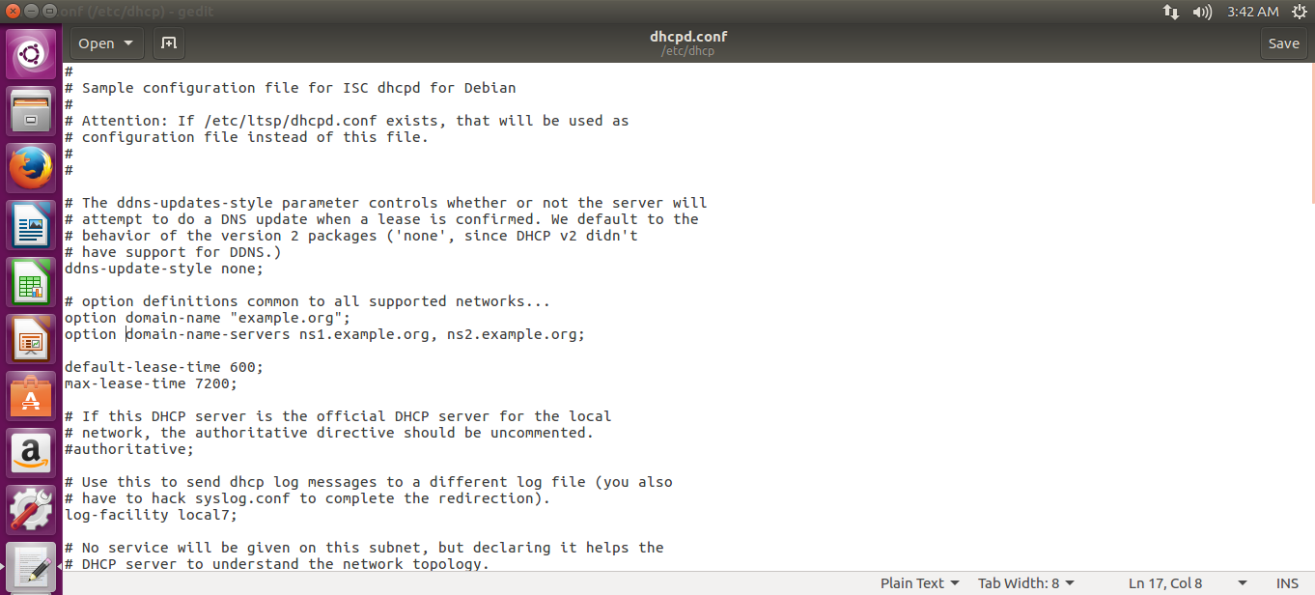

**Figure 19: Uncomment A Line In DHCPD Configuration (Before)**

**AFTER**

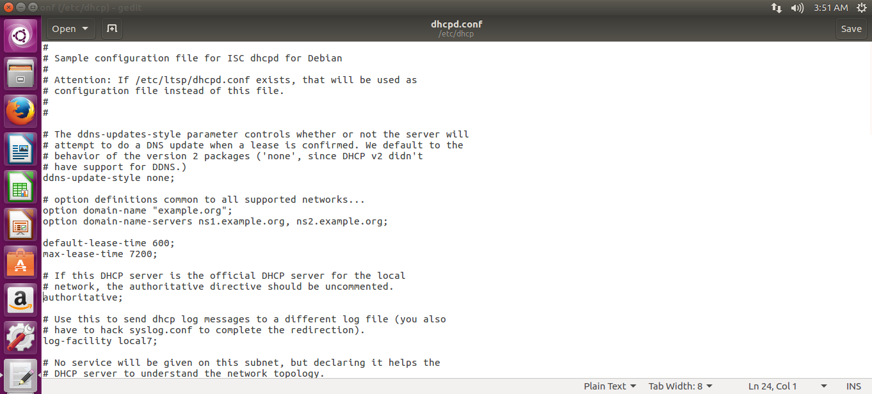

**Figure 20: Uncomment A Line In DHCPD Configuration (After)**

* 1. Add the following lines at the end of the file.

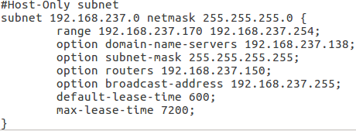

**Figure 21: Add Lines In DHCPD Configuration**

* 1. The subnet of each IP in the file should be changed accordingly, however everything else must be the same.*

*The domain-name-server setting should be the Bridged network, in this case: **192.168.237.138**

1. After configuration is done, start up the DHCP service.
   1. Command: ***sudo service isc-dhcp-server start***
2. Use the following command to check if the isc-dhcp-server is up.
   1. Command:***sudo service –status-all***
3. At this point, you may connect another Virtual Machine in the same notebook (via host-only mode ) or Physical System (via bridge mode) to test your dhcp server. Please note that your gateway – <your subnet>.150 is not set up yet.

#### 

#### **Mininet guide**

Overview:

The purpose of this guide is to guide the user to set up and configure Mininet. Refer to Install The Prerequisites of Secured-T part (e) to install the Mininet before moving on.

#### **Create the Mininet topology with Miniedit**

1. Change the permission of **miniedit.py** so that it could be executed.
   1. Command: ***sudo chmod +x miniedit.py***
2. Find out the network interfaces present. If Setting up VMware Workstation & Virtual Machine is followed, there should be 2 network interfaces (excluding lo).
   1. Command: ***ifconfig***
   2. The following will be shown. Take down the IP addresses and subnets of the interfaces that is NAT and Bridged.
3. In this case: eth0 is NAT while eth1 is Bridged

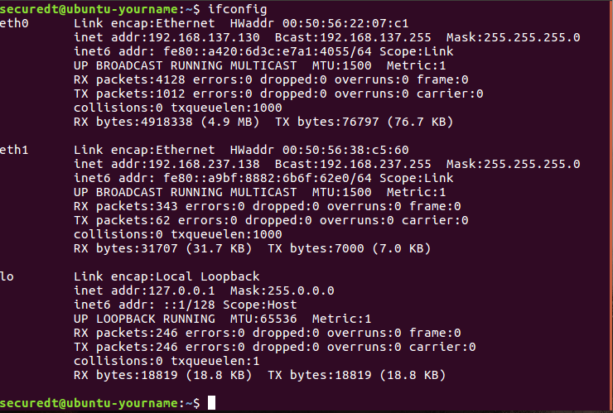

**Figure 22: Checking IP Address And Subnet Of NAT And Bridged**

1. Start miniedit.py and it will open a GUI to create the Mininet topology.
   1. Command: ***./miniedit.py***
2. Use the Miniedit GUI and make the following topology.

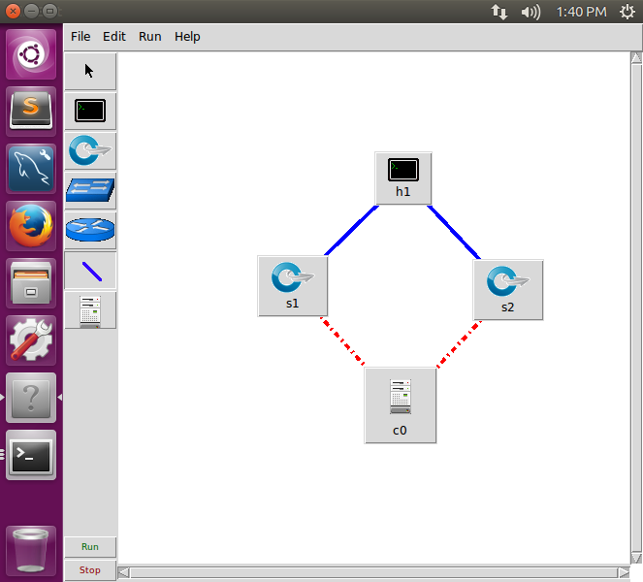

**Figure 23: Topology**

1. This will be the default topology used and will be configured for Secured-T system.
2. Right Click and hold on **s1** and open **Properties.** The following diagram will be shown.

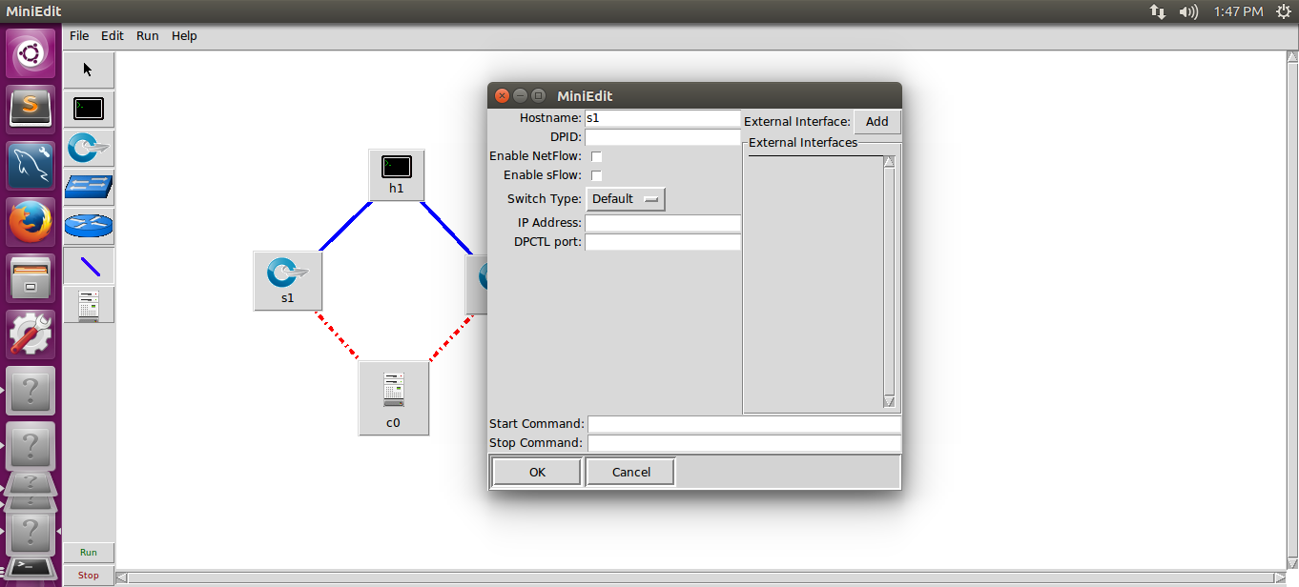

**Figure 24: MiniEdit Properties**

1. Under **DPID**, type in 00000002 and press **Add** beside external interface. Under the new blank, type in **ens33**. This will bind **s1** to the network interface **ens33**, for reasons explained later.

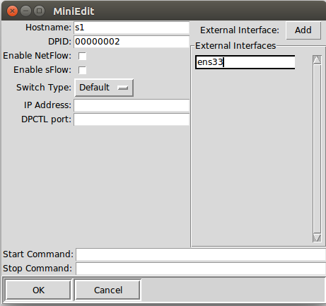

**Figure 25: Add External Interface Eth0**

1. Repeat the steps (g) and (h) for **s2**. However, this time, set the **DPID** as 0000000A and the network interface as **ens34**.
2. Go to **File > Export Level 2 Script**. This will create the basic Mininet topology to configure. Save it under any name you want. For this guide, this file would be referred as **sectestTopo.py**.

#### **Editing the Mininet Topology file for Secured-T System**

1. Change the permission of **sectestTopo.py** to be able to be executed.
   1. Command: ***chmod +x sectestTopo.py***
2. Use an editor to configure the **sectestTopo.py** file.
   1. Command: ***gedit sectestTopo.py***
3. Multiple changes need to be made for the topology to work.
4. Import OVSSwitch from mininet.node

***BEFORE***

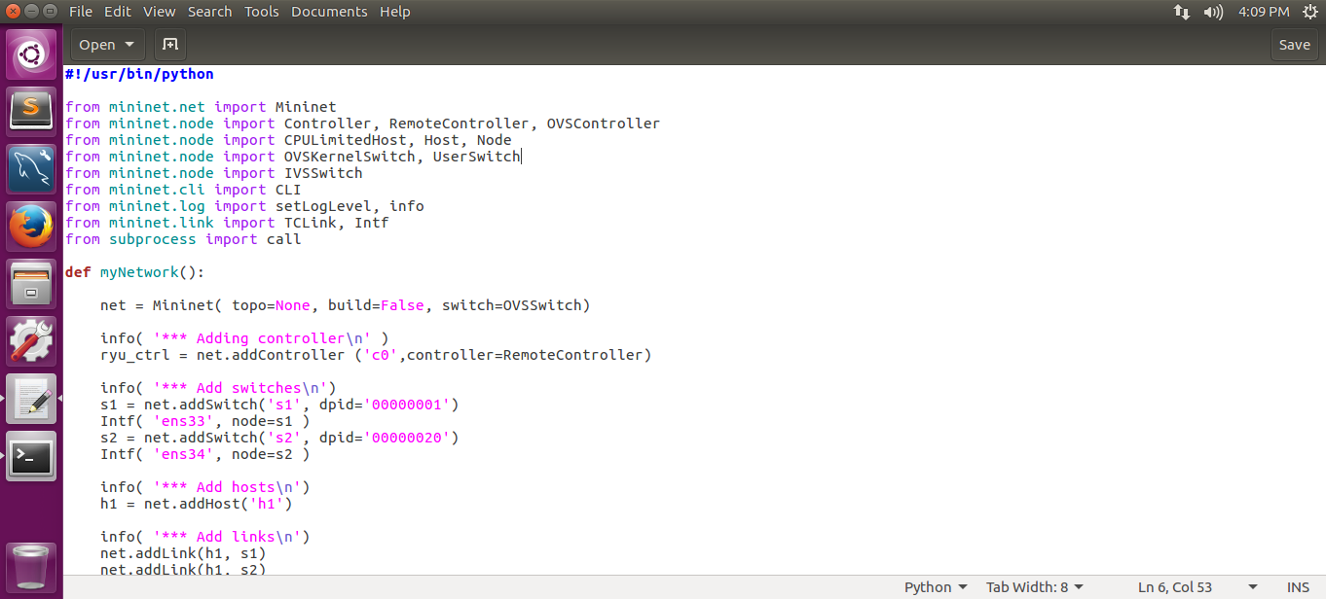

**Figure 26: Import OVSSwitch (Before)**

***AFTER***

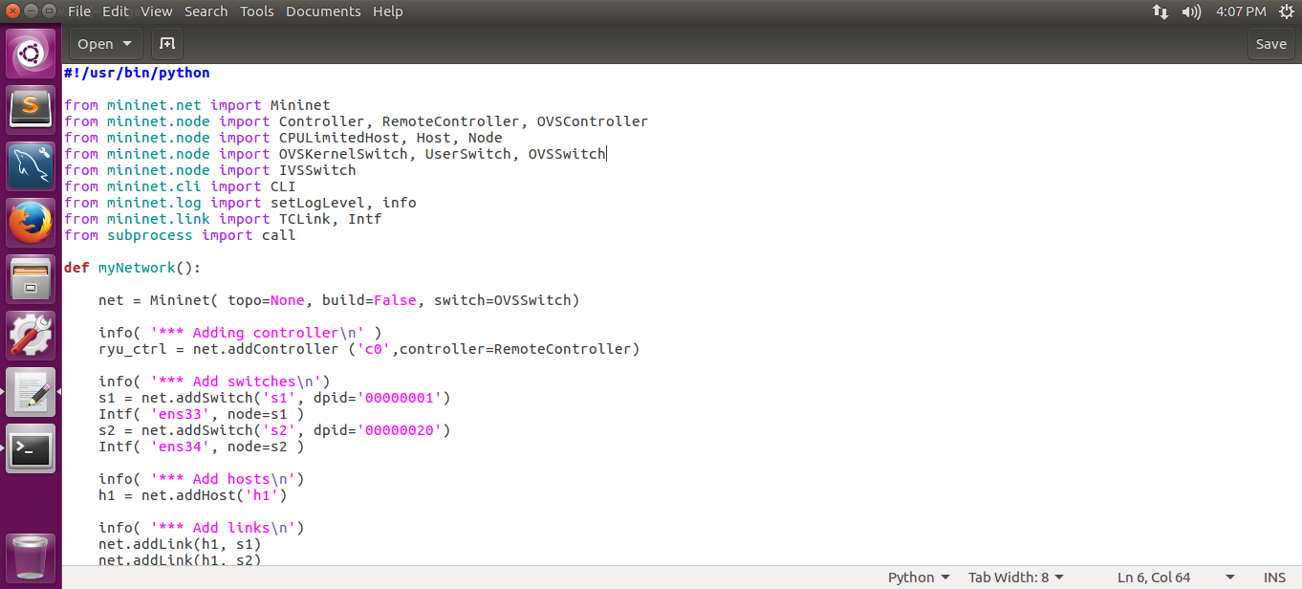

**Figure 27: Import OVSSwitch (After)**

1. Define the switch so that Mininet will know that all switches in this topology is an Open Virtual Switch (OVS).
2. The ipBase is removed as there are 2 different subnets in the topology which could not be used as a base.

***BEFORE***

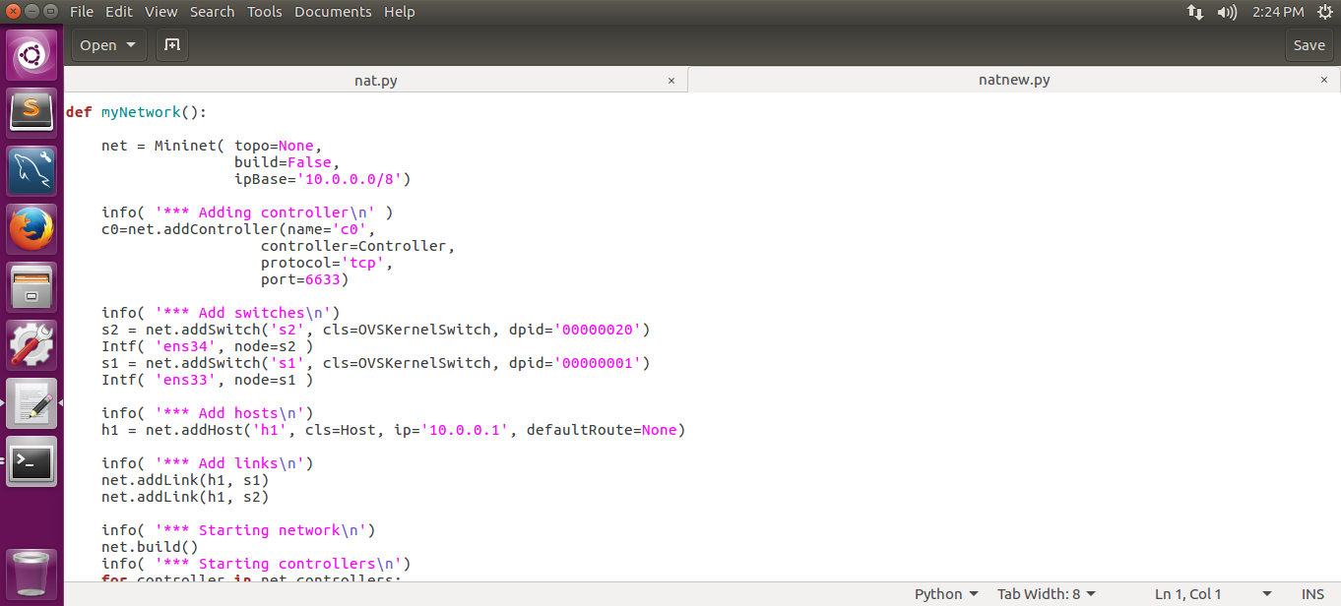

**Figure 28: Define Switch (Before)**

***AFTER***

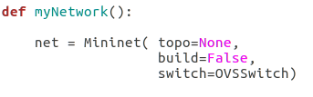

**Figure 29: Define Switch (After)**

1. Instead of using the controller provided by Mininet, the controller would be an external controller from Ryu. For more information, refer to the Ryu Controller Guide.

***BEFORE***

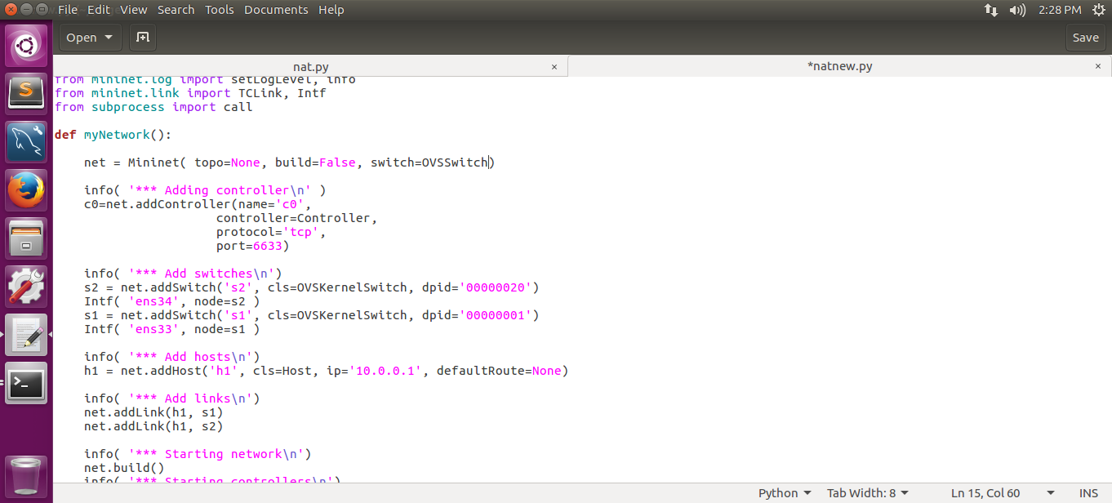

**Figure 30: Change To Ryu Controller (Before)**

***AFTER***

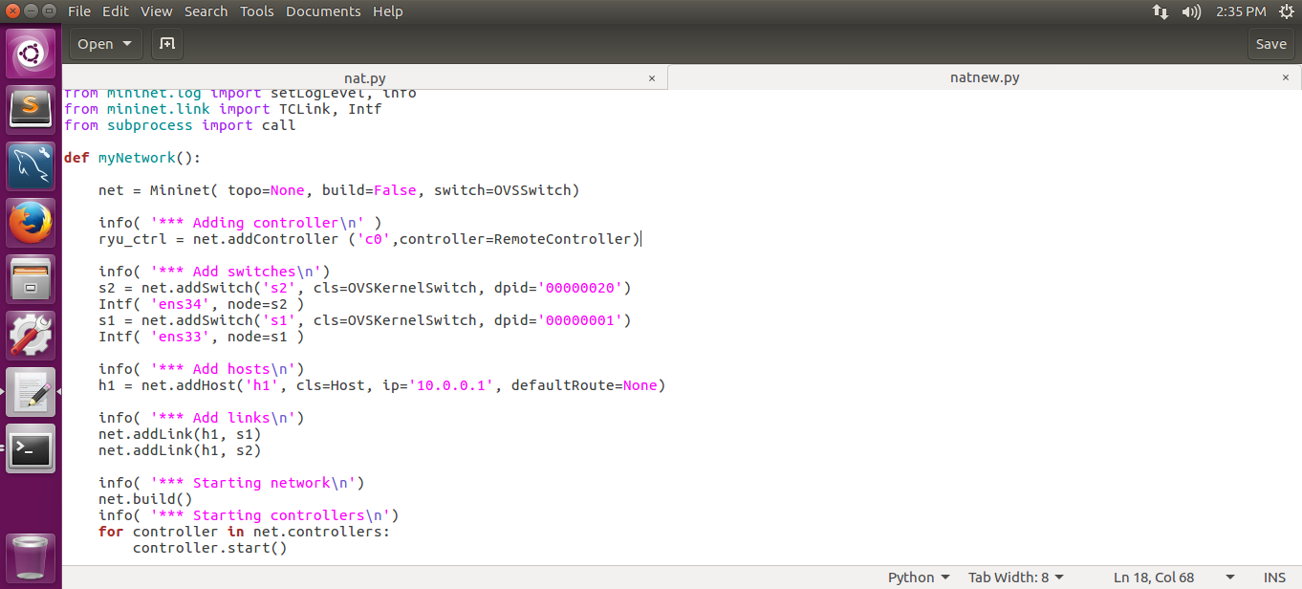

**Figure 31: Change To Ryu Controller (After)**

1. Swap the lines of **s1** and **s2** to avoid confusion since the switch is already defined as an OpenvSwitch, the cls is redundant.’
2. Include protocol openflow 13 at the end as well

***BEFORE***

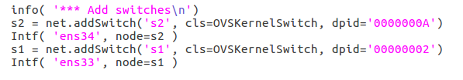

**Figure 32: Edit The Switches (Before)**

***AFTER***

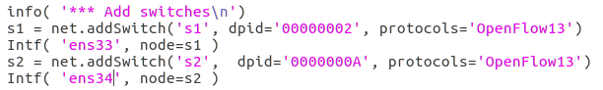

**Figure 33: Edit The Switches (After)**

1. Remove cls, ip and defaultRoute.
2. The characteristics of h1 will be defined in the later part of the program.

***BEFORE***

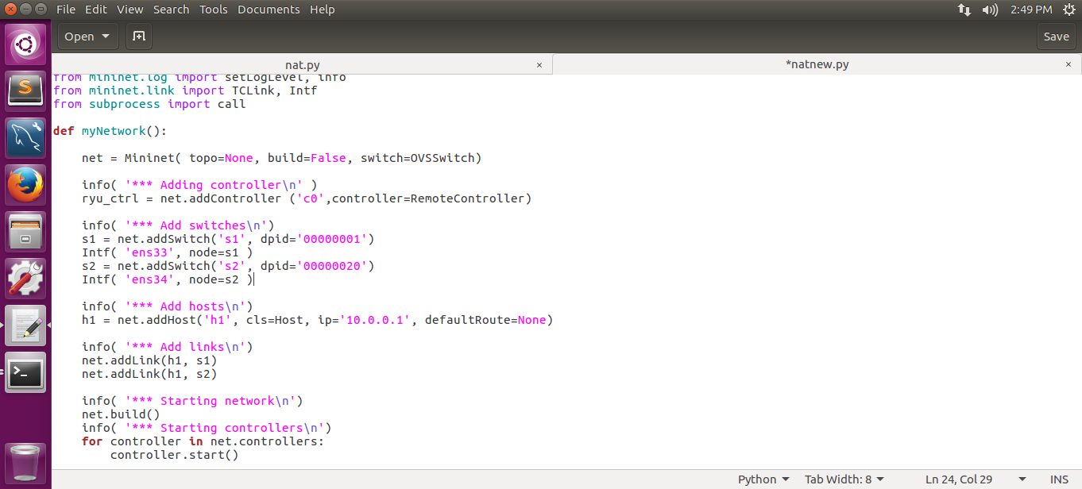

**Figure 34: Edit The Host (Before)**

***AFTER***

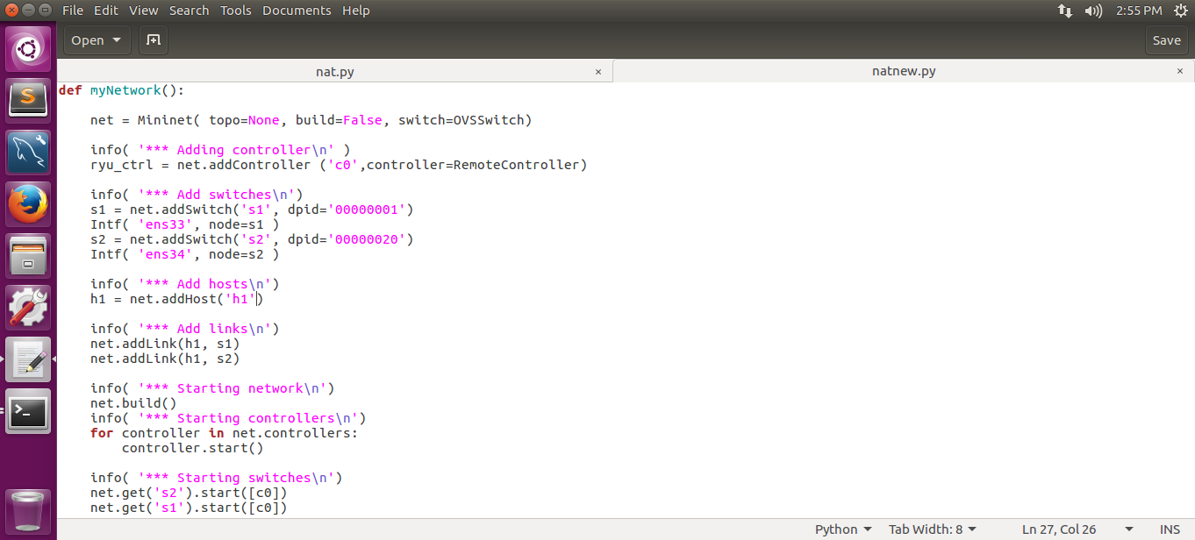

**Figure 35: Edit The Host (After)**

1. Since the controller used is an external controller, starting the controller is unnecessary. Since the controller is named **ryu_ctrl** and not **c0**, adjust accordingly.

***BEFORE***

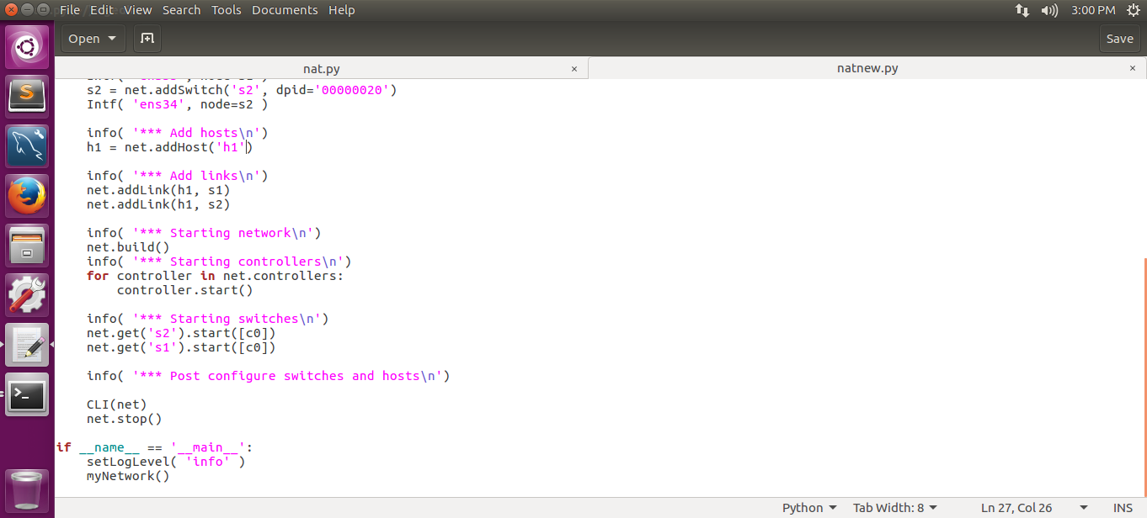

**Figure 36: Edit The Controllers (Before)**

***AFTER***

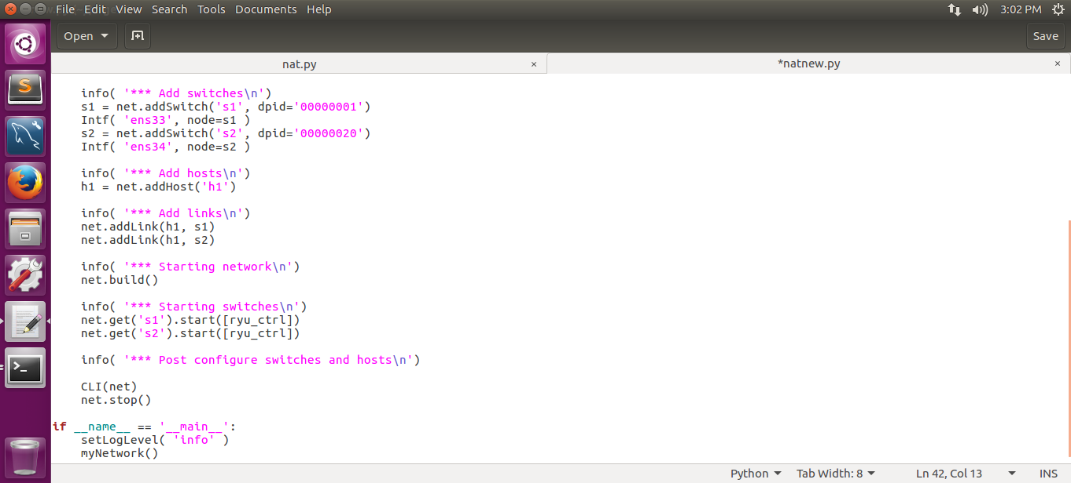

**Figure 37: Edit The Controllers (After)**

1. Take note of the IP address of the two network interfaces of the Virtual Machine. At this point onwards, you can always use eth0 and eth1 to refer to the virtual interfaces. They are set by the mininet, and the names are not affected by the real interface name.
   1. Remove the IP of both the Network Interfaces and give it to the two switches so that all the traffic that comes from the internet or the bridged side goes through the switches instead of the Network Interfaces.
   2. Set the default route of subnets so that Mininet knows which switch to send packets to if it belongs to a certain subnet.
   3. Set the network interfaces of **h1**.
   4. The default route for all packets that do not belong to either of the subnet is sent to the DHCP of the Virtual Machine.
   5. The last 4 lines is needed for the packets to flow between the two subnets. This allows any computer from Bridged subnet to access the Internet if it has the permission to do so.

***BEFORE***

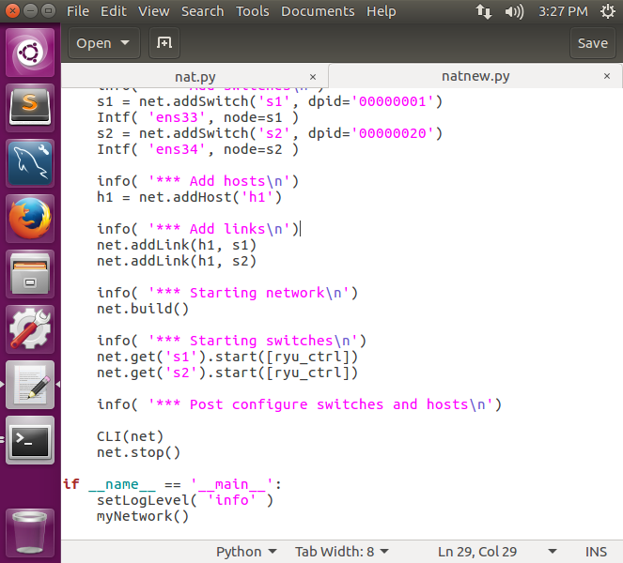

**Figure 38: Configure Switches and Hosts (Before)**

***AFTER***

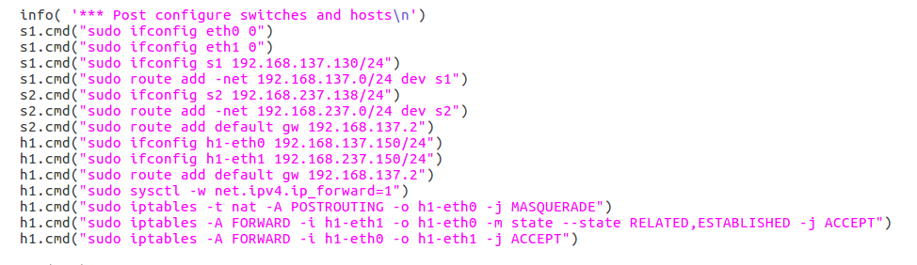

**Figure 39: Configure Switches and Hosts (After)**

1. This modification will give the IP back to the network interfaces once the Mininet is closed.

***BEFORE***

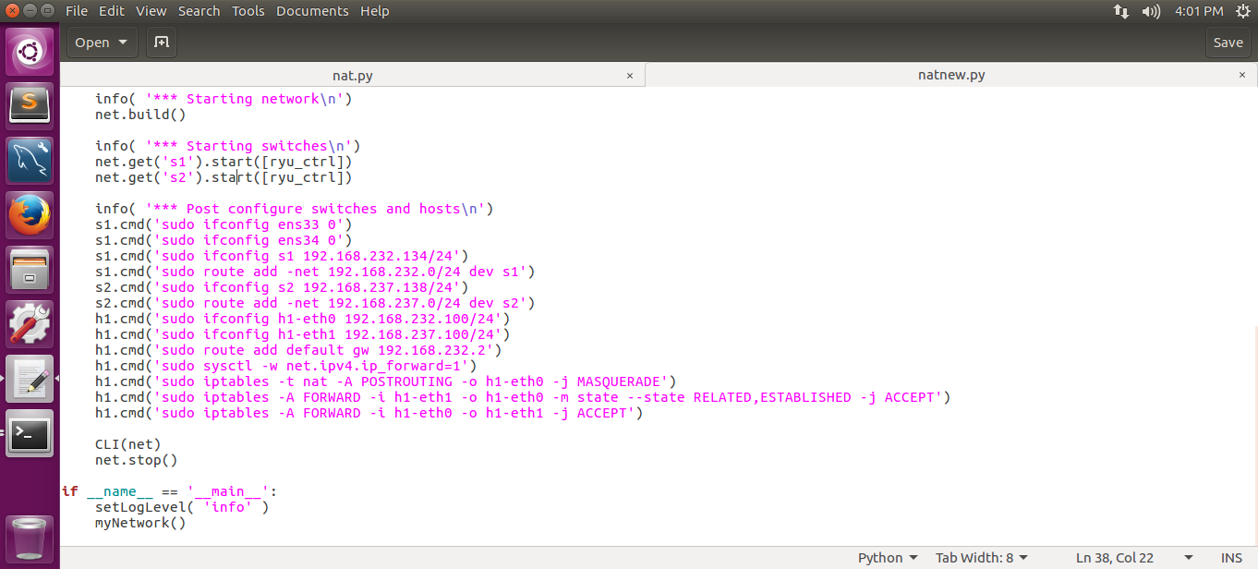

**Figure 40: Closed Mininet Settings (Before)**

***AFTER***

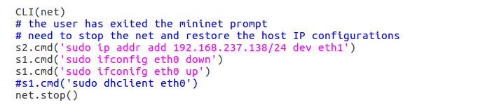

**Figure 41: Closed Mininet Settings (After)**

1. Save the file with CTRL + S and close the editor.
2. The Mininet Topology is now in a deployable state for Secured-T. To execute the file that was set up, simply type in the following command.
   1. Command: ***./sectestTopo.py***

#### **RYU Controller Guide**

Overview:

The purpose of this guide is to guide the user to set up Ryu Controller. Refer to Install The Prerequisites Of Secured-T part (i) for the installation of the Ryu Controller before moving on.

#### **Download The Required Ryu Controller Scripts**

1. Download 3 scripts named ***sim_switch.py***, ***sim_switch_rest.py*** and ***my_db.py*** from Secured-T github and store under ***ryu/ryu/app***.
2. Download a script named ***my_switch.py*** from Secured-T github and store under the home folder.
3. Download script ***simple_switch.sh*** from Secured-T github and store under **ryu**. It will run the ryu controller.
4. Change the permission of ***sim_switch_rest.py***. This would be the file executed for the Ryu Controller.
   1. Command: ***sudo chmod +x sim_switch_rest.py***

#### **DNS Proxy Guide**

Overview:

The purpose of this guide is to setup a DNS proxy. This DNS is used to only allow access to domains that are in the whitelist domain table in the database. This guide would assume that part (j) of Install The Prerequisites Of Secured-T has been done.

1. Disable the Ubuntu build-in local dnsmasq feature (DNS cache).
   1. Ubuntu has start a local DNSCache service to speed up the DNS lookup, and it occupies the port 53. We need to disable it before we can host a new DNS service.

**BEFORE**

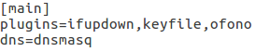

**Figure 42: Disable DNS Cache (Before)**

**AFTER**

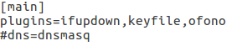

**Figure 43: Disable DNS Cache (After)**

1. Restart the NetworkManager service.
   1. Command: ***sudo service network-manager restart***

#### **Creating and Configuring the DNS Proxy**

1. The deployable version of the file can be found in Secured-T github with the name ***dnsProxy.py***. As our system name and path may be different, you will need to configure the script to work. For this guide, the home directory is ***/home***.
2. Download script ***dnsProxy.py*** from Secured-T github and put it into the home folder.
3. Change the permissions of the file.
   1. Command: ***sudo chmod 777 dnsProxy.py***
4. Edit the file.
   1. Command: ***gedit dnsProxy.py***
5. Edit the following line to your system name and path.



**Figure 44: Edit System Name And Path**

1. Save and exit the file. The file is now in a deployable state.

**Tomcat Installation and Configuration**

1. Switch to root account.
   1. Command: ***sudo -s***

1. Update and upgrade apt-get.
   1. Command: ***apt-get update && apt-get upgrade***

1. Switch to a normal user.

1. Install Apache Tomcat 8.
   1. Command: ***sudo apt-get install tomcat8***

* 1. For development:
     1. Command: **sudo apt-get install tomcat8-docs tomcat8-examples tomcat8-admin**
  2. For production:
     1. Command: **sudo apt-get install tomcat8-admin**

1. Start the Tomcat service.
   1. Command: **systemctl start tomcat8**
2. You can verify if Tomcat is running at the localhost by browsing to ***http://localhost:8080***.
3. In order to run both Tomcat and Ryu Controller, both must not be using the same port number. Since Ryu Controller is using port 8080, we will change Tomcat’s default port to something else.
   1. Command: ***sudo gedit /var/lib/tomcat8/conf/server.xml***

1. Change the port number to (e.g. 7070):

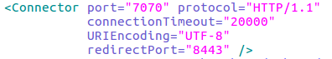

**Figure 45: Change Port Number Of Tomcat**

1. Restart Tomcat service and verify if Tomcat is running at the localhost
   1. Command: **systemctl restart tomcat8**

1. Browse to ***http://localhost:7070*.**

#### **Prepare a tomcat management account**

1. Update the following xml file.
   1. Command: **sudo gedit /var/lib/tomcat8/conf/tomcat-users.xml**
2. With the following tags (change your "username" and "password" accordingly), add this codes to the end of the file.

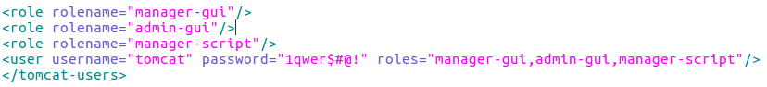

**Figure 46: Edit Tomcat Configuration File**

1. Restart Tomcat service and verify the manager page.
   1. Command: **systemctl restart tomcat8**

1. Browse to ***http://localhost:7070/manager.***

1. Enter your username and password set in the tomcat-users.xml file.

#### **Setting Up mod_JK**

Overview:

The purpose of setting up mod_JK is to bridge apache2 port 80 access to the web applications in tomcat8 so that it won’t be necessary to insert the port number in the url when going to the website.

1. Edit Tomcat server.xml file
   1. Command: ***sudo gedit /usr/share/tomcat8/conf/server.xml***

1. Uncomment the following line:



**Figure 47: Remove Connector**

1. Create a workers.properties file.
   1. Command: ***sudo gedit /etc/apache2/workers.properties***

1. Insert the following lines to define a real worker and set properties for it.

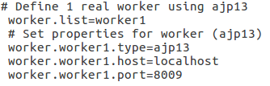

**Figure 48: Define A Real Worker With Properties**

1. Install mod-jk.
   1. Command: ***sudo apt-get install libapache2-mod-jk***

1. Edit jk.conf file.
   1. Command: ***sudo gedit /etc/apache2/mods-available/jk.conf***

1. Change the JkWorkersFile properties in jk.conf.

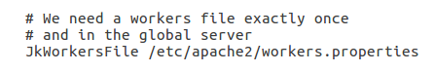

**Figure 49: JkWorkersFile Properties**

1. Finally, to configure the URL of Apache2 to pass through the Tomcat8.
   1. Command:***sudo gedit /etc/apache2/sites-enabled/000-default.conf***

1. Add the following lines in 000-default.conf.

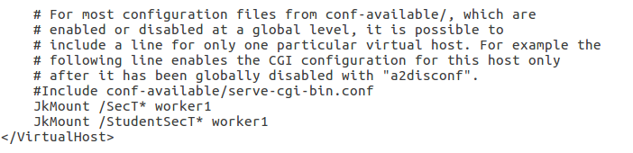

**Figure 50: Configure Apache2 Web Server**

* 1. The trailing * is a wild card to enable all sub folder access.
  2. You may add in multiple JkMount statement if needed.

1. Restart the servers.
   1. Command: ***sudo service tomcat8 restart***

***sudo service apache2 restart***

1. Check the functionality by browsing to ***http://localhost/SecT*** and ***http://localhost/StudentSecT***

#### **MySQL Workbench Installation guide**

Overview:

The purpose of this guide is to install and set up MySQL Workbench for the Secured-T system to store all the details.

1. First, launch a terminal, type the following command to install MySQL Workbench.
   1. Command: ***sudo apt-get install mysql-workbench***

***sudo apt-get install mysql-server\****

***sudo mysql_secure_installation***

***sudo apt-get install mysql-client***

* 1. Remember the password you set for the root account as it will be needed later

1. Once the installation is done, start/enable the service.
   1. Command: **sudo service mysql start**

#### **Adding Connection On MySQL Workbench**

1. After installation, there will be a default root user account. Connect to the root account with the password set during installation.
2. Go to Server > Users and Privileges

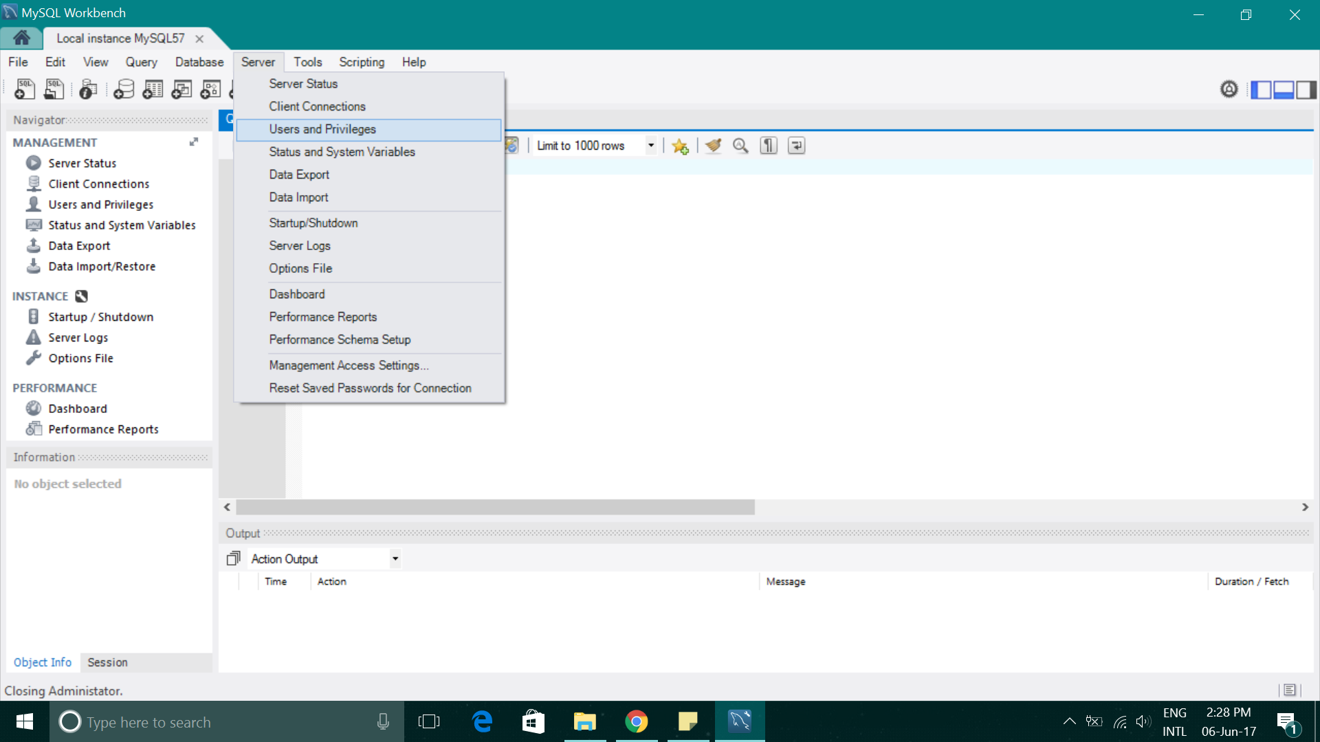

**Figure 51: Users and Privileges**

1. Click Add account and enter the details as follows:

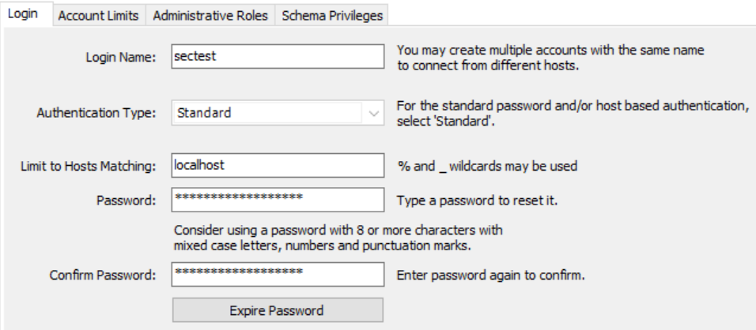

**Figure 52: Database Account Credentials**

1. The password will change it’s length automatically so no need to worry about it.
2. Then, go to the Administrative Roles and tick the role DBA.

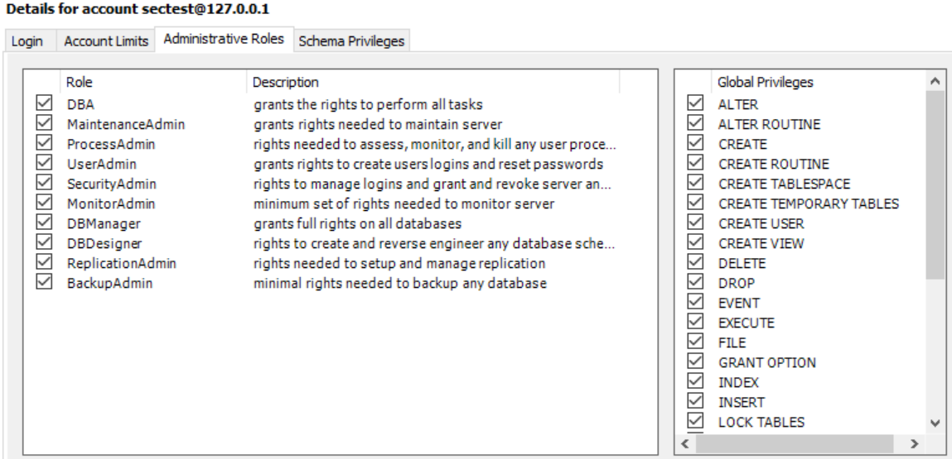

**Figure 53: Grant Rights To Perform All Tasks**

1. Click Apply.
2. Then, go back to the Home Page of MySQL Workbench.
3. Add a connection and enter the details as follows:

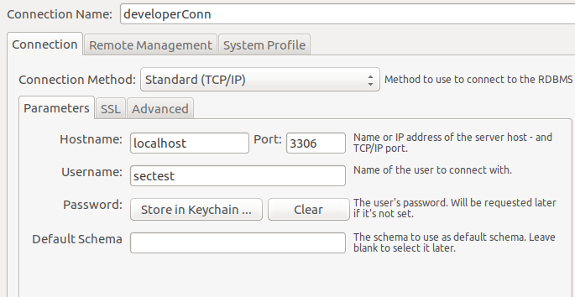

**Figure 54: Add Database Connection**

1. The username must be the same as the account Login Name. Leave the default schema field.

1. Click OK.
2. Connect to the new connection using the password set when adding the account.
3. Next, create a new schema by clicking the icon:

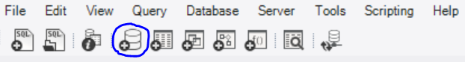

**Figure 55: Add Schema**

1. Enter the details as follows:

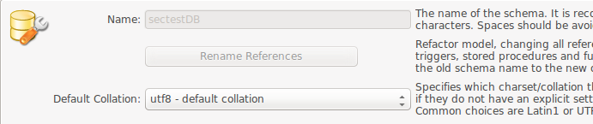

**Figure 56: Create Schema**

1. Next, set the schema created to the default schema.

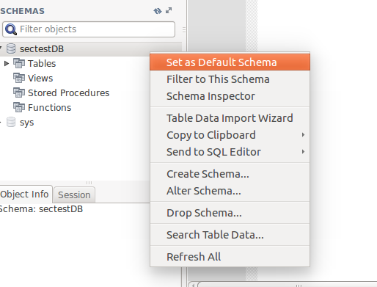

**Figure 57: Set Schema As Default Schema**

1. Now, you should have a custom user account with connection and a schema within it.

#### **Create Database Tables**

1. Create tables as shown in the figures below.



**Figure 58: T_ANNOUNCEMENT**



**Figure 59: T_ASSESSMENT**



**Figure 60: T_LECTURER_INFO**



**Figure 61: T_MODULE**



**Figure 62: T_STUDENT_INFO**



**Figure 63: T_WHITELIST_DOMAIN**

#### **Deployment guide**

Overview:

The purpose of this guide is start up the system for use.

1. After completing all of the installation and configuration stated, do a system reboot
   1. Command: ***sudo reboot***
2. There is a batch attached called ***routeadd.bat****.* Download on the base machine and run it on administrative mode.

#### **Create a shell script**

1. There is a script called ***startAll.sh*** in Secured-T github. Download the script and place it in your home directory.
2. startAll.sh is a script that will open up terminals and run all of the required programs separately.

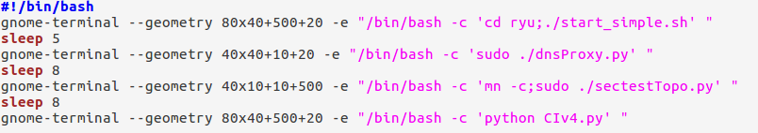

**Figure 64: Script To Run All Four Programs**

1. Now you should have four terminals being displayed on your screen as shown in the table below:

**Table 1: Software/Program And The Corresponding Filename**

|  |  |
| --- | --- |
| **Software/Program** | **Filename** |
| Ryu Controller | start_simple.sh |
| Mininet | sectestTopo.py |
| DNS Proxy Server | dnsProxy.py |
| Controlled Intelligence | CIv4.py |

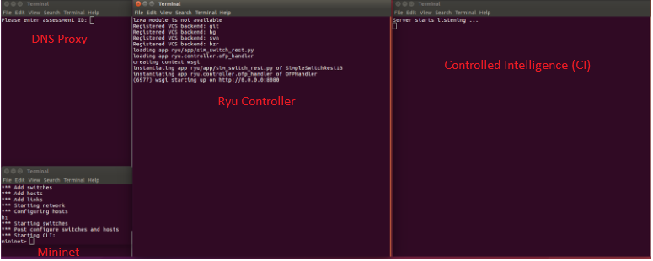

**Figure 65: All Four programs running**

#### **Deploying websites**

1. Download **SectT.war** and **StudentSecT.war** from Secured-T github. These files still need to be deployed on your tomcat. Store the files in the home directory.
2. Go to [***http://localhost***](http://localhost:7070)***:7070***
3. Click manager webapp

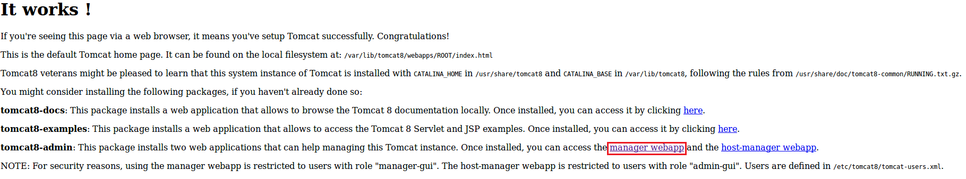

**Figure 66: Tomcat8 Default Page**

1. Key in the username and password of your tomcat account created previously.

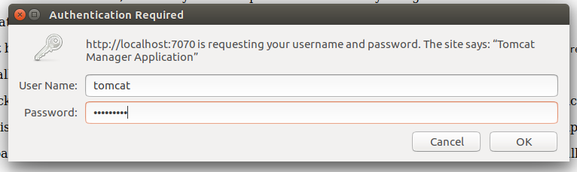

**Figure 67: Tomcat8 Login**

1. You will be directed to tomcat web application manager page, scroll down to ‘Deploy’ and then to ‘War file to deploy’ under it.



**Figure 68: Deploy War File**

1. Select your war file and click deploy.
2. Repeat for the second war file.
3. Now your files will be under Applications and your web applications are up and running



**Figure 69: Webapp Manager**

**The End**

**13.2 Lecturer Guide**



**SECURED-T**

**Lecturer Guide**

**Version 1.0**

**[03 August 2017]**

**Contents**

**LIST OF ILLUSTRATIONS G34**

**Preparation G35**

**Running The Programs: G35**

**Creating A Lecturer Account G35**

**Log In To The Account: G36**

**Managing The Modules G37**

**Managing The Assessments G37**

**Managing The Whitelist Domains G38**

**Managing The Announcements G40**

**Enter AssessmentID In Terminal G40**

**Starting The Assessment G41**

**Instructing The Students G41**

**Monitoring Students G42**

**List All Assessments G45**

**View Students’ Information G45**

**Checking The Submissions G46**

**Clearing Database G46**

**Shutdown The System G46**

#### **LIST OF ILLUSTRATIONS**

**Figures**

Figure 1: Running The Programs

Figure 2: The Four Terminals

Figure 3: Login Page

Figure 4: Home Page

Figure 5: Add Module From Home Page

Figure 6: Remove Module From Home Page

Figure 7: Add Assessment From Assessment Information Page

Figure 8: Delete Assessment

Figure 9: Tutorialspoint Url

Figure 10: Slack Url

Figure 11: Add Whitelist Domains From Whitelist Domain Page

Figure 12: Remove Whitelist Domains From Whitelist Domain Page

Figure 13: Exit Adding Of Whitelist Domains

Figure 14: Add Announcement From Home Page

Figure 15: AssessmentID Of A Particular Assessment

Figure 16: DNS Proxy Terminal

Figure 17: The Four Terminals After Inserting AssessmentID

Figure 18: Start Assessment

Figure 19: Monitor Status Of Students

Figure 20: Start Screen Capture And Keylogger

Figure 21: Stop Screen Capture And Keylogger

Figure 22: Student Cheating Notebook

Figure 23: Popup Alert Cheating Box

Figure 24: Stop Screen Capture And Keylogger When Cheating

Figure 25: Student Disconnected Notebook

Figure 26: Remove Student Disconnected Notebook

Figure 27: End Assessment

Figure 28: List Assessments Icon

Figure 29: View Students’ Information

Figure 30: Students’ Information

Figure 31: Clear Database Information

Figure 32: Logout From Web Application

Figure 33: Quitting The Four Terminals

Figure 34: Cleaning the Mininet

#### **Preparation**

As the lecturer, the first step to using our system is to set up the router and power it on. Then, you can proceed to power on the lecturer notebook and then the Ubuntu image in VMware Workstation Pro.

#### **Running The Programs:**

1. Once the Ubuntu image has booted up, open up a terminal on the taskbar on the left.
2. Type in the command ***sudo ./startAll.sh***.
3. Enter the sudo password for securedt.
   1. Password: ***1qwer$#@!***

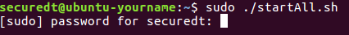

**Figure 1: Running The Programs**

1. Wait for the terminals to appear. There should be 4 terminals in total.



**Figure 2: The Four Terminals**

#### **Creating A Lecturer Account**

1. Create an account on the lecturer web application, SecT, by browsing to ***secured-t/SecT*** on the base machine.
2. Click on the ‘Create an account’ link.

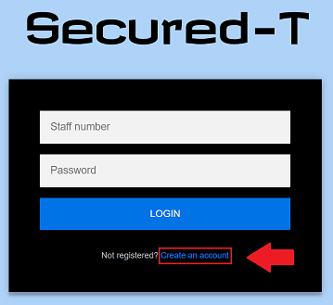

**Figure 3: Login Page**

1. Enter your staff number, name and password.
   1. Make sure your staff number is not more than 8 characters.
   2. Make sure your password contains alphabetic and numeric numbers and is 8-16 characters long.
   3. The staff number is unique in the database, therefore you cannot create another account with the same staff number.
2. After that, you will see a feature list as to what you can do on the web application.
3. Read it and then proceed to login.

#### **Log In To The Account:**

1. Enter your staff number and password for the account you have created earlier on.
2. You will be brought to the home page, where it will be pretty empty.

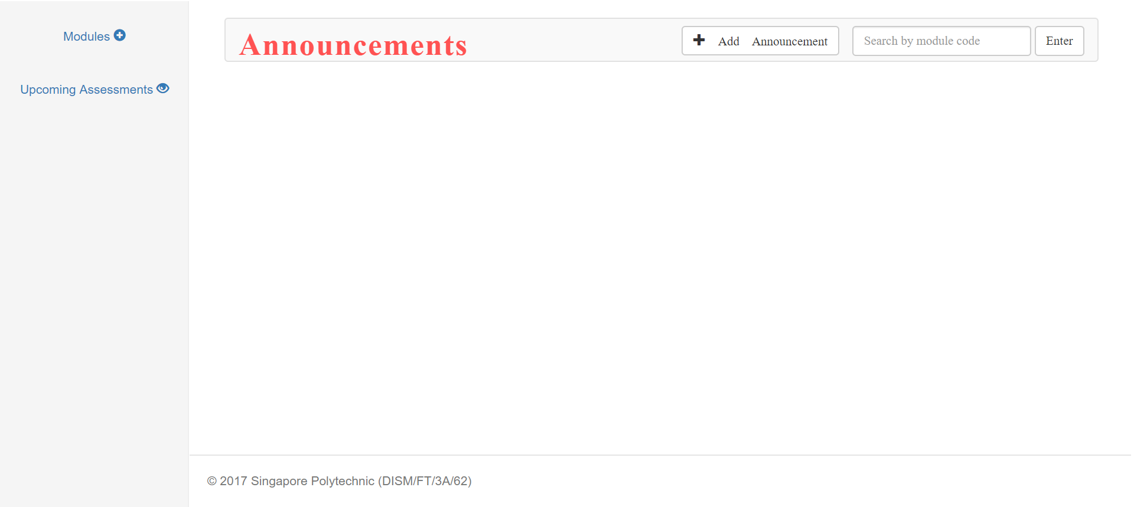

**Figure 4: Home Page**

#### **Managing The Modules**

1. Click on the add modules button on the left-hand side.

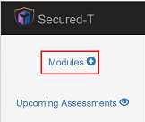

**Figure 5: Add Module From Home Page**

1. Enter the module code (e.g. ST1234) and the module name.
2. Click Add.
3. You should see the module you have added earlier on displayed on the home page under the “Modules” button.
4. If you want to remove a module, mouse-over that particular module and click the (-) button.

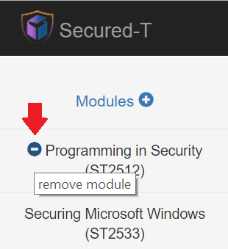

**Figure 6: Remove Module From Home Page**

#### **Managing The Assessments**

1. At the home page, manage the assessments by clicking the upcoming assessments button.
2. Add an assessment by clicking on the add assessment button on the right-hand side.



**Figure 7: Add Assessment From Assessment Information Page**

1. Choose the module name and enter the assessment name, time limit of the assessment in minutes, date and time of the assessment and the exam code for students to enter to the assessment.
2. Click Done.
3. You should see the assessment you have added earlier on displayed on the home page under the “Upcoming Assessments” button.
4. If you want to remove an assessment, click Delete for the particular assessment under upcoming assessments.

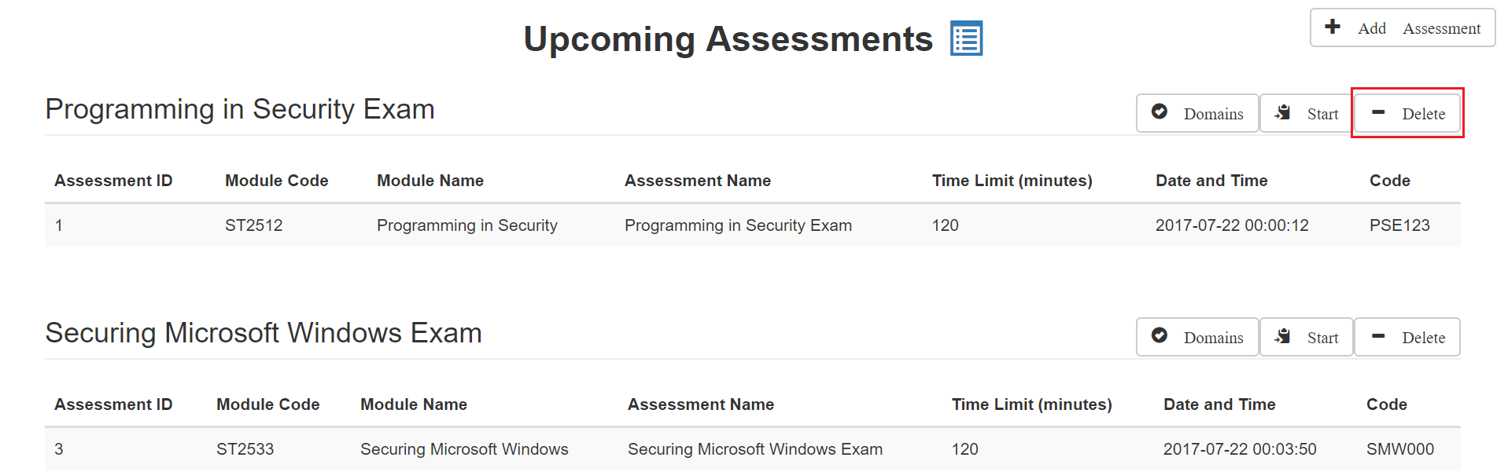

**Figure 8: Delete Assessment**

#### **Managing The Whitelist Domains**

1. After adding an assessment, you can manage the whitelist domains allowed in the particular assessment by clicking on the domains button under upcoming assessments.
2. Before adding the whitelist domains, it is important to check if the website’s url contains “www.” at the start or not.
   1. For example, in the tutorialspoint url, you can see the “www.” at the start.



**Figure 9: Tutorialspoint Url**

* 1. Then in the slack url, you can see that there is no “www.” at the start.



**Figure 10: Slack Url**

1. Add multiple whitelist domains by typing in the correct url in the input box and pressing enter on the keyboard.
2. Press the (x) button next to the domain names to cancel it.
3. After entering all the domains to be allowed in the particular assessment, click Done.

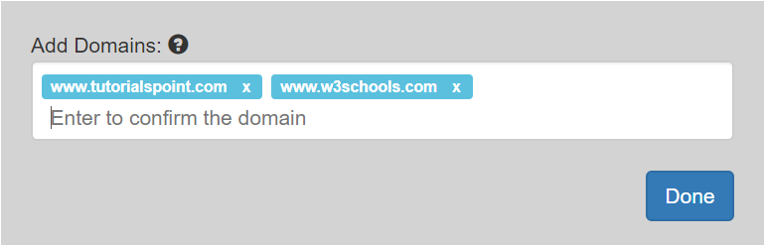

**Figure 11: Add Whitelist Domains From Whitelist Domain Page**

1. If you want to remove a whitelist domain after adding it already, mouse-over that particular domain and click the (x) button.

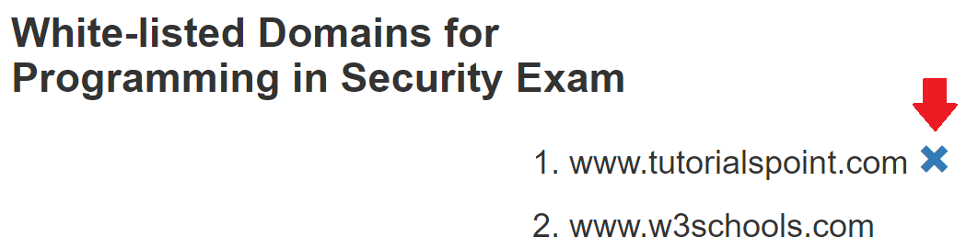

**Figure 12: Remove Whitelist Domains From Whitelist Domain Page**

1. Click Finish to go back to view the upcoming assessments or return to the home page by clicking on the Secured-T logo on the top left-hand corner.

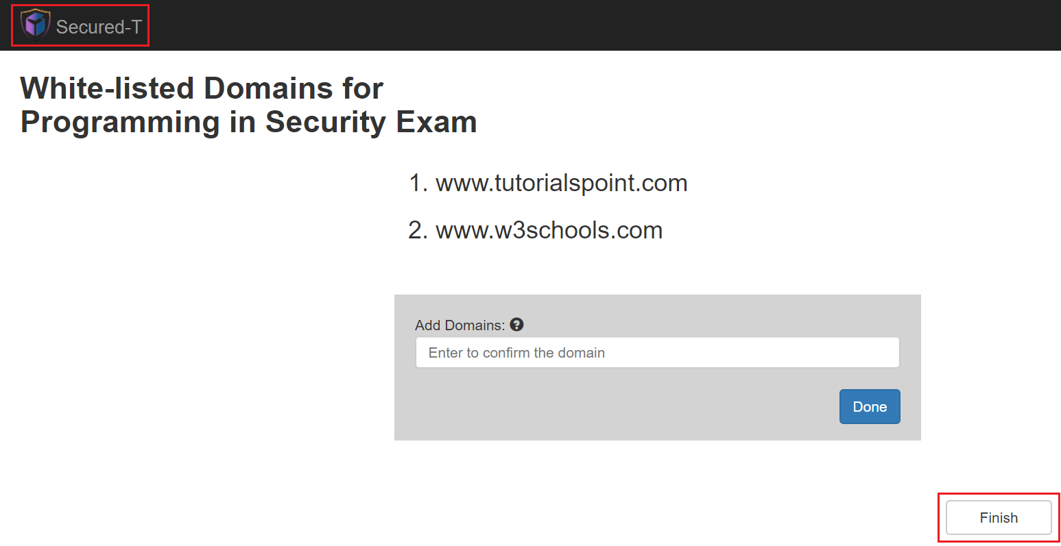

**Figure 13: Exit Adding Of Whitelist Domains**

#### **Managing The Announcements**

1. At the home page, add announcements by clicking on the add announcement button.



**Figure 14: Add Announcement From Home Page**

1. Choose the assessment you have added earlier on and type in the desired announcement.
2. Click Add.
3. You should be see the announcement you have added earlier on displayed at the home page.
   1. The announcements are arranged in descending order of the time it is added.
4. You can search for announcements by the module code in the search bar beside Add Announcement.

#### **Enter AssessmentID In Terminal**

1. After successfully creating assessments, with or without announcements, you can start the assessment.
2. Note the assessmentID that is shown in the upcoming assessments page.

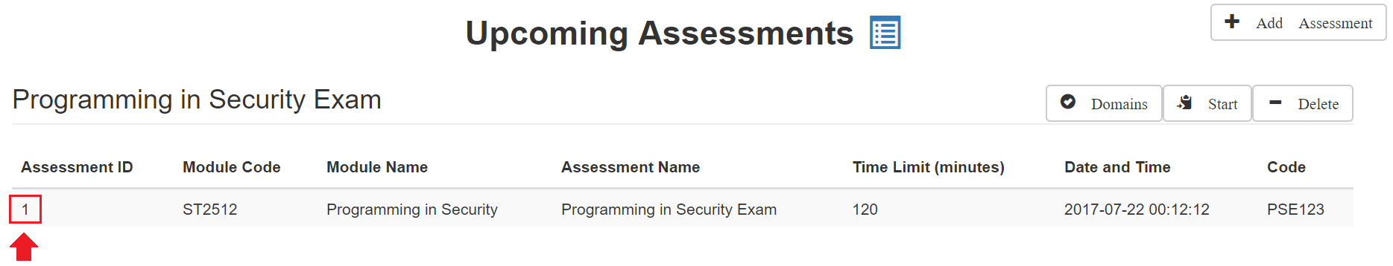

**Figure 15: AssessmentID Of A Particular Assessment**

1. Go back to the ubuntu image.
2. Enter the assessmentID into the DNS Proxy terminal.

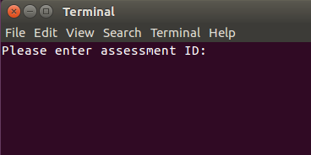

**Figure 16: DNS Proxy Terminal**

1. The 4 terminals should now look like the figure shown below.

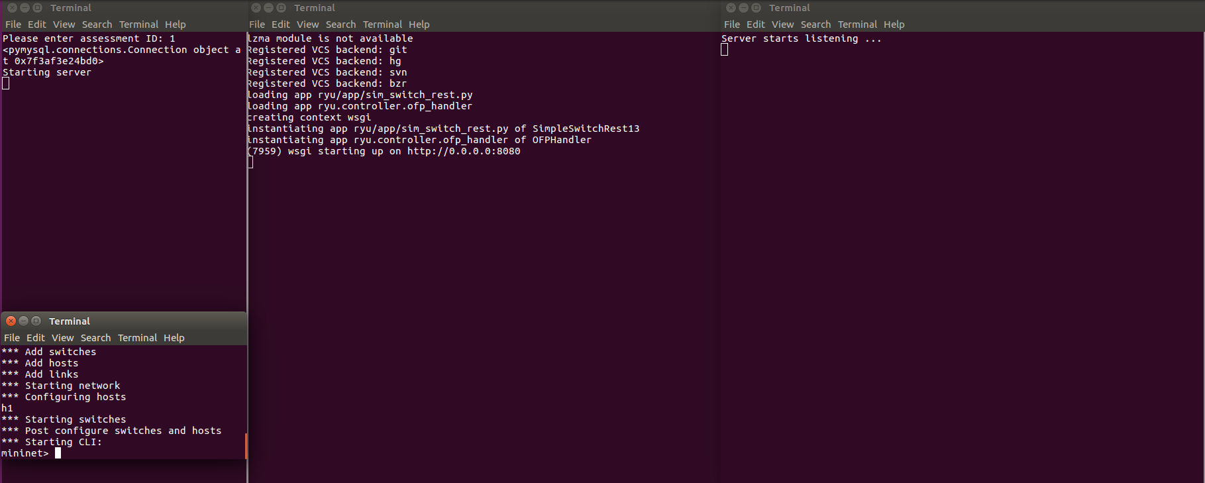

**Figure 17: The Four Terminals After Inserting AssessmentID**

#### **Starting The Assessment**

1. At the upcoming assessments page, click the “Start” button in the middle of Domains and Delete.

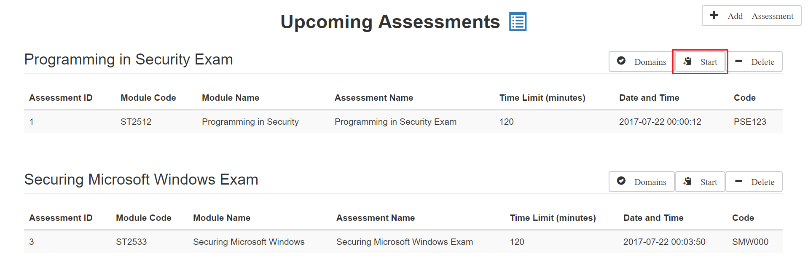

**Figure 18: Start Assessment**

1. A new window will appear where you can monitor the student’s connection status to the network.

#### **Instructing The Students**

1. Write down the exam code you have set for the assessment on the whiteboard so that students can connect to the correct assessment.
2. Inform the students of the domains they are allowed to enter. It will be shown on the student’s web application, StudentSecT, as well.
3. Whenever a new announcement is added during the assessment period, inform the students as well.

#### **Monitoring Students**

1. On the display page, you will see the students connecting.
2. The numbers on the notebook represents the last octet of the student’s IP address.
3. Mouse-over the notebooks to see the details of the students such as their admission number, table number, full IP address, port number and the updated timestamp.

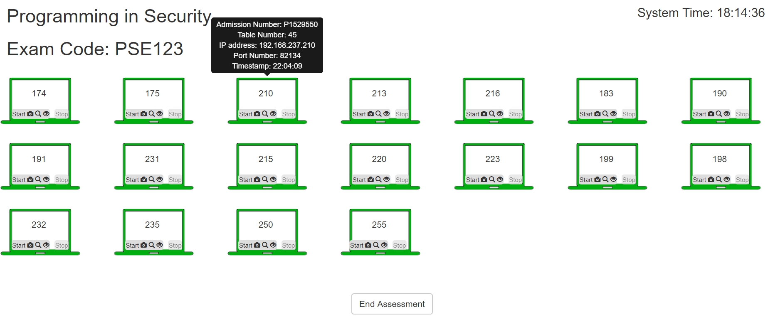

**Figure 19: Monitor Status Of Students**

1. When the notebook is green in colour, it represents that the student is obeying the rules and is not cheating or disconnected.
2. You can manually start the screen capture and keylogger if the student is suspicious by clicking on the Start button.
3. The screen capture and keylogger will be started in approximately 3-5 seconds.

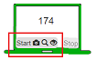

**Figure 20: Start Screen Capture And Keylogger**

1. You can then stop the screen capture and keylogger after you think you have captured enough evidence.

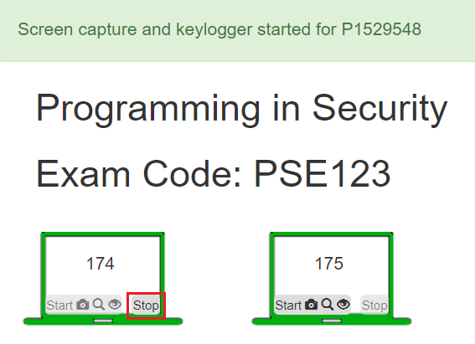

**Figure 21: Stop Screen Capture And Keylogger**

1. When the notebook is blue, it represents that the student is cheating. Screen capture and keylogging will be started automatically.

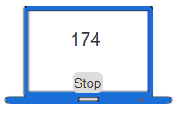

**Figure 22: Student Cheating Notebook**

1. An alert will also popup, telling you that 1 or more student(s) is/are cheating.

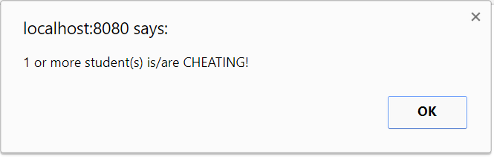

**Figure 23: Popup Alert Cheating Box**

1. You can then stop the screen capture and keylogger after confirming the student’s activity by clicking the stop button.

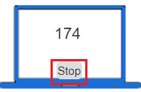

**Figure 24: Stop Screen Capture And Keylogger When Cheating**

1. When the connection is red, it represents that the student is disconnected. This could mean that the student has exited the website and/or network.

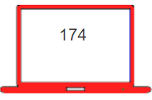

**Figure 25: Student Disconnected Notebook**

1. If the student is disconnected from the network, you must check to ensure that the student’s disconnection is not on purpose.
2. After checking, you can then remove the notebook from the display page to allow the student to login again if the reason is valid.
3. Mouse-over the notebook and click the (x) button to remove the notebook.

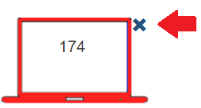

**Figure 26: Remove Student Disconnected Notebook**

1. After the assessment has ended, end the assessment properly by clicking on the “End Assessment” button.

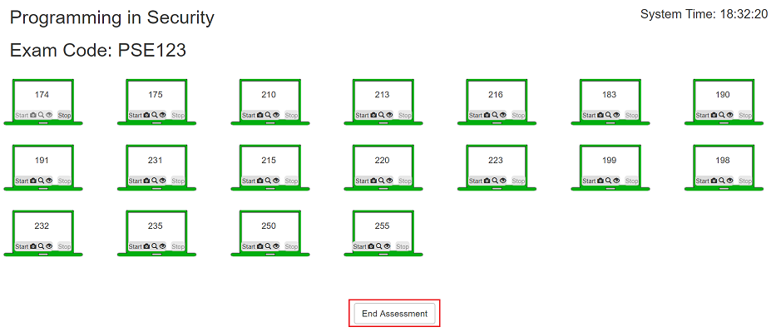

**Figure 27: End Assessment**

1. If you have exited the browser without clicking that button, the assessment will be considered to be still in progress.

#### **List All Assessments**

1. After the end of an assessment, you can review the list of assessments that have been hosted.
2. At the upcoming assessments page, click the icon that looks like a list beside the title “Upcoming Assessments”.



**Figure 28: List Assessments Icon**

#### **View Students’ Information**

1. At the all assessments page, you can view the students’ information for the particular assessment.
2. Click the “Students” button.

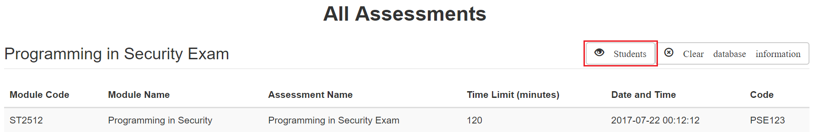

**Figure 29: View Students’ Information**

1. At the student information page, you can see details such as the students’ admission number, IP address, port number, last updated time before they disconnect, filename of their last submission and the number of versions of submissions.

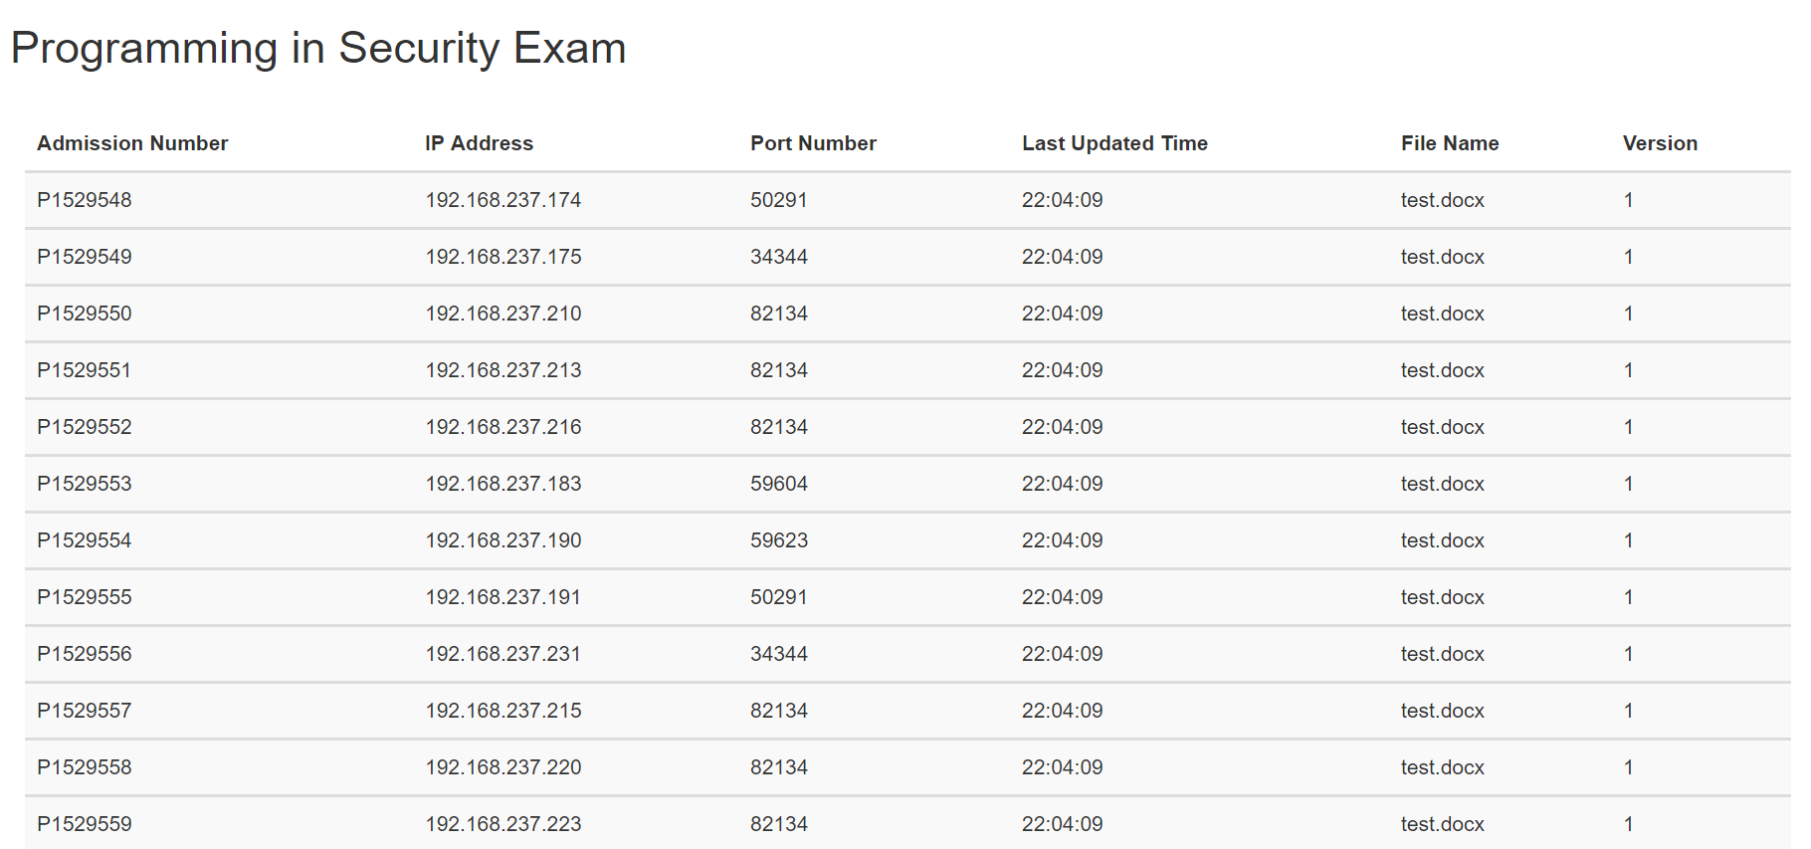

**Figure 30: Students’ Information**

#### **Checking The Submissions**

1. After the assessment has been completed, the submissions submitted by the students will be stored in the ***/home/securedt/submission*** folder.
2. Browse to that folder and you will see all the files. The files are named with the last octet of their IP address, followed by their admission number, followed by the filename.
   1. The last octet of the IP address and their admission number is inserted by the program, thus the filename does not have to include any identification of the students.

#### **Clearing Database**

1. After the assessment has been completed and you think you no longer need information related to the assessment, you can clear the database related to that assessment.
   1. This includes the announcements, the students’ information, the whitelist domains and the assessment itself.
   2. The module will remain since you may need it for another assessment.
2. Please only clear the database when you are sure you no longer need the information since it cannot be reverted.
3. Click the “Clear database information” button to clear the database.

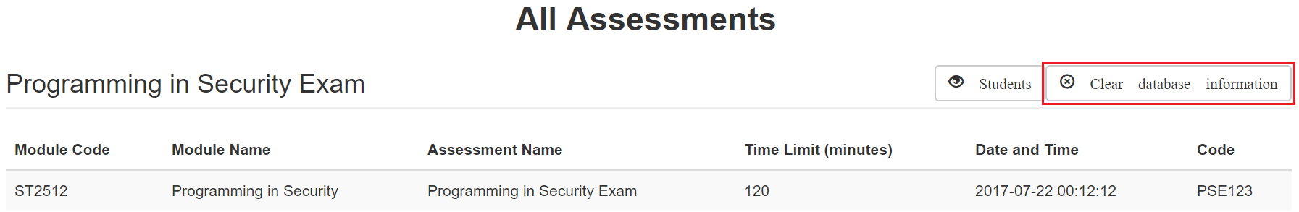

**Figure 31: Clear Database Information**

**Shutdown The System**

1. After you have done using SecT, logout from the web application and shut down the system.

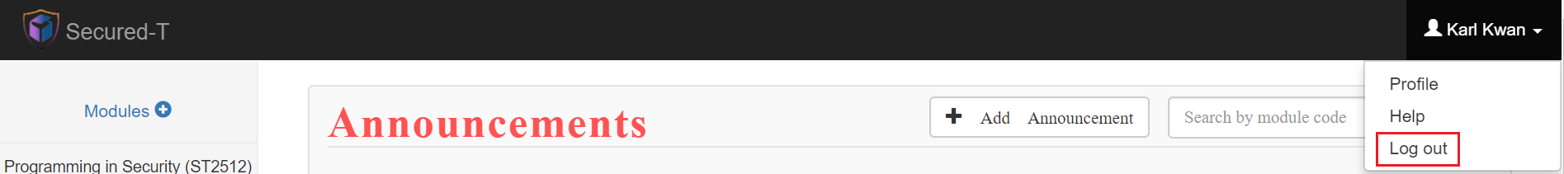

**Figure 32: Logout From Web Application**

1. Press ***Ctrl+C*** to quit the DNS Proxy, CI Program and Ryu Controller.
   1. Make sure that no one is connected to the network before quitting the Ryu Controller.
   2. If you are sure that no one is connected but it cannot be closed, use ***Ctrl+Shift+\*** instead.
2. For the Mininet, type in ***exit*** to quit.



**Figure 33: Quitting The Four Terminals**

1. In addition, clean the Mininet configurations by running ***sudo mn -c***.
2. Enter the sudo password for securedt.
   1. Password: ***1qwer$#@!***

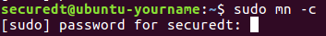

Figure 34: Cleaning the Mininet

**The End**

**13.3 Student Guide**



**SECURED-T**

**Student Guide**

**Version 1.0**

**[03 August 2017]**

**Contents**

**LIST OF ILLUSTRATIONS G50**

**Connect To The Network G51**

**Download The Required Program G51**

**Register Using The CSI Program G52**

**Log In To The StudentSectT G54**

**Logging In Errors G54**

**Navigating Through StudentSecT G57**

**Submissions G57**

**Logout G59**

**Exiting The Program G59**

#### 

#### 

#### **LIST OF ILLUSTRATIONS**

**Figures**

Figure 1: Uncheck Auto Connections

Figure 2: Select Network

Figure 3: Download prompt

Figure 4:Store CSI program

Figure 5: Proceeding From Downloads

Figure 6: CSI Program

Figure 7: Invalid Input Error Message

Figure 8: Connection Error Message  
Figure 9: Successfully Connected Message   
Figure 10: Placement Of CSI  
Figure 11: Login Screen

Figure 12: Invalid Exam Code Error   
Figure 13: Invalid Registration Error   
Figure 14: Logged In Error   
Figure 15: Disconnected Error  
Figure 16: Announcement Page  
Figure 17: Submission Page  
Figure 18: Submission Error Message  
Figure 19: Submission Successful Message  
Figure 20: Pop-up Confirmation Warning

#### 

#### 

#### 

#### **Connect To The Network**

As a student, the first step to enter into our system is to connect to our network.

1. On your WiFi settings, make sure to uncheck the auto connection to other networks.

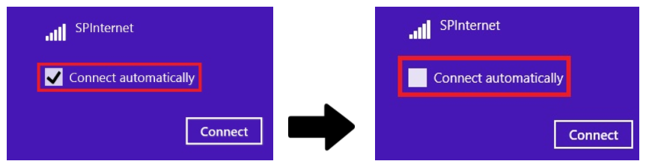

**Figure 1: Uncheck Auto Connections**

1. On your WiFi settings, search for the SSID of the router. Choose either ***Sectest1*** or ***Sectest2*** and check the box to auto connect so as to stay connected***.***

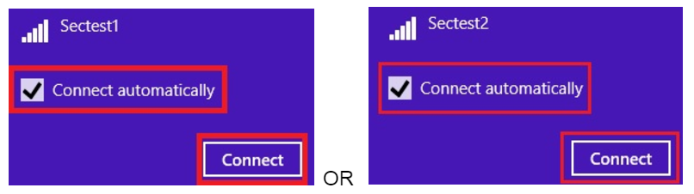

**Figure 2: Select Network**

1. Then, key in the passcode for the respective SSID.
   * SSID: ***Sectest1***

Passcode: ***sectest1***

* + SSID: ***Sectest2***

Passcode: ***sectest2***

#### **Download The Required Program**

Navigate to our student web application, StudentSecT.

1. Browse to ***192.168.237.138/StudentSecT***.
2. If there is a prompt to auto download our CSI program, accept the download.



**Figure 3: Download prompt**

1. Store it where it is easily accessible for you, eg. Desktop

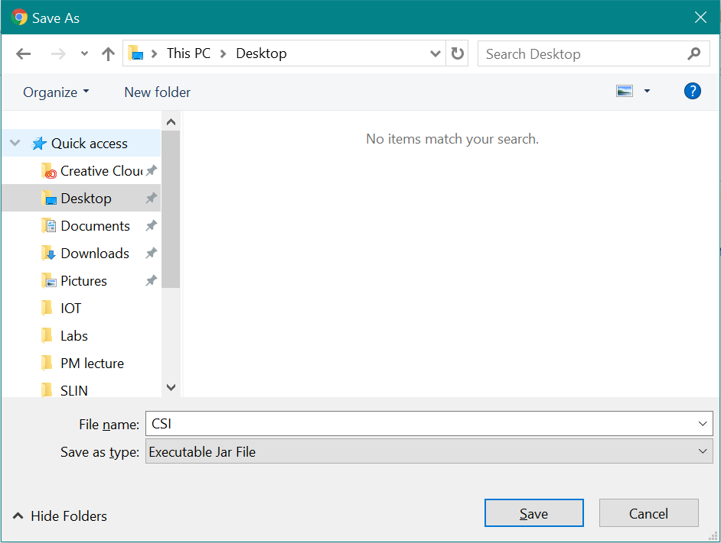

**Figure 4: Store CSI program**

1. Then, click on ‘Proceed’.

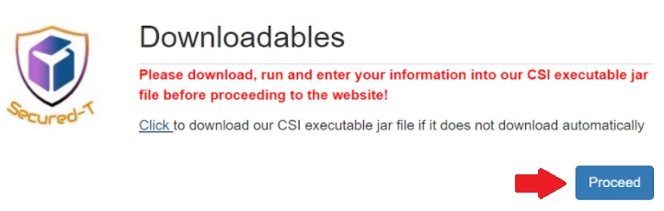

**Figure 5: Proceeding From Downloads**

#### **Register Using The CSI Program**

Before logging into the website, you will have to register your admission number into the CSI program to be authorized.

1. Double-click on the CSI jar file to run it.
2. Enter your admission number, (eg. P1234567) into the field and click “Connect”.

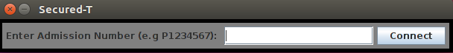

**Figure 6: CSI Program**

1. If you receive the following error message, please note that you need to enter exactly 8 characters into the field. Close the program and re-run it.

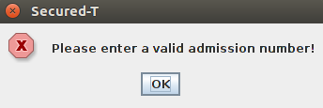

**Figure 7: Invalid Input Error Message**

1. If you receive the following error message, please inform the lecturer.

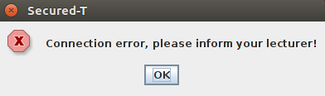

**Figure 8: Connection Error Message**

1. Once you have clicked “Connect”, there will be an acknowledgement message that says you have been connected. Click ‘OK’.

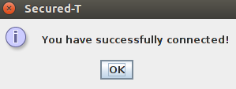

**Figure 9: Successfully Connected Message**

*\*\*Please note: Once you have successfully connected to our system, the “Connect” button will be disabled and will not be able to it anywhere.* ***Please place the frame at a position on your screen that will not hinder you when doing your assessment.*** *However, you should be authorized to log in to the* ***StudentSecT*** *site.*

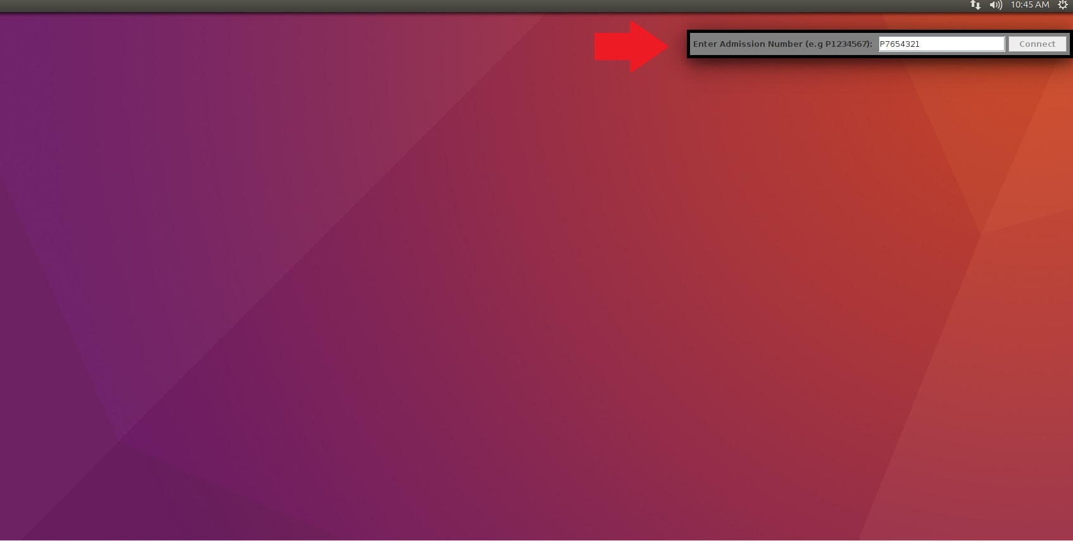

**Figure 10: Placement Of CSI**

#### **Log In To The StudentSectT**

Once you have registered, you can now use the StudentSecT site. It is very important for you to know that you are only allowed to **login once** and **logout** **only at the very end** to be on the safe side of avoiding login errors.

1. Log in using your admission number, the exam code that will be written on the whiteboard and your table number assigned to you and click “Enter”.



**Figure 11: Login Page**

#### **Logging In Errors**

There may be 4 instances of error messages you may receive if you have been unsuccessful. Here is what to do:

1. If you receive the following error, this means that you have typed the wrong exam code. Simply retype the correct code and you can log in.

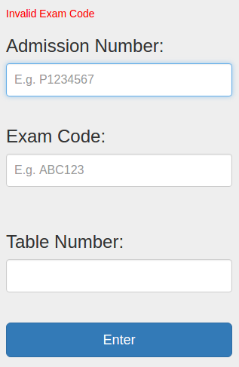

**Figure 12: Invalid Exam Code Error**

1. If you receive the following error, this means that you have not registered your admission number through the CSI program beforehand. Register yourself to the CSI first.

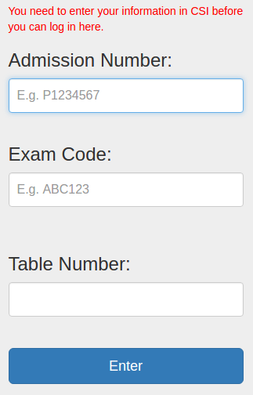

**Figure 13: Invalid Registration Error**

1. If you receive the following error, this means that you have already been logged in. In the case that you have never logged in before but received this error, then it may mean that someone else had logged in as you. Inform your lecturer immediately. However, if you have logged in before and have accidentally closed the browser, you can type in the following link to get back: [***http://192.168.237.138/StudentSecT/announcement.jsp***](http://192.168.237.138/StudentSecT/announcement.jsp)

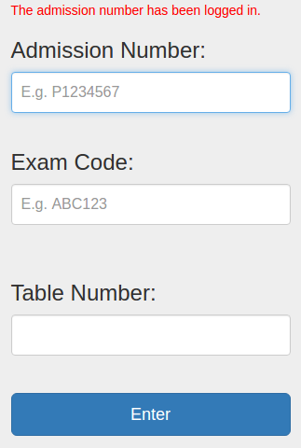

**Figure 14: Logged In Error**

1. If you receive the following error, this means that you have already exited the assessment and you are prohibited from logging in again. It is only a one-time login. Unless you have a valid reason, inform your lecturer. However, they will decide whether or not to allow you access to the assessment again.

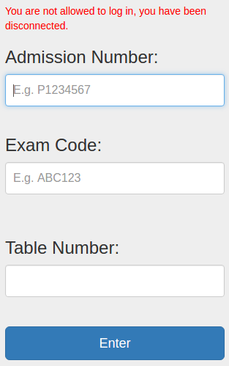

**Figure 15: Disconnected Error**

1. If the reason is valid, you will have to repeat the process of registering with CSI and log in to StudentSecT again.

#### **Navigating Through StudentSecT**

Upon login, **you are highly advised to not use the back button on the browser to backtrack.**

You will see the main page where you can view the announcements from your lecturer for the assessment you are taking. Kindly click on the “Announcements” tab to reload it if you cannot view the allowed domains for the assessment and any new announcements from the lecturer at the start. Then, you can minimize the browser and continue doing your assessment.

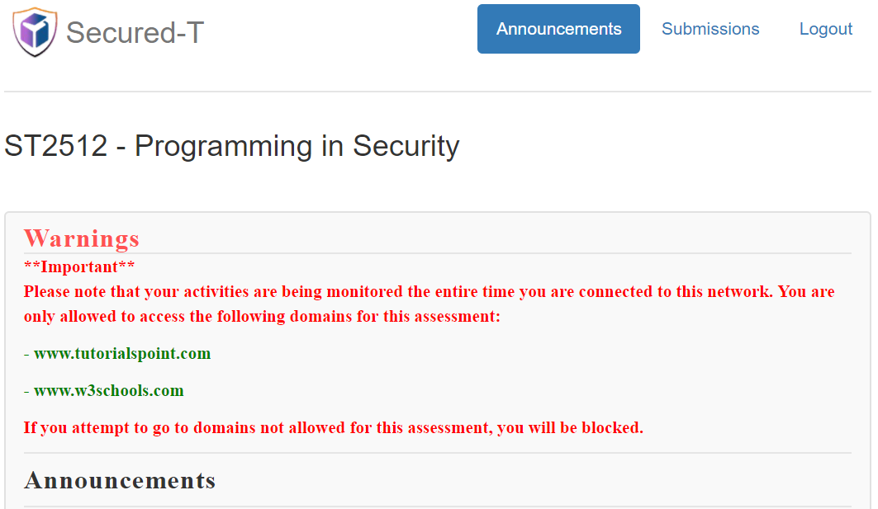

**Figure 16: Announcement Page**

*\*\*Please take note of the warnings and read it.*

You may click on the “Submissions” tab when submitting answers and then proceed to logout.

#### **Submissions**

When you wish to submit the answers, bring up the browser, or if you have closed the browser, navigate to [***http://192.168.237.138/StudentSecT/announcement.jsp***](http://192.168.237.138/StudentSecT/announcement.jsp)and click on the “Submissions” tab.

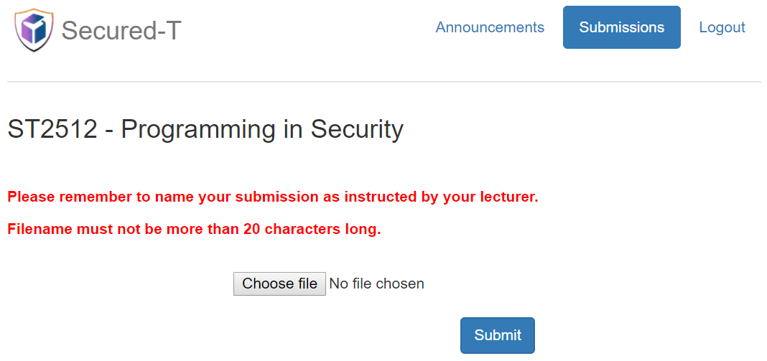

**Figure 17: Submission Page**

1. Click “Choose File” and choose your submission answers with a filename not more than 20 characters in length. If you did not fulfill this requirement, you will receive the following error.

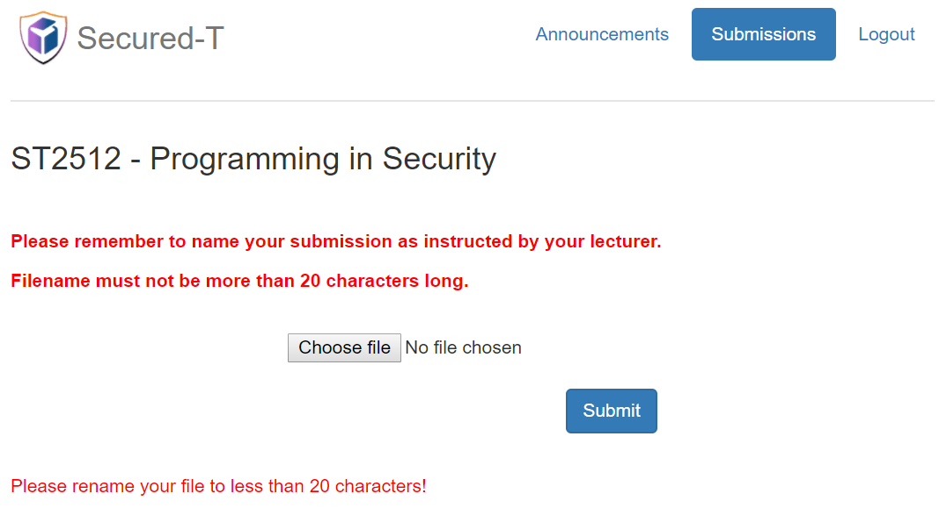

**Figure 18: Submission Error Message**

1. If you are successful, you will be notified.

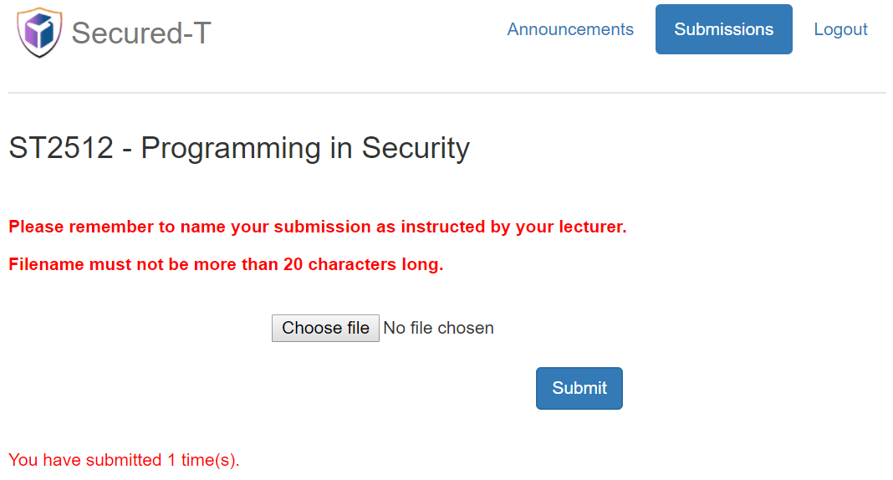

**Figure 19: Submission Successful Message**

1. You may be allowed to submit as many times as you wish until you logout.

#### **Logout**

When you are done submitting your answers, just press the “Logout” tab. There may be a pop-up notification asking for your confirmation to logout.

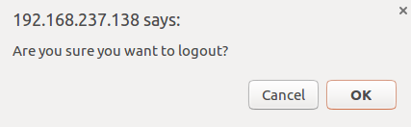

**Figure 20: Pop-up Confirmation Warning**

**Please note: You are only to logout once and will no longer be able to access the assessment. Hence, make sure you click on the button only at the end, once you are ready.

#### **Exiting The Program**

Upon logout, the CSI program will cease and be terminated automatically.

**The End**